Using the USC Medicine Library Page

- This service is a privilege of being a part of INBRE. If you abuse this, share it with someone outside of my lab or in any way allow other individuals to use the information contained in this document, you WILL forfeit my privileges. That will make me unhappy. Please do not abuse this gift. Please.

- Goto: http://uscm.med.sc.edu/

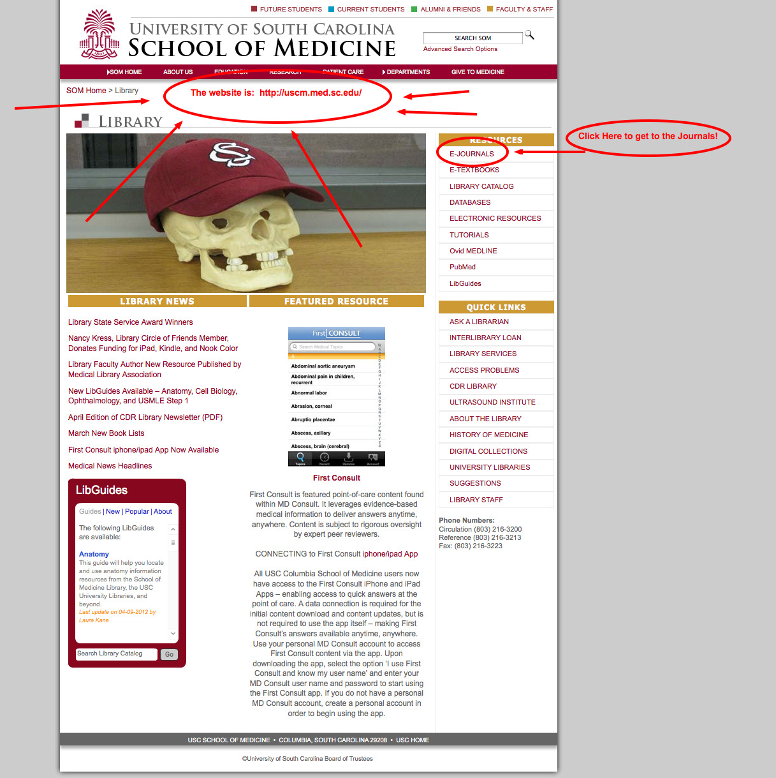

- Once there, you’ll need to head to the journals section. Click the “E-Journals” link.

- Log in using: hurlbertj/scbrin52

- After you login, you’ll need to search for the journal you want to pull an article from. Enter part of the journal name in the search box.

6) Once you find the journal you are looking for, click on one of the links that will take you to the resource. BE AWARE that the library only has access to certain dates for each journal. Frequently the article you want may be unavailable. Sad face.

