CHEM523 Protein Sequencing Problem

Problem 1
1) You are in a South American rain forest looking for naturally occuring peptides with potential as drugs. You have a mobile biochemistry lab with common reagents and enzymes, an amino-acid analyzer, gel-filtration and ion-exchange chromatography, and electrophoresis. You also have an Edman Sequenator, but you have contaminated one or more of your reagents, and as a result, you cannot sequence peptides longer than about 12 residues before contaminants obscure the results. While screening extracts from the ovaries of an tropical orchid, you find a peptide with potential as an antiviral. Deduce its amino-acid sequence using the available tools.
1) MW by electrophoresis can tell you how big a sequencing problem you are up against.
Result: about 4000
This doesn’t really tell us much, does it? Sometimes extra information is just that: extra.
2) Amino-acid analysis can help you decide how to fragment the peptide for sequencing:
Result: A₂C₂D₂E₄FG₃HKLMN₂P₂Q₂R₄S₄T₃W
3) How many peptides expected from each of these possible cleavage reagents?
- Cyanogen bromide (C-side of M).
  - There’s 1 Met, so you would expect a single cleavage unless it is the last amino acid
- Staph. aureus V8 protease (C-side of D and E).
  - Since there are 6 Asp and Glu residues, you’d expect 6 cuts unless any of them are at the carboxy-terminusof the peptide.
- Trypsin (C-side of K and R).
  - There are 4 Arg and 1 Lys, so you’d expect 5 cuts unless any of them are on the carboxy terminus of the protein.
4) Cleavage by trypsin followed by gel-filtration chromatography gives the expected 6 products, which you sequence (shown in order of emergence from column):
T-1 ETMESSAGEFGR
T-2 SQTWALDHSECR
T-3 GPQDNK
T-4 TCR
T-5 NP
T-6 R
Five possible cuts would generate 6 peptides, so we know that Arg and Lys aren’t at the carboxy-termnius. This tells us a lot. Most importantly, we know the sequence of the tryptic peptides.
5) Cleavage by Staph. aureus V8 protease followed by gel-filtration chromatography gives the expected 7 products, which you sequence (shown in order of emergence from column):
S-1 RSQTWALD
S-2 FGRGPQD
S-3 NKTCRNP
S-4 SSAGE
S-5 TME
S-6 CRE
S-7 HSE
Deduce the primary structure of this polypeptide.
To do this, you need to overlap the peptides. I’ll write the Tryptic peptides in Purple and the V8 peptides in Green.
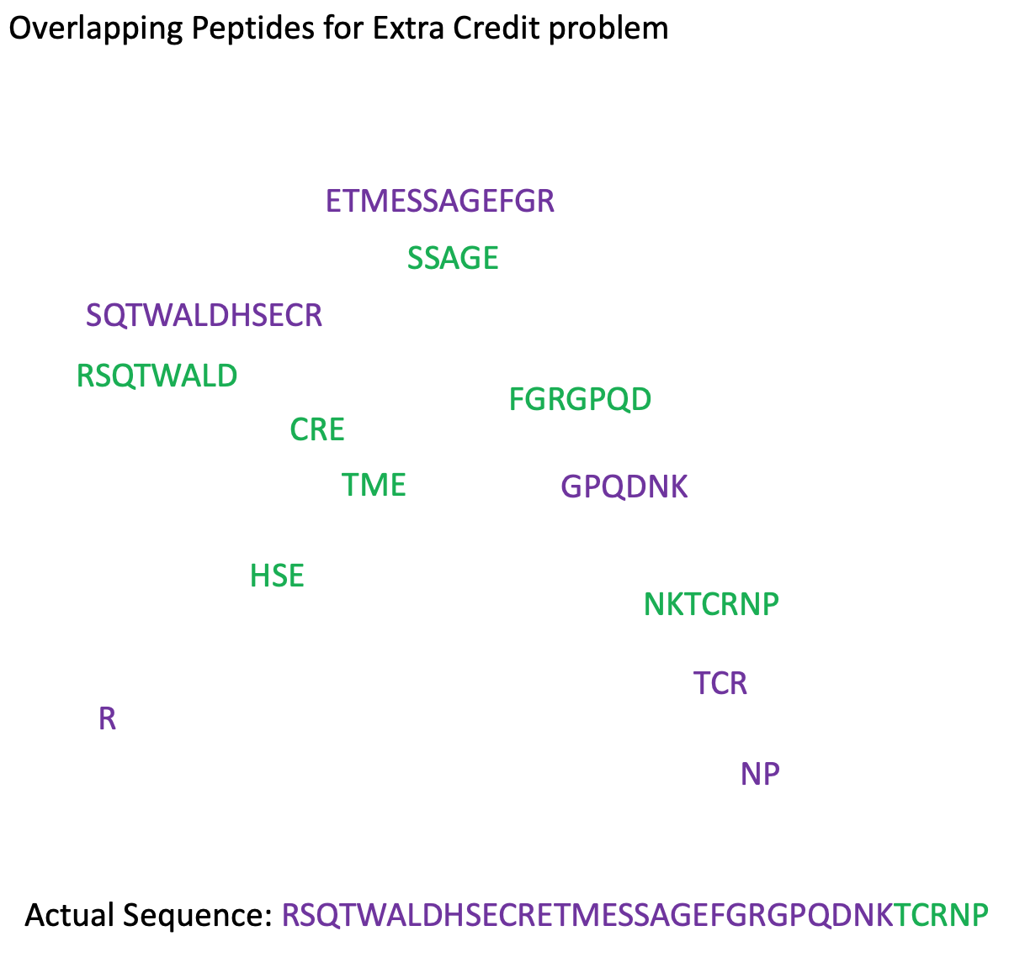

Additional questions that could be asked as part of this problem:
Why would cyanogen bromide not be a good choice as a cleavage reagent?
Can you account for the order of elution of peptides from the two chromatographies?
Predict the order of elution of the tryptic peptides from a cation-exchange column eluted with pH-8.5 buffer and a salt gradient.
Predict the order of elution of the V8 protease peptides from an anion exchange chromatography column eluted with a pH-6.5 buffer and a salt gradient.

