CHEM523 Homework 5

Send me your answers via Rocketbook by the due date.
- What are the 5 ways we mentioned in class to regulate the activity of a protein? Give an example of each one.
- What is the evolutionary advantage of allostery? Use a curve and specific points on the curve to support your answer.
- Why aren’t Aspartic acid and Glutamic acid targets for protein phosphorylation?
- What is divergent evolution? Give an example.
- What is convergent evolution? Give an example.
- Draw the mechanism for carbonic anhydrase. What would happen to the Vo if you mutated the histidine of the proton shuttle to an alanine?
- Draw the mechanism for the phosphorylation of a serine residue by a protein kinase, knowing that the enzyme catalyzes the reaction by proximity (no covalent intermediate, the kinase just binds the two substrates and a reaction occurs). The substrate and products are below:

Substrates bound into the enzyme:
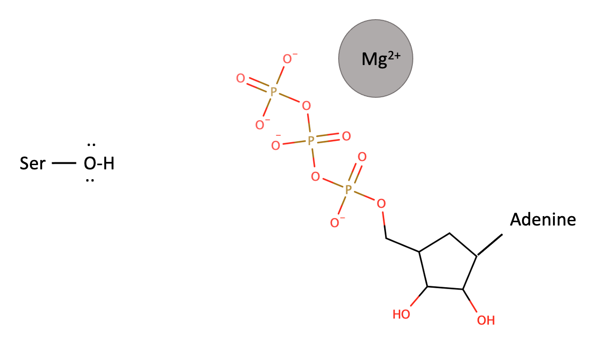
Products after kinase catalyzed phosphorylation:
