CHEM520 Homework 3

- The pKa of an acid depends partly on its environment. Predict the effect of each of the following environmental changes on the pKa of a glutamic acid side chain.
- A lysine side chain is brought into proximity.
- The terminal carboxyl group of the protein is brought into proximity.
- The glutamic acid side chain is shifted from the outside of the protein to a nonpolar site inside.

This question is absolutely critical to understanding how proteins work. Because of their tertiary structure, the main chain can fold back on itself in any number of ways and put similarly charged residues in proximity to each other. If an ionizable amino acid side chain is surrounded by other similar ionizable side chains, then the surrounded residue’s pK_{A} shifts either up or down depending on the residue. Remember, the side chain pK_{A} of glutamic acid is 4.5.
- Lysine is positively charged at physiological pH, so if you brought it near a glutamic acid, the glutamic acid would deprotonate to form a “salt bridge” between the negatively charged glutamate and the positively charged lysine. In this case the pK_{A} is lowered to make sure that the side chain is deprotonated.
- The terminal carboxyl group of the protein has a pK_{A} of 2.5, so it is negatively charged. This would shift the pK_{A} of the glutamic acid up so that it would remain protonated, even at physiological pH so as to prevent two negatively charged residues being in proximity to each other. In this case the pK_{A} is raised to make sure that the side chain remains protonated.
- This is a tricky one. There’s no real reason for the glutamic acid side chain to do anything differently BUT there’s no advantage to being deprotonated, and having a negative charge surrounded by hydrophobic amino acid side chains, so in this case the pK_{A} is raised to make sure that the side chain remains protonated.

- Does myoglobin exhibit a Bohr effect? Why or why not?

Myoglobin stays in the peripheral tissues far from the lungs. It does experience changes in pH as an effect of aerobic respiration, but it always behaves the same; it has to for the survival of the organism. Myoglobin’s job is to become readily saturated with oxygen from hemoglobin in the capillary beds and deliver it to low pO2 tissues. The Bohr effect relies on the change in protonation state of alpha-chain His146 and its varying interactions with alpha chain Asp 94 and a beta chain lysine. Since myoglobin is a monomer, it doesn’t have a quaternary structure and therefore cannot exhibit a Bohr effect.

- With the use of site-directed mutagenesis, hemoglobin has been prepared in which the proximal histidine residues in both the α and the β subunits have been replaced by glycine. The imidazole ring from the histidine residue can be replaced by adding free imidazole in solution. Would you expect this modified hemoglobin to show cooperativity in oxygen binding? Why or why not?

No, because the 0.4 angstrom movement of the imidazole side chain of the proximal histidine with the Fe²⁺ as oxygen binds causes the F-Helix to move more than 1 angstrom, causing the rearrangement of an adjacent subunit. A free imidazole group would move, but because it isn’t covalently bonded to the main chain of the protein, the F-Helix wouldn’t move, so the adjacent subunit wouldn’t rearrange to accommodate the motion caused by oxygen binding.

- The illustration below shows several oxygen-dissociation curves. Assume that curve 3 corresponds to hemoglobin with physiological concentrations of CO₂ and 2,3-BPG at pH 7. Which curves represent each of the following perturbations?
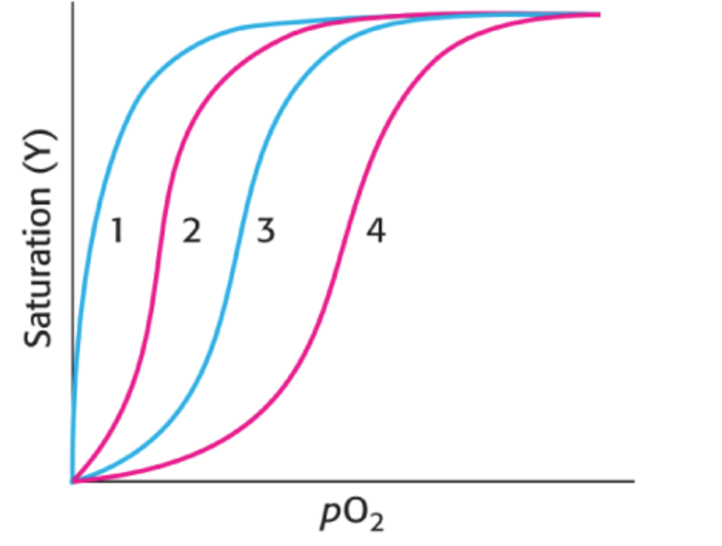

- Decrease in CO₂
2
- Increase in 2,3-BPG
4
- Increase in pH
2
- Loss of quaternary structure
1

- Lampreys are primitive organisms whose ancestors diverged from the ancestors of fish and mammals approximately 400 million years ago. Lamprey blood contains a hemoglobin related to mammalian hemoglobin. However, lamprey hemoglobin is monomeric in the oxygenated state. Oxygen-binding data for lamprey hemoglobin are as follows:

pO2 (Torr) | Fractional Saturation (Y)
0.1 | 0.006
0.2 | 0.0124
0.3 | 0.019
0.4 | 0.0245
0.5 | 0.0307
0.6 | 0.038
0.7 | 0.043
0.8 | 0.0481
0.9 | 0.053
1 | 0.0591
2 | 0.112
3 | 0.17
4 | 0.227
5 | 0.283
7.5 | 0.42
10 | 0.5
15 | 0.64
20 | 0.721
30 | 0.812
40 | 0.865
50 | 0.889
60 | 0.905
70 | 0.917
80 | 0.927
90 | 0.935
100 | 0.941
150 | 0.96
200 | 0.97

Plot these data to produce an oxygen-binding curve.
At what oxygen partial pressure is this hemoglobin half-saturated?
On the basis of the appearance of this curve, does oxygen binding seem to be cooperative?

YO₂
pO₂ (Torr)

This hemoglobin molecule is 50% saturated at 10 Torr
No, it does exhibit sigmoidal binding kinetics, so it does not display cooperativity.

