CHEM523 Homework 2 Key

Answer the following questions on your Rocketbook pages and send me your answers by Friday, September 10 at midnight. Late submissions will not be accepted. Be certain to include your name on every page in the top right hand corner.

- When performing his experiments on protein refolding, Christian Anfinsen obtained a quite different result when reduced ribonuclease was reoxidized while it was still in 8 M urea and the preparation was then dialyzed to remove the urea. Ribonuclease reoxidized in this way had only 1% of the enzymatic activity of the native protein. Why were the outcomes so different when reduced ribonuclease was reoxidized in the presence and absence of urea?

By allowing disulfides to form by removing the beta-mercaptoethanol but preventing secondary structures from forming (which prevents tertiary structures from forming), any cysteine that was near any other cysteine EVEN IN A DIFFERENT PROTEIN CHAIN could form a disulfide bond. Once the urea was removed and the protein was allowed to form secondary and ultimately tertiary structures, none of the protein molecules were in the correct shape.

- Myoglobin is a monomeric protein that accepts oxygen from the heterotetrameric hemoglobin protein in capillaries and muscle tissue. The α and β subunits of hemoglobin bear a remarkable structural similarity to myoglobin. However, in the subunits of hemoglobin, certain residues that are hydrophilic in myoglobin are hydrophobic. Why might this be the case?

Myglobin is a monomer and hemoglobin is a heterotetramer. Residues that interact between the alpha and beta chains of hemoglobin are hydrophobic to drive the two chains together via the hydrophobic effect. (That keeps coming up, doesn’t it?). In myoglobin, since it is a monomer, all amino acids on the surface of the protein are in contact with water and should, therefore be hydrobphillic so that they can form ion-dipole and dipole-dipole IMFs with solvent and ion molecules.
- The following reagents are often used in protein chemistry:

CNBr
Urea
Mercaptoethanol
Chymotrypsin
Trypsin
Performic acid
6 N HCl
Phenyl isothiocyanate

Which reagent is the best suited for accomplishing each of the following tasks?

- Determination of the amino acid sequence of a small peptide.
Phenyl isothiocyanate (Edman degradation reagent)
- Reversible denaturation of a protein devoid of disulfide bonds. Which additional reagent would you need if disulfide bonds were present?
Urea. If disulfide binds are present, you would also need beta-mercaptoethanol to reduce them.
- Hydrolysis of peptide bonds on the carboxyl side of aromatic residues.
Chymotrypsin
- Cleavage of peptide bonds on the carboxyl side of methionines.
Cyanogen bromide
- Hydrolysis of peptide bonds on the carboxyl side of lysine and arginine residues.
Trypsin

- The detergent sodium dodecyl sulfate (SDS) denatures proteins. Suggest how SDS destroys protein structure.
The hydrophobic tail of SDS is able to “reach” into the hydrophobic core of globular proteins and since IMFs are interchangeable since they all have the same energy, one LDF is the same as another, so the SDS replaces the LDFs at the hydrophobic core of the protein.

- Monoclonal antibodies can be conjugated to an insoluble support by chemical methods. Explain how these antibody-bound beads can be exploited for protein purification.
If you had the F_{c} portion of the antibody stuck to an insoluble support and the F_{Ab} portion sticking out away from the bead, the antibody would bind the epitope of the antigen it was raised against.

- Your frustrated colleague hands you a mixture of four proteins with the following properties:

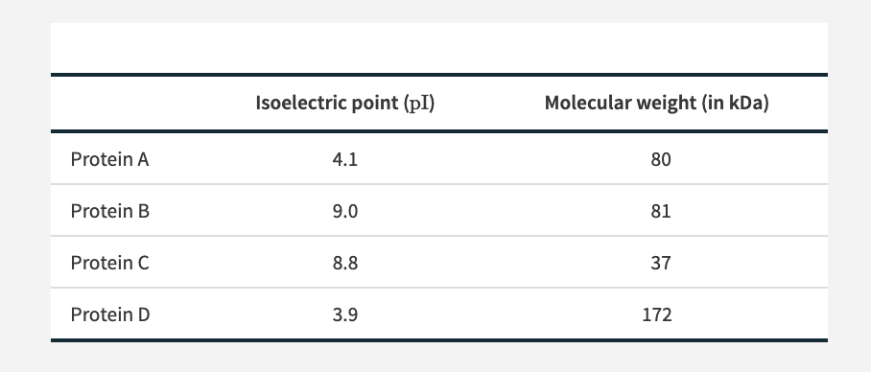

Propose a method for the isolation of Protein B from the other proteins. (b) If Protein B also carried a His tag at its N-terminus, how could you revise your method?

Looking at what makes Protein B unique from the other proteins, you can see that it has the most basic pI and the only other protein with a basic pI is half the size (Protein C). I would dialyze the sample in a buffer with a pH above the pI of Proteins A and D, say pH 7.2, then perform Anion exchange chromatography. Proteins A and D will have a negative charge since their pI’s are 4.1 and 3.9, respectively. They will stick to the column, whereas Proteins B and C will flow through since at pH 7.2, they will have a positive charge and be repelled by the anion exchange resin. Then I’d take that flowthrough sample containing Proteins B and C and apply it to a gel filtration column. Protein B would elute well before Protein C since it is twice the size.

You could also use cation exchange chromatography with a buffer of pH 7.2 since Proteins B and C would have a positive charge at that pH (it is below their pI). Proteins A and D would flow through, then you could add a solution with increasing [NaCl] to knock Proteins B and C off of the CIEX resin then proceed to gel filtration chromatography as described above.

b) If Protein B had a hexahistidine tag, I would use Nickel Metal Chelating Chromatography and take advantage of the fact that at pH 8, the imidazole groups of the tag would be deprotonated (Check Table 2.1 for the pK_{A} of histidine) and able to bind the immobilized nickel ions on the column. Proteins A, C and D would flow through the column, leaving only Protein B bound to the resin. I’d then elute Protein B from the column with an increasing gradient of imidazole in buffer at pH 8.

- Determine the sequence of hexapeptide on the basis of the following data. Note: When the sequence is not known, a comma separates the amino acids (Table 3.3).

Amino acid composition: (2R, A, S, V, Y)
N-terminal analysis of the hexapeptide: A (This is the first amino acid of the peptide)
Trypsin digestion: (R, A, V) and (R, S, Y) (Since we know that Ala is the first amino acid and trypsin cleaves after R and K, then the first three amino acids have to be AVR)
Carboxypeptidase digestion: No digestion. (According to Table 3.3 in your book, Carboxy peptidase will not cleave if the last amino acid is R, K or P. This puts the second R at the carboxyterminus of the peptide. Thus far, we know that the sequence is: AVR(S or Y)(S or Y)R
Chymotrypsin digestion: (A, R, V, Y) and (R, S) (Chymotrypsin cleaves after Y, so that puts the Y in the 4th position, which means that S is in the 5th position. The sequence is: AVRYSR)

