CHEM523 Test 1 Name:________________________________

Answer the following 12 questions in the 75 minutes allotted. DO NOT ANSWER THE QUESTIONS IN ORDER. Flip through the exam and answer the ones that you can answer immediately as soon as you identify them.

1) (10 points total) Draw the structures of and give the One and three letter abbreviations for:

- (6 points) The following three amino acids: i) A hydrophobic amino acid that would be bound in the substrate specificity pocket of chymotrypsin, ii) a polar amino acid that has an amide group on its side chain and iii) the most basic (with respect to side chain pKa) of the 20 naturally occurring amino acids

- (4 points) Draw the structure of and 3-letter abbreviations of two amino acids that are commonly used as nucleophiles in biological reactions. Draw the structures as they would be found at physiological pH.

2) (10 points total) Leupeptin, also known as N-acetyl-L-leucyl-L-leucyl-L-argininal (it has an aldehyde instead of the normal carboxylate on the carboxy-terminus), is a naturally occurring compound that is a transition state-inhibitor of trypsin.

- (2 points) Draw the structure of Leupeptin.

- (5 points) Draw the complex that would be formed by trypsin and leupeptin when trypsin is inhibited by the compound. You only need to include atoms that are directly part of the acyl-enzyme intermediate.

- (3 points) Why does this compound inhibit trypsin but not chymotrypsin? Give specific chemical reasoning for this observation in your answer.

3) (10 points) The serine proteases are a novel group of enzymes that have fascinated chemists and biochemists for years. Answer the following questions about this interesting group of enzymes.

- (4 points) Explain how this family of enzymes serves to illustrate the two different types of molecular evolution.

- (2 points) What are the catalytic residues of these enzymes?

- (2 points) These enzymes employ a special method of stabilizing the transition state during the reaction. What is it and what is the chemical basis for it? Include all relevant amino acids and show all relevant chemical interactions.

- (2 points) When we discussed the reaction mechanism in class, we mentioned a unique IMF between two of the catalytic residues. What is this IMF and how does it contribute to the reaction mechanism?

4) (9 points total) Describe the three types of non-covalent enzyme inhibition by:

a) (6 points) Drawing the double-reciprocal plots of the enzymatic reaction in the absence and presence of two concentrations of inhibitor. Place the name of each type above each plot.

b) (3 points) Describing the molecular species each type of inhibitor binds to (use reaction pathways (eg: A+B-> AB, in your answer)

5) (10 points total) You have identified a new protease (You call it Thompsonase) from an organism growing in the refrigerator of Thompson Hall. You have cloned the protein and DNA sequence analysis has determined that it has a pI of 8.5, has 480 amino acids. After salting out, SDS-PAGE analysis showed the presence of four proteins in the sample with molecular weights of 15, 20, 35 and 55 kilodaltons.

- (3 points) Describe a three-step purification protocol (That means three different purification steps using different chemical mechanisms. You may also assume that you have placed some sort of tag on the protein, it is up to you which one, during the cloning process) that will allow you to obtain a purified sample of the new enzyme. Be very specific in your answer or no credit will be given.

- (2 points) Draw an image of the SDS-PAGE gel you would obtain if you ran the sample after salting out in one lane and after and your three steps in another lane. Be certain to label everything. How can you tell what the masses of the proteins are?

- (5 points) Mutagenic studies have shown that Cysteine165 in the protein is absolutely essential for catalytic activity. Mutation of the residue to an alanine resulted in no product formation. Mutation of the residue to a serine resulted in decreased activity. Based upon these observations, draw a possible mechanism for Thompsonase.

d) (5 POINT Bonus) What technique could you use to prove that the protein you purified was indeed Thompsonase? It is a common technique that takes advantage of a very specific protein-protein interaction. Describe the technique in enough detail to show that you know what you are talking about.

6) (8 points total) Write out:

a) (4 points) The Michaelis-Menton equation and show what a plot of V₀ versus [S] would look like for an enzyme that follows Michaelis-Menton kinetics. Clearly label V_{m} and Km on the plot.

b) (4 points) The Lineweaver-Burk equation and show what a plot of 1/V₀ versus 1/[S] looks like. Label the slope and intercept terms for the plot.

7) (10 points) Draw the reaction coordinate for a non-catalyzed chemical reaction and an enzyme-catalyzed reaction. What are some features of an enzyme that account for the difference between the two coordinates? Be specific in your answer (ie: Give specific chemical examples to support your answer).

8) (5 points) Give a specific, complete chemical explanation for the observation that RNase A catalyzes the cleavage of RNA polymers but not polymers of DNA.

9) (10 points) Briefly describe how proteins fold. Your answer must lay out the facts in a logical, chronological form that fully describes the chemical entities, forces and energies involved. You must include a description of the hydrophobic effect and the roles of the solvent and polypeptide. Start with the primary structure and describe the event in chronological order until the final, tertiary structure is reached.

10) (10 points) What are the four intermolecular forces that we have discussed in class? Rank them in terms of energy and give the Coulombic energy expression for each.

11) (10 points) Answer the following questions about lysozyme

- (2 points) Describe a unique feature of how the enzyme binds substrate.

- Complete the reaction mechanism for lysozyme. Draw in the side chain atoms of the catalytic residues in the boxes provided.
Start

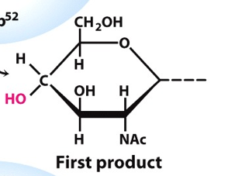
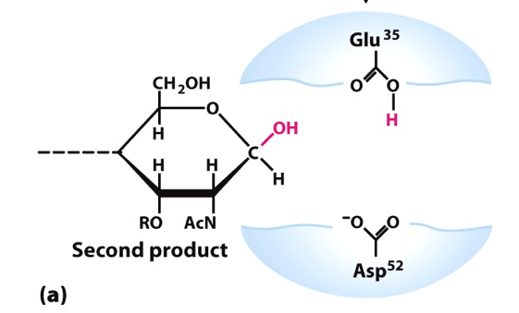

Finish

c) What effect do you think mutating Glutamate 35 to an aspartic acid might have on the chemical reaction catalyzed by lysozyme? Why?

12) (10 points) What is the Bohr Effect? Explain how hemoglobin is involved in regulating both oxygen and carbon dioxide levels by the Bohr effect. Include specific terms, amino acids and descriptions in your answer for full credit.

