CHEM523 Exam 3 Spring 2014 Name: _______________________________

Answer the following 11 questions completely, unambiguously and clearly. Your answers must be well organized and concise. You have 75 minutes to complete the exam.

1) (10 points) Draw the mechanism of the reaction catalyzed by DNA polymerase that occurs between deoxyribose at the end of a DNA chain and a deoxyribonucleoside triphosphate. Include the chemical structure of the phosphate group, the structure of the sugar (the nitrogenous base may be drawn as a rectangle that says “Base”), and show the rearrangements of electrons that occur.

2) (4 points) List two proteins or enzymes, other than DNA polymerase III, that are found at the replication fork in E. coli; describe each of their functions with a single, coherent and complete sentence (that means nouns, verbs, adjectives and adverbs in an intelligent and relevant arrangement).

3) (4 points) Draw the general structure of a typical operon as observed on a bacterial chromosome. Give a brief explanation of the role of each section of the operon.

4) (6 points) Describe the Meselson-Stahl experiment. What did it prove?

5) (8 points) Answer the following questions about bacterial RNA Polymerase.

i) What is a sigma subunit?

ii) How does the enzyme move along the template strand? (Describe the biochemical basis for the motion)

iii) Name two compounds that can inhibit the enzyme.

iv) How does the enzyme correct any mismatched bases that might be incorporated into the synthesized RNA strand?

6) (10 points) Describe the following protein domains making certain to include relevant amino acids, structural features and binding targets.

  - Helix-Turn Helix

  - Zinc-finger

  - Homeodomain

  - Leucine Zipper

  - Helix-Loop-Helix

7) (10 points) Answer the following questions about alcohol dehydrogenase:

i) What is the reaction catalyzed by the enzyme? Please give the substrate(s) and the product(s)

ii) What cofactor is needed?

iii) Draw the reaction mechanism for the enzyme. If you need help, please raise your hand and I will “sell” you the relevant species involved in the mechanism for 2 points. It will be up to you to arrange them into a mechanism.

8) (20 points) Answer the following questions about DNA Polymerases.

i) Which DNA polymerase is the primary replicative polymerase in E. coli? Give two reasons why this is true.

ii) What is the biochemical basis for determining if the correct nucleotide triphosphate has entered the active site and formed a Watson-Crick base pair with the template strand?

iii) Which two enzymes are responsible for finishing DNA synthesis on the lagging strand after the primary replicative polymerase has done its work?

iv) Draw the reaction mechanism for the 3’ -> 5’ exonuclease activity found in some DNA polymerases.

9) (8 points) Draw a schematic of the lac operon and show what the operon would look like under the following conditions. Your diagram must show proteins and relative mRNA levels in addition to clearly labeling the regions of DNA that define the operon.

i) High [Glucose] and no lactose present

ii) Low [Glucose] and no lactose present

iii) High [Lactose] and no glucose present

iv) No lactose and no glucose present

10) (10 points) What is attenuation? Describe how attenuation works to regulate the trp operon. Please use figures to aid in your explanation.

11) (10 points) Label the components of the following diagram (10 total parts)

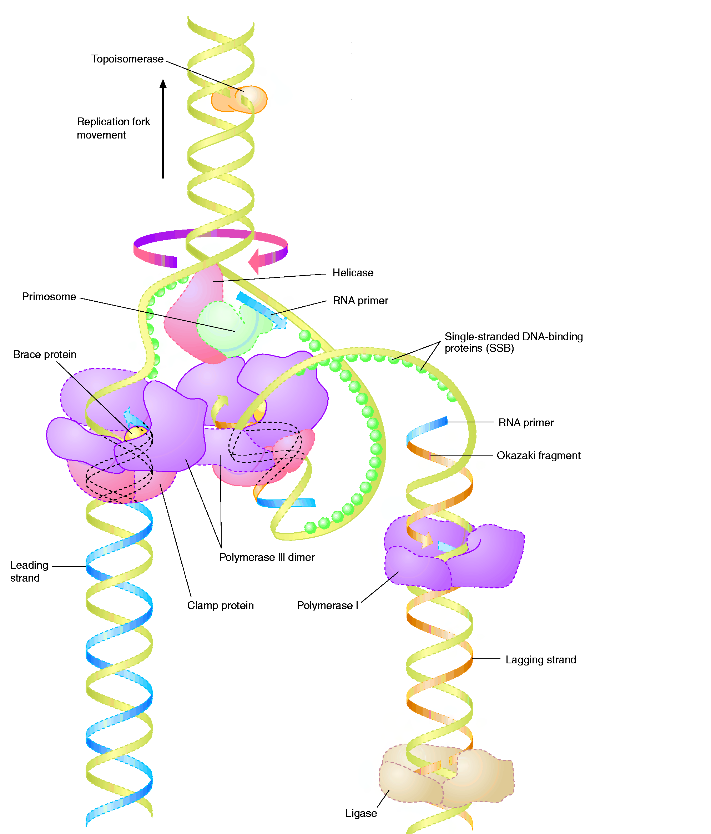
This protein relieves torsion of the chromosome:

___________________________________

2 parts: This protein hydrolyzes ________ to unwind the double strands:

___________________________________

DNA ___________

_____________ Strand
DNA Pol ______
DNA Pol ______

______________ Strand

___________________________________
This protein stabilizes unwound DNA:
___________________________________

