CHEM523 Final Exam Name: ___________________________

Answer the following questions. Each question is worth 4 points. You have 3 hours to complete this exam.

1) Below are seven amino acids. Indicate all characteristics that apply to each amino acid by writing the appropriate letter(s) in the blanks provided. Note: Each entry may have more than one letter associated with it.

Amino acid Characteristics

lysine _____________ a) forms disulfide bonds

arginine ____________ b) is charged at pH=7

proline ____________ c) non-polar/hydrophobic

aspartic acid ____________ d) ring of side chain covalently linked to peptide backbone
tryptophan _____________

cysteine _____________ e) has a ring

glutamic acid _____________ f) absorbs light at wavelength 280 nm

g) contains sulfur

h) polar/hydrophilic

2) You have identified a new lipase (an enzyme that hydrolyzes fatty acids of glycerophosphoslipids) from an organism growing in a Thompson Hall grease trap.

- Describe a three-step purification protocol that will allow you to obtain a purified sample of the new enzyme. Be very specific in your answer or no credit will be given.

- Draw an image of the SDS-PAGE gel you would obtain if you ran samples after each of your three steps on it. Be certain to label everything. How can you tell what the masses of the proteins are?

- If the enzyme catalyzes the hydrolysis of a stearic acid residue from the C-2 of phosphatidylcholine, what mechanism would you expect your enzyme to employ? Draw the mechanism being certain to label specific amino acids, substrates, intermediates and products that occur during the reaction.

3) We discussed two types of evolution that occur in biological systems this semester. Using specific biochemical examples, compare and contrast the two types of evolution.

4)
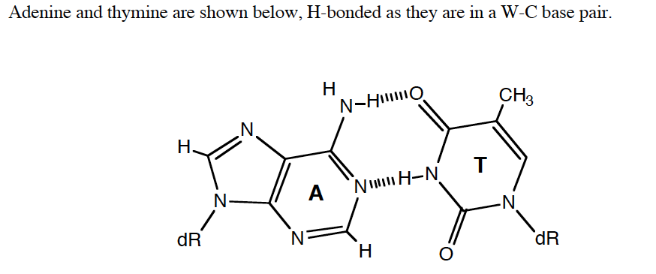

- On the structure above, label the major and minor groove sides of the base pair and label the hydrogen bond donors and acceptors in each groove.
- Asparagine residues in DNA binding domains are often found to recognize adenine in duplex DNA. In the space below, draw a plausible structure for the interaction of an asparagine side chain with the major groove of adenine.

5) This question has 5 parts.
a) Draw the covalent structure of the tripeptide Tyr-Pro-Val, with trans peptide bonds, as it would exist at pH 7.

b) Indicate the two protons which would be lost at pH 12.
c) Circle and label two hydrogen bond donors and two acceptors on your structure.
d) Write the 1-letter code for each of the three amino acids below the structure.
e) Indicate with an arrow which peptide bond might be found in the cis conformation in a protein.

6) A cysteine residue in a protein active site has a pKa of 7.6 (referring to deprotonation of the -SH group as below). What fraction of the cysteines are deprotonated (-S-) at pH 6 and at pH 8?
Cys-SH Cys-S- + H+ pKa = 7.6

7) Many membrane proteins are attached in the hydrophobic interior of the lipid bilayer by one or more α-helices which span the membrane.

- How can we sometimes identify the trans-membrane α-helices strictly by examination of the protein sequence, even for a new protein with no homology to any others? Use what you know about the geometry of the α-helix and the properties of transmembrane proteins.

- When β-sheets are found in membranes, they are usually complete barrels, not one or two strands. Why (contrast your answer with all α-helical proteins in membranes)?

8) Draw the structure of proline. Why does proline typically break an α-helix? Why does it break a β-sheet? (These are two different answers…but they are similar)

8) Samples of an unknown peptide are subjected to the two treatments below. After each treatment the resultant peptides are purified and sequenced by Edman's method to provide the data given. Determine the sequence of the unknown peptide using the overlapping peptide method.

i. Cyanogen bromide: ii. Trypsin:
Asp-Ile-Lys-Gln-Hser Gln-Met-Lys
Lys Gly-Met-Asp-Ile-Lys
Lys-Phe-Ala-Hser Phe-Ala-Met-Lys
Tyr-Arg-Gly-Hser Tyr-Arg

Bonus information. Treatment of the peptide with α-chymotrypsin yielded 3 smaller peptides. One peptide had a single amino acid, the second peptide had three amino acids and the third peptide contained 10 amino acids

Sequence of unknown peptide:
_________________________________________________________________________________________________

9) Draw the Haworth structures and full chemical names of Maltose and Lactose.

Maltose |  | Lactose

10) Draw a schematic of the Central Dogma of Molecular Biology.

11) Briefly describe how proteins fold. Your answer must lay out the facts in a logical, chronological form that fully describes the chemical entities, forces and energies involved. You must include a description of the hydrophobic effect and the roles of the solvent and polypeptide. Finally, relate your description to features of the current best model of the protein folding funnel we discussed in class.

12) Calculate the pH at the equivalence point of the titration of 25.00 mL of 0.195 M napthalic acid, C₁₀H₉COOH, with 0.15 M NaOH. [pK_{A} for C₁₀H₉COOH = 4.2]

13) β-Galactosidase is a glycosyl hydrolase that hydrolyzes the glycosidic bond of β-D-galactosylosyl-(1,4)-β-D-galactopyranose, releasing two galactopyranose residues.

a) Draw the chemical structures of the substrate and the products formed in the reaction.

b) Based upon what you know about glycosyl hydrolases, draw the likely reaction mechanism for the enzyme. You must include all necessary amino acid side chains, substrate atoms, and arrows.

14) Describe the three types of non-covalent enzyme inhibition by:

a) Drawing the double-reciprocal plots of the enzymatic reaction in the absence and presence of two concentrations of inhibitor
b) Giving the molecular species each type of inhibitor binds to
c) Giving the kinetic parameters affected by each type of inhibitor

15) Write out:

a) The Michaelis-Menton equation and show what a plot of V₀ versus [S] for an enzyme that follows Michaelis-Menton kinetics. Clearly label Vm and Km on the plot.

b) The Lineweaver-Burk equation and show what a plot of 1/V0 versus 1/[S] looks like. Label the slope and intercept terms for the plot.

16) Define the following terms relating to enzyme kinetics (Use equations where appropriate):

- The steady state assumption

- Turnover number

- Diffusion-limited reaction rate

d) Free-energy of binding

17) Nearly every topic we have discussed this semester has come down to Intermolecular forces. You have seen these forces in every aspect of chemistry and molecular biology.

- What are the four primary intermolecular forces from lowest energy to highest energy?

- What are the Coulombic energy equations that describe each IMF?

18) Speculate on why it is that when allosteric regulation is needed, proteins with quaternary structures rather than single-domain proteins have often evolved to fill the need.

19) Describe one structural difference between the R and T states of hemoglobin.

20) Why do proteins tend to denature when organic solvents are added to the solution? Base your answer on a comparison of folded vs. unfolded states ± denaturant.

21) In a set of four wild type homologous proteins, presumably with similar 3° structures, you notice a pattern of amino acid substitutions at four positions, as tabulated below. The mutant protein 5 (= protein 1: Asp84 -> Val) fails to fold.

a) In the table below, identify 2 residues which are likely to be in the core of the protein, 1 surface residue, and 1 active site residue, and give a rationale for your guesses.

b) Explain why you think the mutant fails to fold.

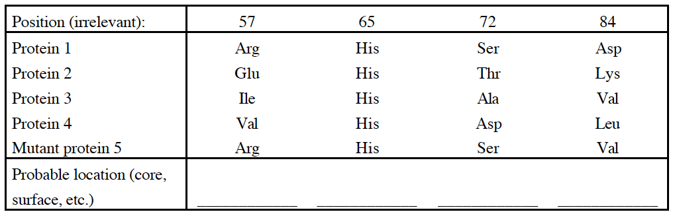

22) Why don’t proteins get cavities? Specifically, in terms of the thermodynamic forces stabilizing proteins, explain why an Ile Gly mutation in the hydrophobic core of a protein tends to decrease Tm (i.e. make the folded protein less stable relative to unfolded).

23) Draw the chemical reaction that occurs at the peptidyl transferase center of the ribosome. All that needs to be drawn fully is the ribose ring of tRNA and the amino acid conjugated to it. Label the sites of the ribosome. Amino acid side chains do not need to be drawn.

24) What are the 5 stages of Protein synthesis in a cell?

25) Draw the reaction mechanism of RNase A.

26) Draw the reaction mechanism of trypsin cleaving the peptide: Gly-Arg-Gly. You do need to show amino acid side chains, all relevant intermediates and any essential interactions between the protein, substrate and intermediate.

28) List two post-translational modifications and state how they work/what their functions are.

29) Draw the reaction mechanism for the 3’-5’ exonuclease reaction catalyzed by the exonuclease domain of DNA Pol I. (Hint: Tyr 423 of DNA Pol I activates a water molecule which then serves as a nucleophile to begin the cleavage of the base from the strand. A metal ion is involved in the reaction as well.)

30) Draw a schematic of the lac operon. Label the operator, promoter and gene encoding regions. What proteins are encoded by the operon?

31) Digestion of proteins in the stomach is accomplished with the aid of the enzyme pepsin. The activity of this enzyme requires the deprotonation of a pair of aspartic acid residues in the active site.

a) This poses a problem at the normal stomach pH of ~2. Why? What is the expected charge on the side chain of aspartic acid at this pH?

b) Based upon your answer to the first part of this question, how is it possible for pepsin to function?

32) Describe attenuation in terms of the trp operon.

