CHEM523 Exam #1 Name: _______________________

Section 1. Fun! (10 questions, 3 points each, 30 points total) (Here we go!)

Answer the following questions with the best possible answer given the choices available. If a question can be answered by more than one possible choice, it will say so in the question itself. Circle your answer completely, not just the letter.

1. Hydrophobic interactions make important energetic contributions to:
A) binding of a hormone to its receptor protein.
B) enzyme-substrate interactions.
C) membrane structure.
D) three-dimensional folding of a polypeptide chain.
E) All of the above are true.

2. A compound has a pK_{a} of 7.4. To 100 mL of a 1.0 M solution of this compound at pH 8.0 is added 30 mL of 1.0 M hydrochloric acid. The resulting solution is pH:
A) 6.5.
B) 6.8.
C) 7.2.
D) 7.4.
E) 7.5.

3. The most important contribution to the stability of a protein's conformation appears to be the:
A) entropy increase from the decrease in ordered water molecules forming a solvent shell around it.
B) maximum entropy increase from ionic interactions between the ionized amino acids in a protein.
C) sum of free energies of formation of many weak interactions among the hundreds of amino acids in a protein.
D) sum of free energies of formation of many weak interactions between its polar amino acids and surrounding water.
E) stabilizing effect of hydrogen bonding between the carbonyl group of one peptide bond and the amino group of another.

4. In an aqueous solution, protein conformation is determined by two major factors. One is the formation of the maximum number of hydrogen bonds. The other is the:
A) formation of the maximum number of hydrophilic interactions.
B) maximization of ionic interactions.
C) minimization of entropy by the formation of a water solvent shell around the protein.
D) placement of hydrophobic amino acid residues within the interior of the protein.
E) placement of polar amino acid residues around the exterior of the protein.

5. Roughly how many amino acids are there in one turn of an α helix?
A) 1
B) 2.8
C) 3.6
D) 4.2
E) 10

6. In the α helix the hydrogen bonds:
A) are roughly parallel to the axis of the helix.
B) are roughly perpendicular to the axis of the helix.
C) occur mainly between electronegative atoms of the R groups.
D) occur only between some of the amino acids of the helix.
E) occur only near the amino and carboxyl termini of the helix.

7. The major reason that antiparallel β-stranded protein structures are more stable than parallel β-stranded structures is that the latter:
A) are in a slightly less extended configuration than antiparallel strands.
B) do not have as many disulfide crosslinks between adjacent strands.
C) do not stack in sheets as well as antiparallel strands.
D) have fewer lateral hydrogen bonds than antiparallel strands.
E) have weaker hydrogen bonds laterally between adjacent strands.

8. Proteins often have regions that can fold and function as an independent entity from the whole protein. These regions are called:
A) domains.
B) oligomers.
C) peptides.
D) sites.
E) subunits.

9. An allosteric interaction between a ligand and a protein is one in which:
A) binding of a molecule to a binding site affects binding of additional molecules to the same site.
B) binding of a molecule to a binding site affects binding properties of another site on the protein.
C) binding of the ligand to the protein is covalent.
D) multiple molecules of the same ligand can bind to the same binding site.
E) two different ligands can bind to the same binding site.

10. The steady state assumption, as applied to enzyme kinetics, implies:
A) K_{m} = K_{s}.
B) the enzyme is regulated.
C) the ES complex is formed and broken down at equivalent rates.
D) the K_{m} is equivalent to the cellular substrate concentration.
E) the maximum velocity occurs when the enzyme is saturated.

Section 2. Games! (6 questions, 24 points total) Wheeeeeeee!
Answer the following questions as completely and thoroughly as possible. You must be concise and use complete sentences.

11. (4 points) The artificial sweetener NutraSweet®, also called aspartame, is a simple dipeptide, aspartylphenylalanine methyl ester, on which the free carboxyl of the dipeptide is esterified to methyl alcohol. Draw the structure of aspartame, showing the ionizable groups in the form they have at pH 7.

12. (2 points each) Answer 1 of the following 3 questions about the fibrous proteins we discussed in lecture. If you answer all 3, you'll receive bonus points.

i) Why is silk fibroin so strong, but at the same time so soft and flexible?

ii) What gives collagen its high tensile strength?

iii) α-keratin has a unique amino acid in it. What is this amino acid and what disease is caused by a deficiency of it?

13. (4 points) Answer the following questions about protein folding:

i) What was the Anfinsen experiment? What did his work show?

ii) Describe the chronology of the folding of a globular protein. You must use the terms and concepts we discussed when describing how a protein goes from a linear sequence of amino acids to a compact, functional molecule.

iii) What is meant by the terms "Motifs" and "Domains"? What are the differences between the two?

14. (4 points) This question has 2 parts.

i) What is the effect of pH on the binding of oxygen to hemoglobin (the Bohr Effect)? Specifically, I want to know the conformational changes that occur when oxygen binds to iron in hemoglobin.

ii) Briefly describe the mechanism of this effect using specific details, amino acids, chemical reactions in terms of the cellular compartments where it is most important.

15. (4 points) Answer the following 3 questions about enzyme-catalyzed reactions:

i) Write out the enzyme-catalyzed chemical reaction with all terms (E, S and P), the correct arrows and all rate constants over their respective errors.

ii) Draw and label a reaction coordinate diagram for an enzyme-catalyzed reaction, S -> P.

iii) How does an enzyme decrease the ΔG* (transition state free energy) for the chemical reaction? In other words, what traits of enzymes allow them to be efficient catalysts?

16. (6 points) Answer the following questions about enzyme kinetics.

i) The Michaelis-Menten constant, K_{m}, is actually a summary of three terms. What is the mathematical representation of the Michaelis constant and what does it represent for most enzyme catalyzed reactions?

ii) Write out the Michaelis-Menton equation and show what a plot of initial velocity as a function of substrate concentration would look like. Label the Vm and the Km on your plot.

iii) What is the Lineweaver Burk approximation of the Michaelis-Menton equation? Using this equation, how would you determine Vm and Km for a given enzyme? (Drawing a figure and label it would be the easiest way to answer this question)

Carnival! (5 questions, 46 points total) (WubWubWubWubWubWub!)

You're tired and its late, but now is when you need to summon all of your might and crush this thing! C'mon, you've got this!

17. (10 points) Answer the following questions about serine proteases. You must give speciifc chemical and biological names in your answers.

i) How do these enzymes stabilize the transition state?

ii) What structural motif is the hallmark of this family of enzymes?

iii) Only one amino acid in your answer to question (ii) is the nucleophile for the reaction, what role do the other amino acids in the motif play? What specific and unique interaction do they have?

iv) Serine proteases are a perfect example of the two types of molecular evolution. What are these types and give specific examples of how the serine proteases serve as an example of each.

v) Complete the reaction mechanism for a typical serine protease below:

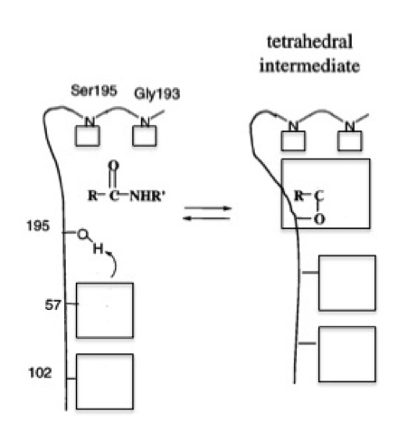

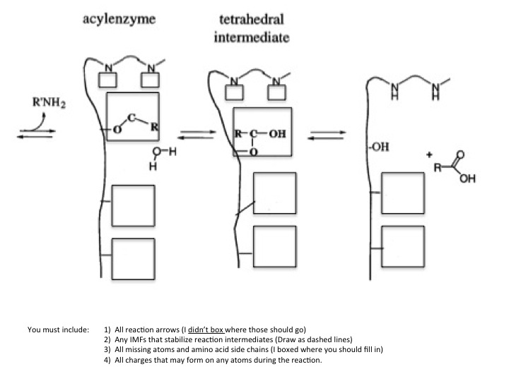

18. (12 points) Draw Lineweaver-Burk plots for each of the three types of non-covalent inhibition at 2 concentrations of inhibitor. You must draw the chemical reaction for each type of inhibition and give the name of the type of inhibition under each of the plots.

19. (12 points) Answer the following questions about RNAse A.

i) RNAse A catalyzes a reaction that is an example of a General ________-________ type of reaction mechanism (fill in the blanks please).

ii) Complete the reaction mechanism for RNAse A given below by drawing all necessary reaction arrows and putting the correct chemical species in the boxes provided.

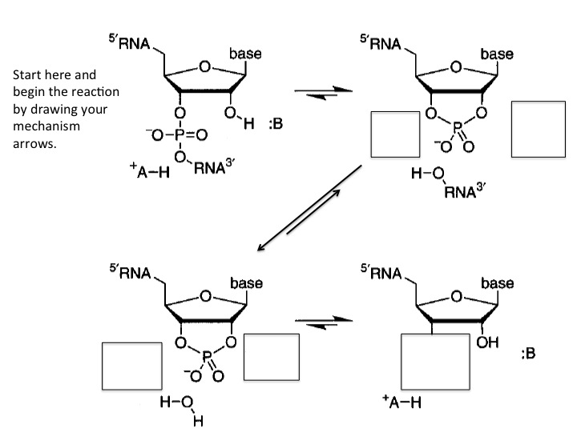

20. (4 points) Take your pick: Lysozyme or HIV protease. What are the catalytic amino acids involved in the reaction mechanism of your chosen enzyme? You must have the correct protonation state for each amino acid or no credit will be given!

21. (8 points) Name the intermolecular forces we have discussed this semester from highest energy to lowest energy. Give the Coulombic energy equations for each.

Answer Key - PossibleExam1

1. E
2. D
3. A
4. D
5. C
6. A
7. E
8. A
9. B
10. C
11. See the structure on p. 83.
12. Unlike collagen and keratin, silk fibroin has no covalent crosslinks between adjacent strands, or between its stacked sheets, making it very flexible. Fibroin's unusual tensile strength derives from the fact that the peptide backbone of antiparallel β-strands is fully extended, and that the R-groups in the stacked pleated sheets interdigitate, preventing any longitudinal sliding of the sheets across one another.
13. Motifs are particularly stable arrangements of elements of secondary structure (e.g., α helix and β conformation), including the connections between them, which are found in a variety of proteins.
14. (a) The affinity decreases with decreasing pH. (b) At lower pH (i.e., higher H⁺ concentration), there is increasing protonation of protein residues such as histidine, which stabilizes the low affinity conformation of the protein subunits.
15. See Fig. 6-3, p. 187.
16. K_{m} = (k₂ + k₋₁)/ k₁, where k₋₁ and k₁ are the rate constants for the breakdown and association,
respectively, of the ES complex and k₂ is the rate constant for the breakdown of ES to form E + P. K_{m} can be determined graphically on a plot of V₀ vs. [S] by finding the [S] at which V₀ = 1/2 V_{max}. More conveniently, on a double-reciprocal plot, the x-axis intercept = –1/ K_{m}.
17.
18.
19.
20.

