CHEM106 Section 001 Quiz 2 Key Name: ______________________________

Answer each question completely and legibly. This is a pop quiz that is meant to ascertain how you have been keeping up with the material between assignments.

- (6 points) Draw a kinetic curve for an enzyme that operates according to Michaelis-Menton kinetics. Label each axis with title and units and clearly label the two kinetic parameters deducible from the graph itself. (1 point for each axis, 2 points for the curve, 1 point for each parameter)

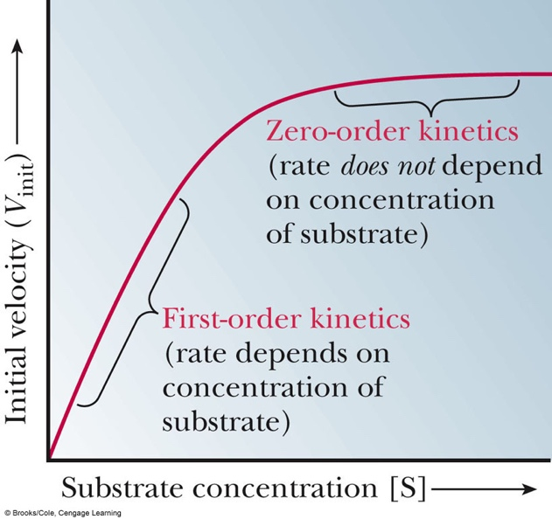

- (6 points) Name the three types of non-allosteric enzyme inhibition we have studied. (2 points for each type)

Competitive, Noncompetitive, Uncompetitive

- (4 points) Name the 4 Intermolecular Forces we have studied this semester. (All or none at this point, 4 points for the block)

Ion-Dipole
Dipole-Dipole
Dipole-Induced Dipole
Induced Dipole-Induced Dipole

- (4 points bonus) Give me an example of each intermolecular force using amino acids ONLY!!!!!!!

Ion-Dipole: Lys-Ser, Arg-Cys, Glu-Ser, Asp-Ser, etc
Dipole-Dipole: Ser-Ser, Cys-Cys (not a disulfide bridge), Asn-Asn, Gln-Gln, etc
Dipole-Induced Dipole: Ser-Leu, Cys-Val, Asn-Ala, etc
Induced Dipole-Induced Dipole: Leu-Leu, Val-Val, Ile-Ile, Phe-Phe, etc

