1. Nomenclature
Give the proper IUPAC name for each of the following structures on the lines provided.

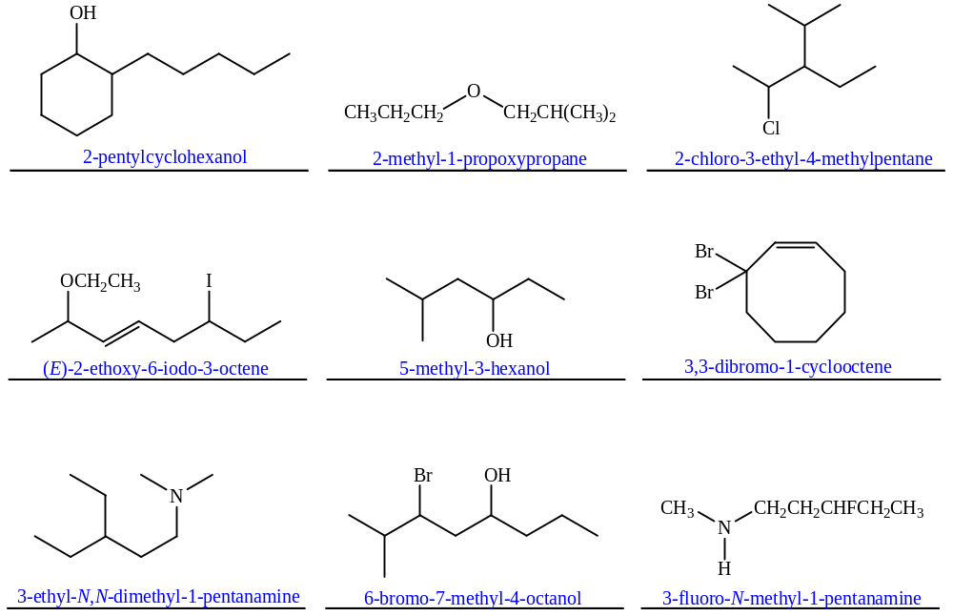

2. Substitution Equilibria
Indicate which side (LEFT or RIGHT) is favored at equilibrium for the following reactions in the boxes provided.

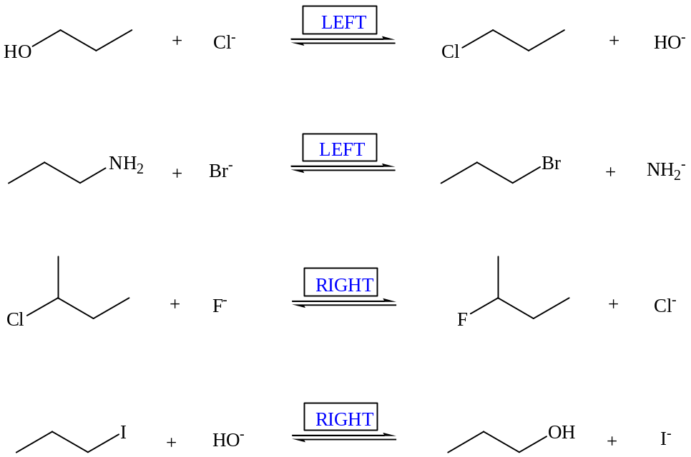

3. Effects of Conditions on Substitutions
a. Rank the following electrophiles in order of fastest (1) to slowest (4) in the S_{N}1 reaction with methanol.
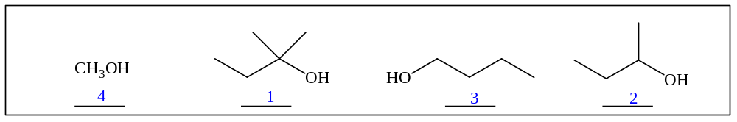

b. Rank the following electrophiles in order of fastest (1) to slowest (4) in the S_{N}2 reaction with methoxide (CH₃O⁻).
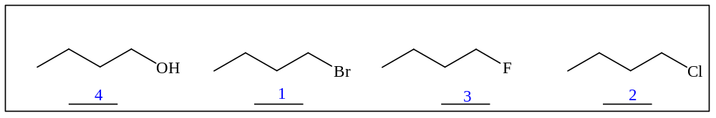
4. Mechanisms
Draw complete arrow-pushing mechanisms for the following reactions.
a.

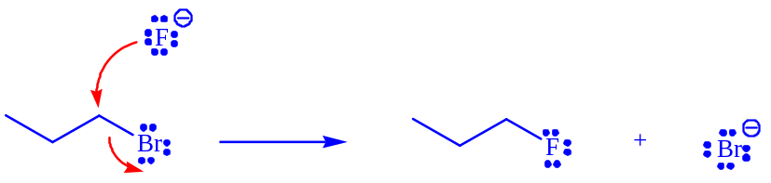

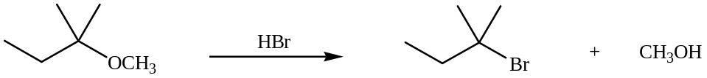

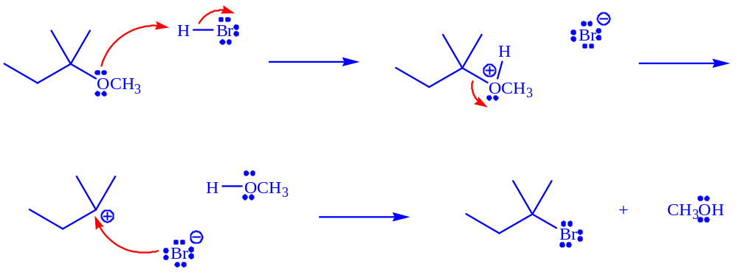

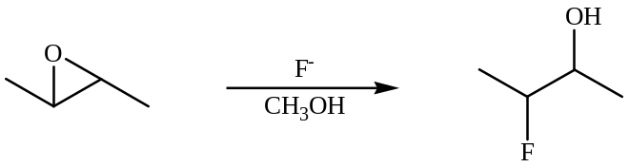

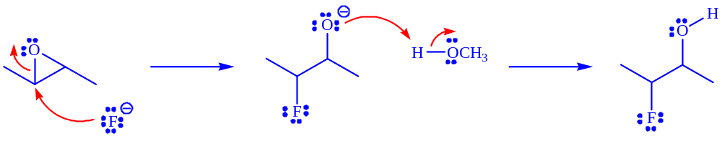

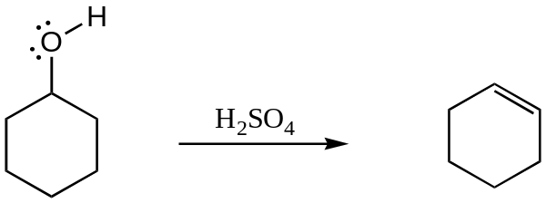

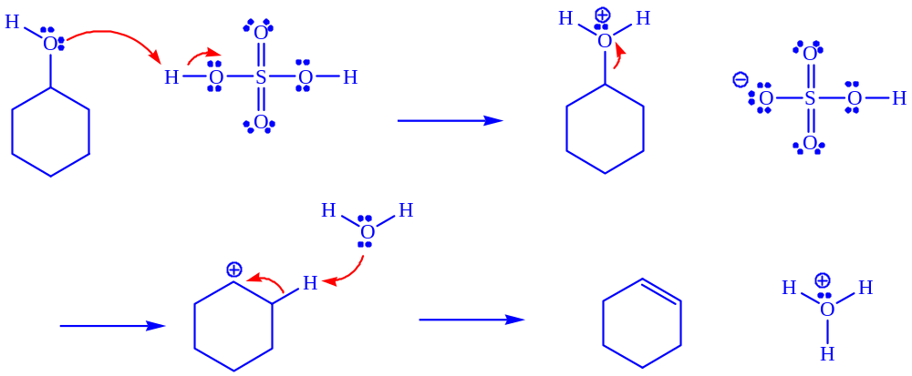
5. Reactions
a. Draw the major product or products of each of reaction in the boxes provided. If multiple organic products are equally likely, show each. For stereoselective reactions, be certain that your structures clearly indicate stereochemistry. In addition to providing products, also describe each of the following reactions as S_{N}1, S_{N}2, E1 or E2.

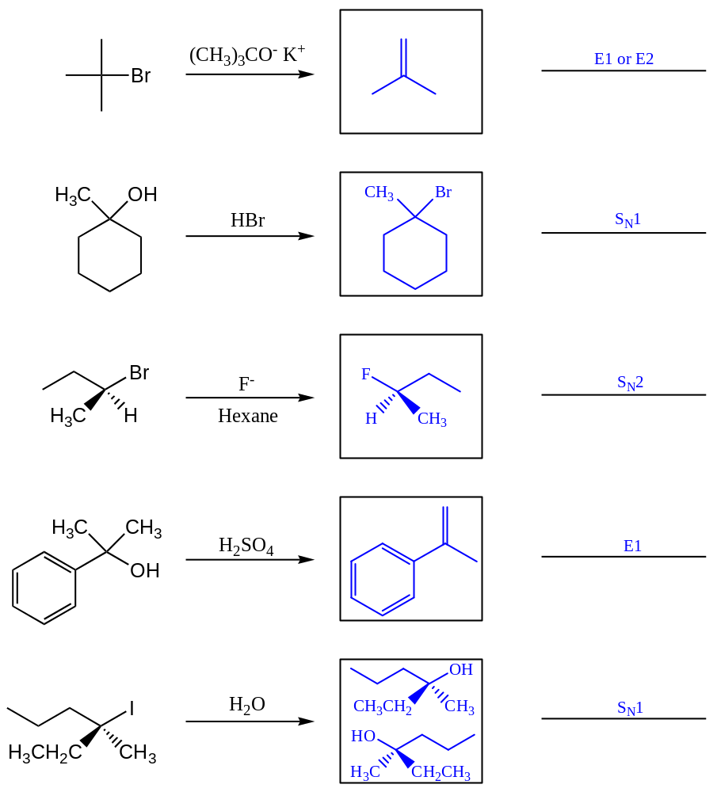

b. Provide the reagents necessary to perform the following reactions in the boxes provided. Be explicit when showing multi-step reactions.



