1. Atoms and Orbitals
a. Using horizontal lines and arrows, draw an accurate ground state electronic configuration of silicon. Label each orbital and clearly show relative energies.

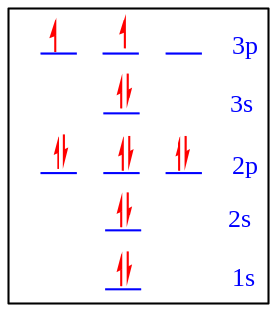

b. Provide the orbital hybridization of the indicated atoms.

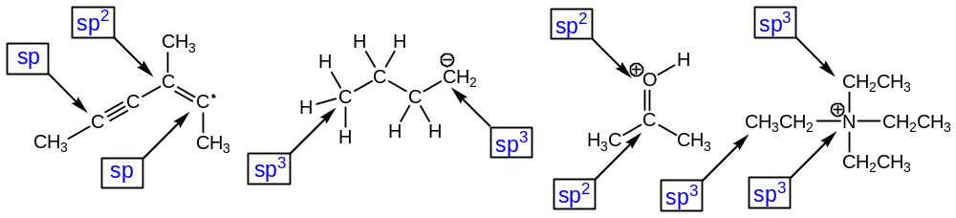

c. Describe the two orbitals that overlap to form the bonds indicated by each arrow.

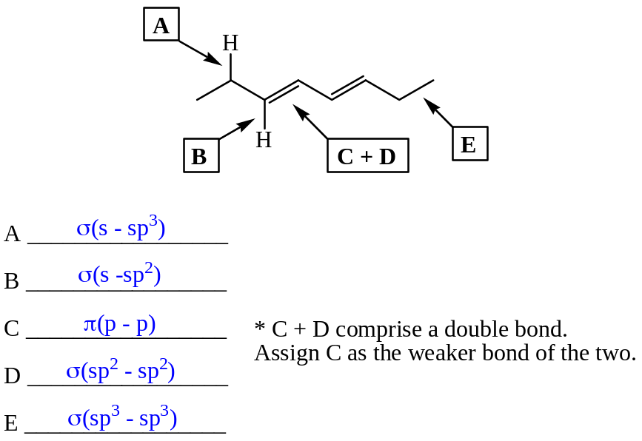
2. Lewis Structures
Draw complete Lewis structures for each of the following species.

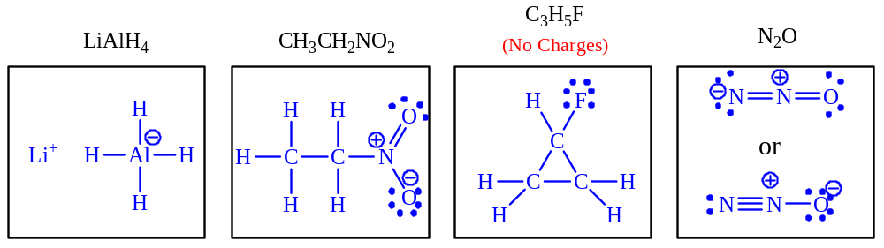

3. Compound Classes and Functional Groups
Indicate what functional class (alkane, ketone, ether, etc.) each compound represents.

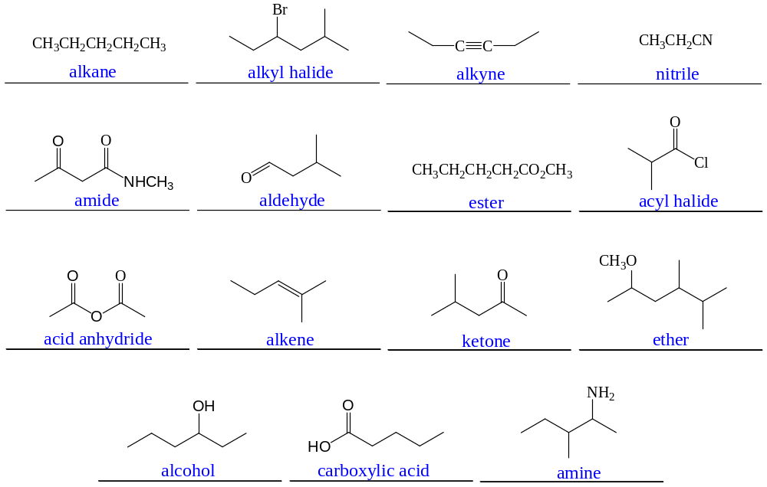

4. Nomenclature
Give the proper IUPAC name for each of the following structures on the lines provided.

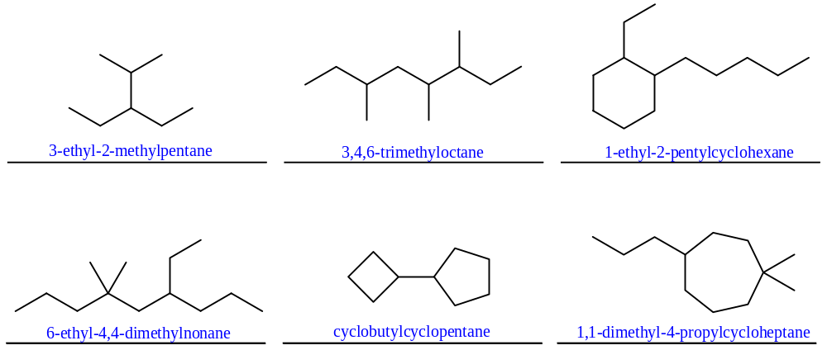

5. Dipoles and Physical Properties
a. Use symbols (δ+ and δ-) to designate the dipoles of the indicated bonds for each molecule. Rank the bonds in each set in order of decreasing polarity (1 most polar to 3 least polar).

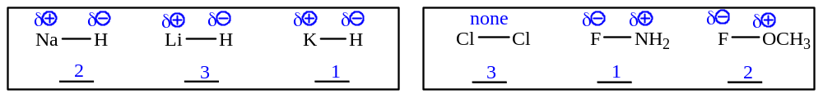

b. Rank each from HIGHEST boiling point (1) to LOWEST boiling point (5).

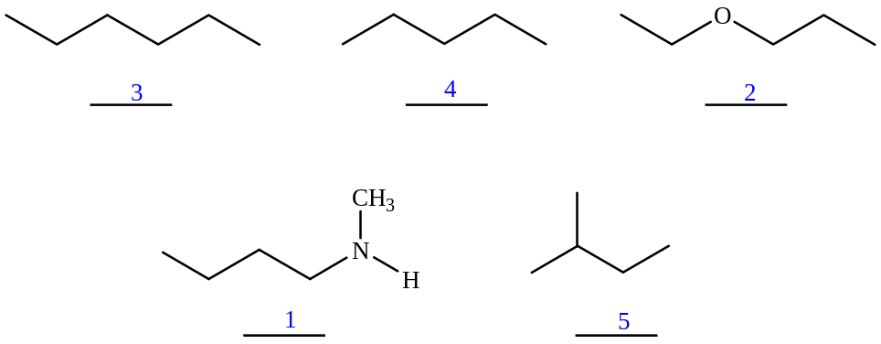
6. Free Rotations
Draw Newman projections for each of the three staggered conformations of 2-methylpentane along the C2-C3 bond. Circle the LEAST stable conformation.

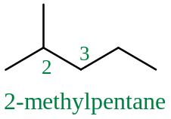

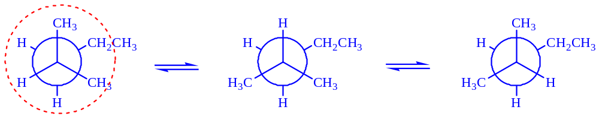

7. Conformational Inversion
Draw the two chair conformations of the following molecule. Circle the more stable conformation. Be sure to label all substituents on each ring (including hydrogen).

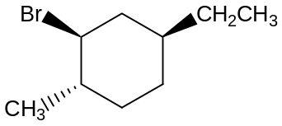

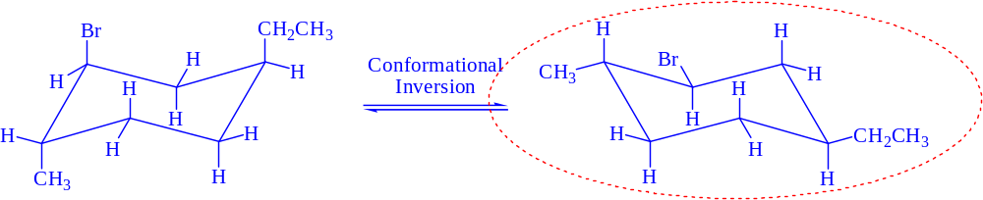

8. Chirality and Chirality Centers
a. Circle all of the chirality centers on the following molecule, which is a potent anti-tumor compound found in a species of marine sponge.

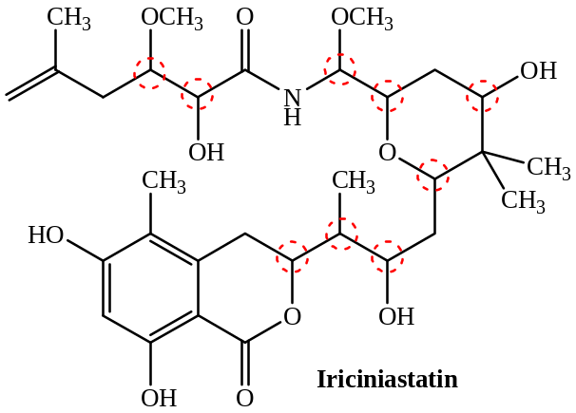

b. Circle all of the compounds below that are chiral.
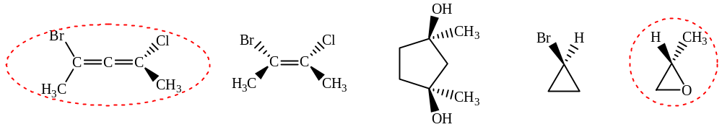

9. Stereochemical Configurations and Relationships
a. In the boxes provided, assign the stereochemical configuration for each chirality center. In the blank space provided, describe the stereochemical relation between the two molecules.

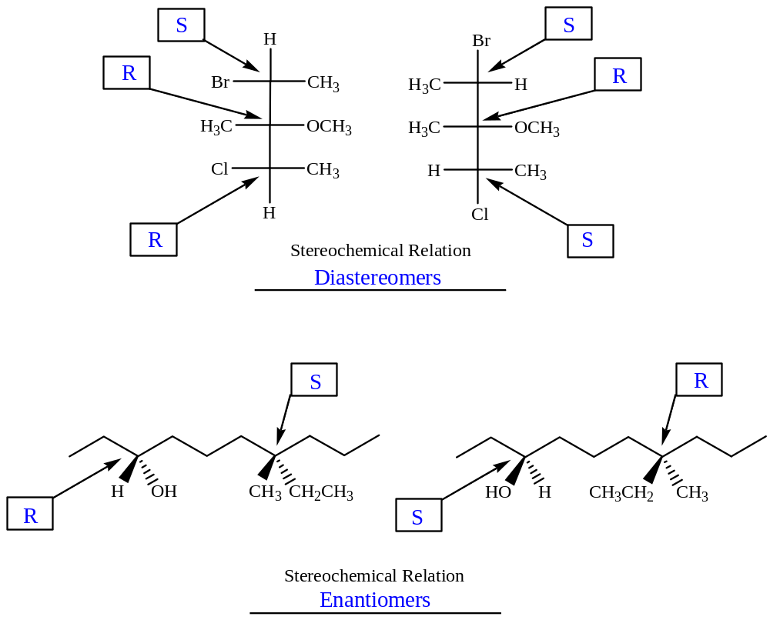

b. In the blank space provided, describe the stereochemical relation between the two molecules of each pair.

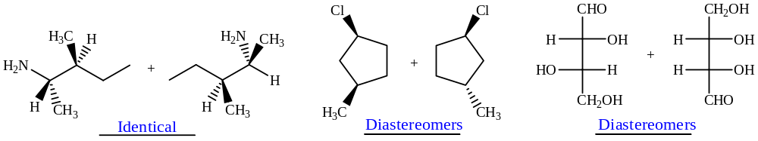

10. Application of Concepts
a. Before you are three bottles, each containing a clear, colorless liquid. One bottle contains pentane 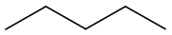, another contains heptane 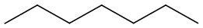 and the remaining contains 1-hexanol 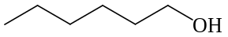. Using concepts discussed so far in class, how can you determine which compound is in each bottle? Explain your plan and rationale.

Because of the differences in size and functional groups, these compounds will have very different boiling points. One could simply determine the boiling point of the liquid from each bottle, and know that the highest boiling must be 1-hexanol (large and capable of hydrogen bonding) and the lowest boiling must be pentane (smallest and lacking other strong intermolecular forces). The remaining liquid is therefore heptane.

b. Draw the structure of the only acyclic (no rings) 7-carbon tertiary alcohol that also has a quaternary carbon.
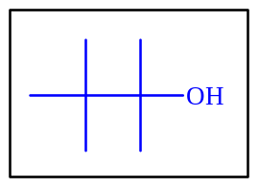

c. Draw the Lewis structure for methanamine hydrochloride (CH₃NH₃⁺ Cl⁻).

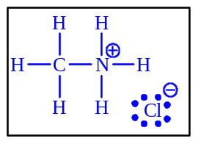

How many electrons are in this compound? 36 electrons

How many valence electrons are in the cation? 14 electrons

How many neutrons are found in this compound? 31(assuming most abundant isotopes)

How many total bonding interactions are there in this compound? 8 (7 covalent and 1 ionic)

