1. Nomenclature
a. Give the proper IUPAC name for each of the following structures on the lines provided. Include stereochemistry where appropriate.

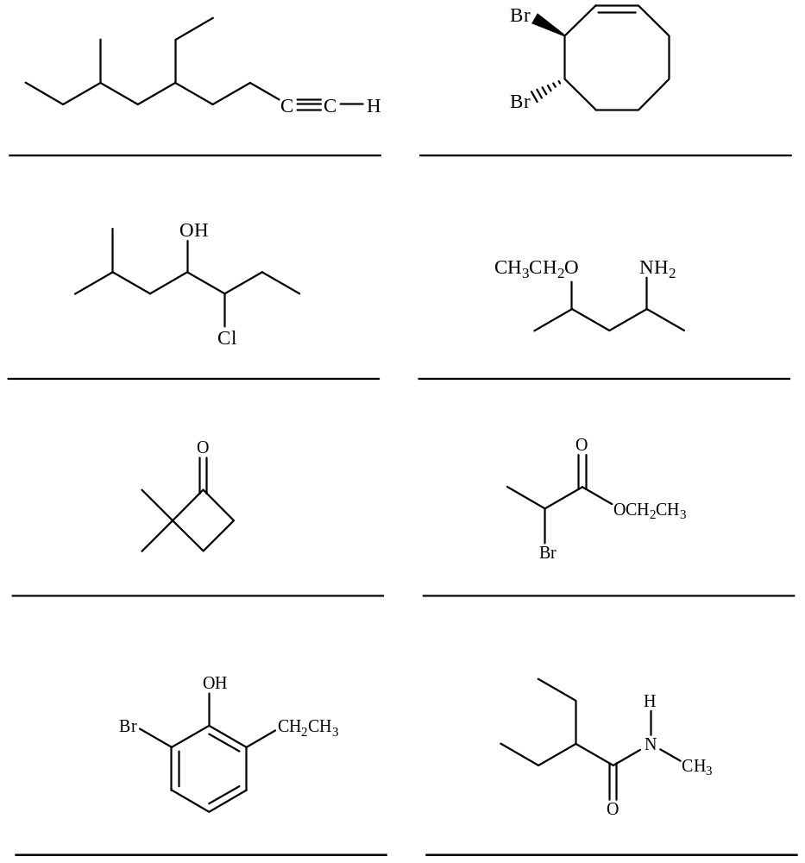

b. Label each molecule with its functional classification and the descriptive terminology appropriate for its class (e.g. “terminal alkyne”).
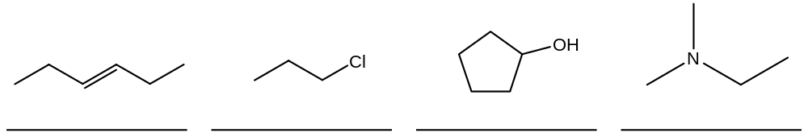
2. Concepts
a. Rank the following in order of decreasing boiling point (1 highest to 4 lowest).

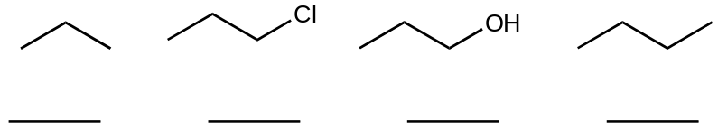

b. Give the hybridization of the atoms indicated in the boxes provided.
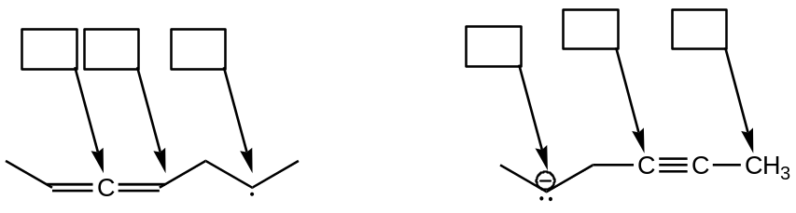

c. Rank the indicated bonds in order of decreasing strength (1 strongest to 4 weakest).

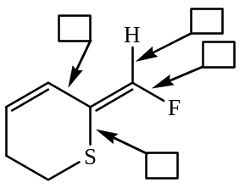

d. Label each compound as AROMATIC or NONAROMATIC.

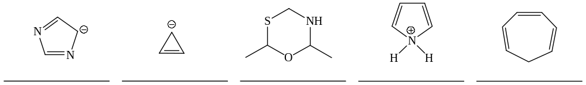

3. Stereochemistry
a. Provide the proper stereochemical assignment in the small boxes. Draw the requested stereoisomer in the large boxes.

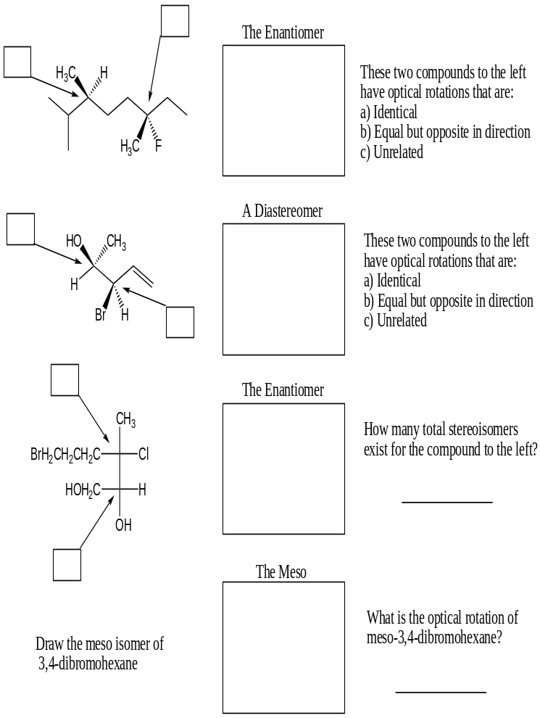

b. Circle all chiral molecules.
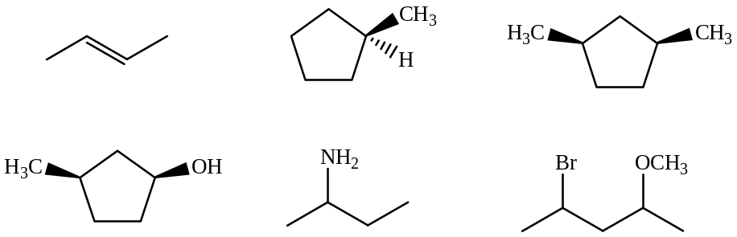

4. Conformational Analysis
Draw Newman projections for each of the three staggered conformations of 2,3-dichlorobutane along the C2-C3 bond. Circle the most stable conformation.
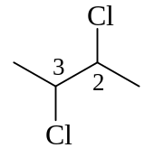

5. Chair Conformations of Cyclohexanes
Perform a chair flip on the following molecule and draw in on the provided. Be sure to label all substituents (including hydrogen). Circle the more stable chair conformation.

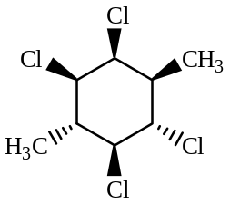

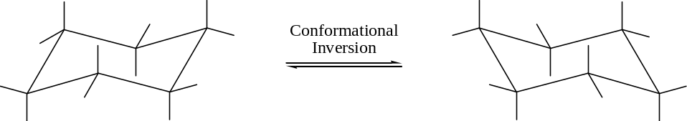

6. Acids and Bases
a. Rank the following in order of decreasing acidity (1 most to 4 least).

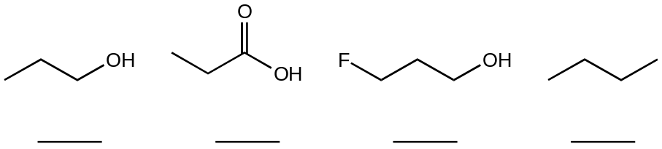

b. Draw the conjugate base for each acid above. Include all non-bonding electrons.

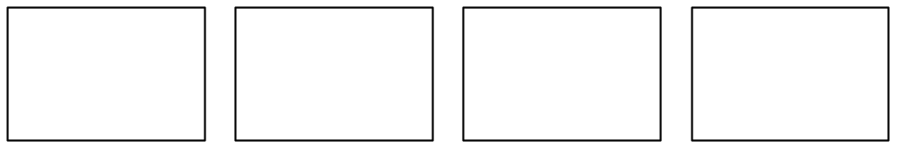

c. Rank the following in order of decreasing basicity (1 most to 4 least).

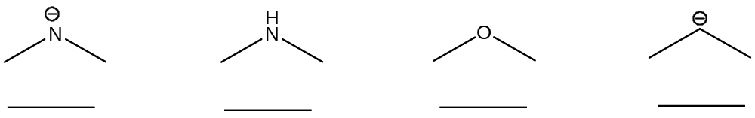

d. Draw the conjugate acid for each base above. Include all non-bonding electrons.

7. Reaction Equilibria
Indicate whether the equilibrium for each reaction lies to the RIGHT or LEFT.

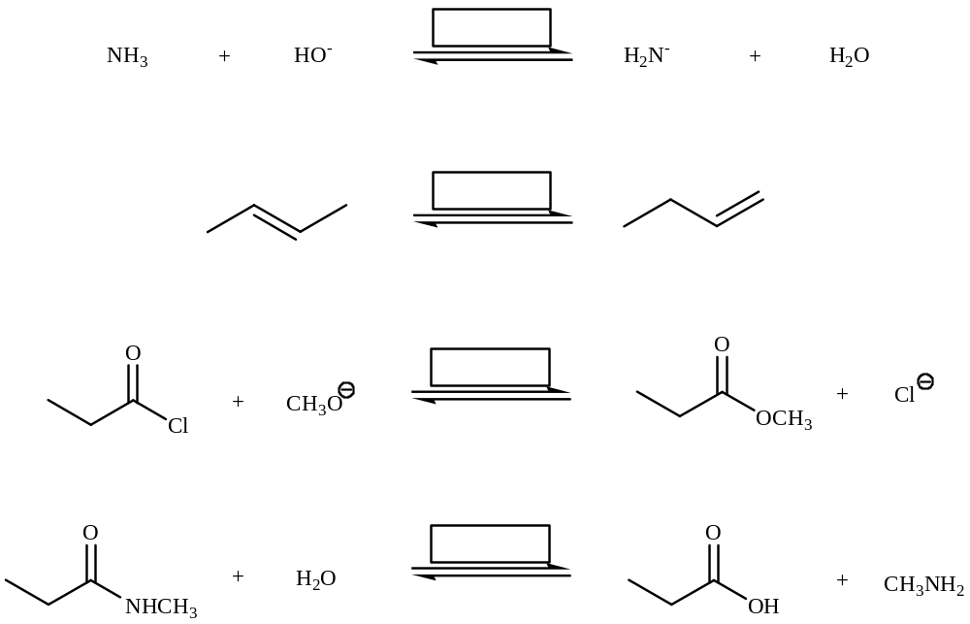

8. Mechanisms
Draw complete arrow-pushing mechanisms for the following reactions.
a.
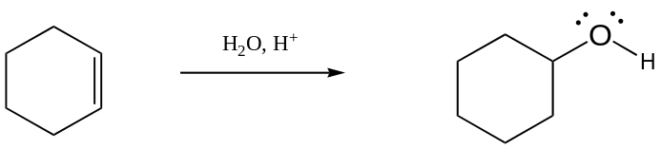

b.
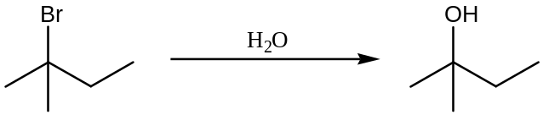

c.
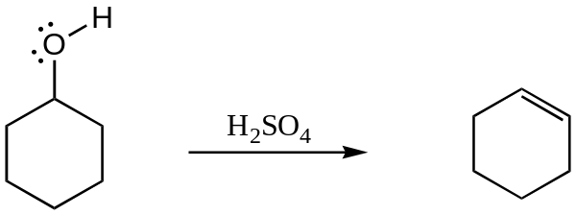

d.
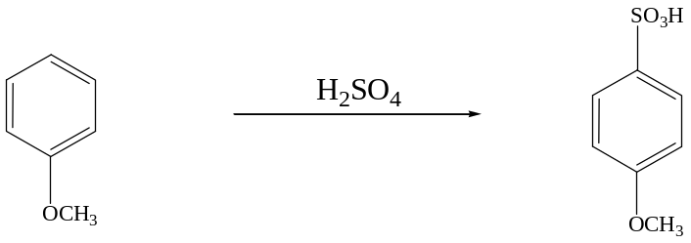

e.
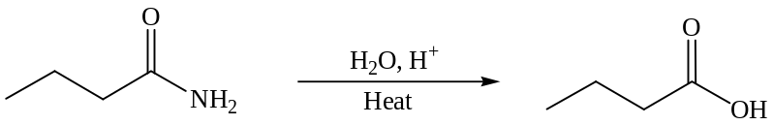

f.
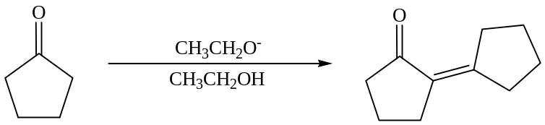

9. Reactions
a. Draw the major product or products of each of reaction in the boxes provided. If multiple organic products are equally likely, show each. For stereoselective reactions, be certain that your structures clearly indicate stereochemistry.

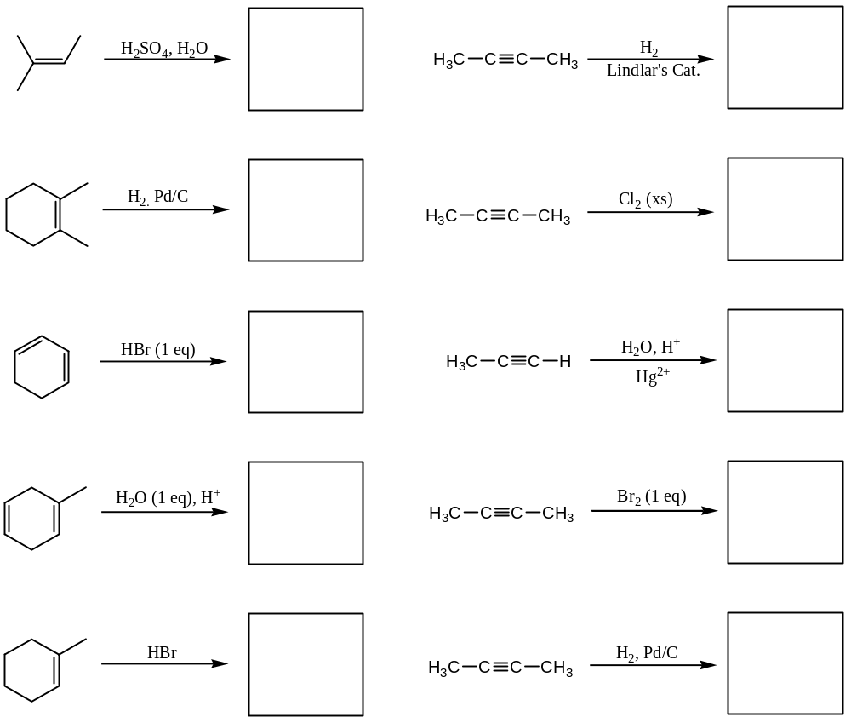

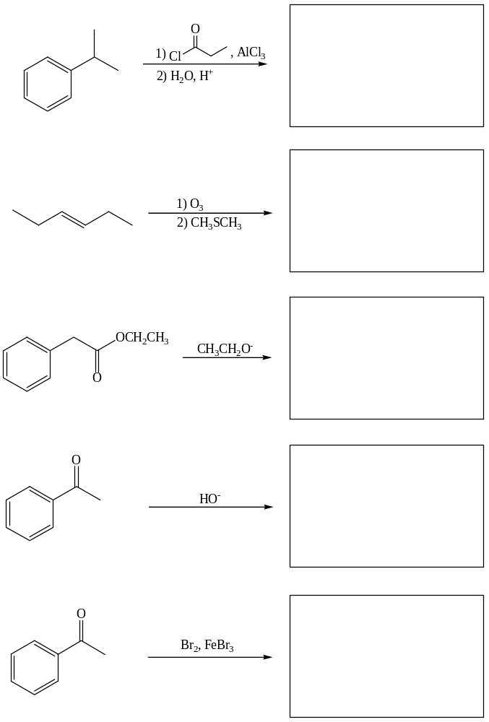

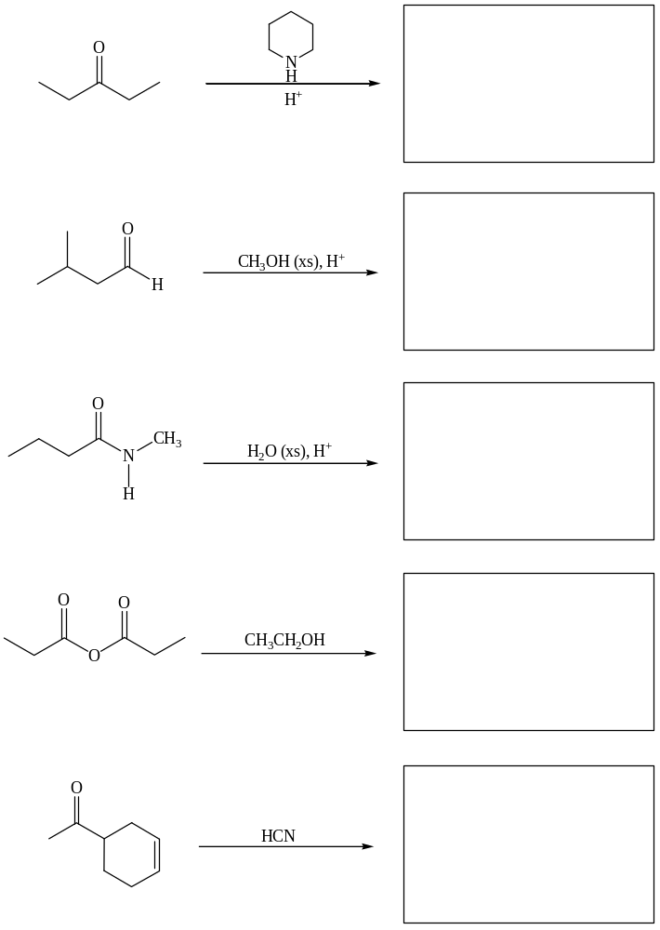

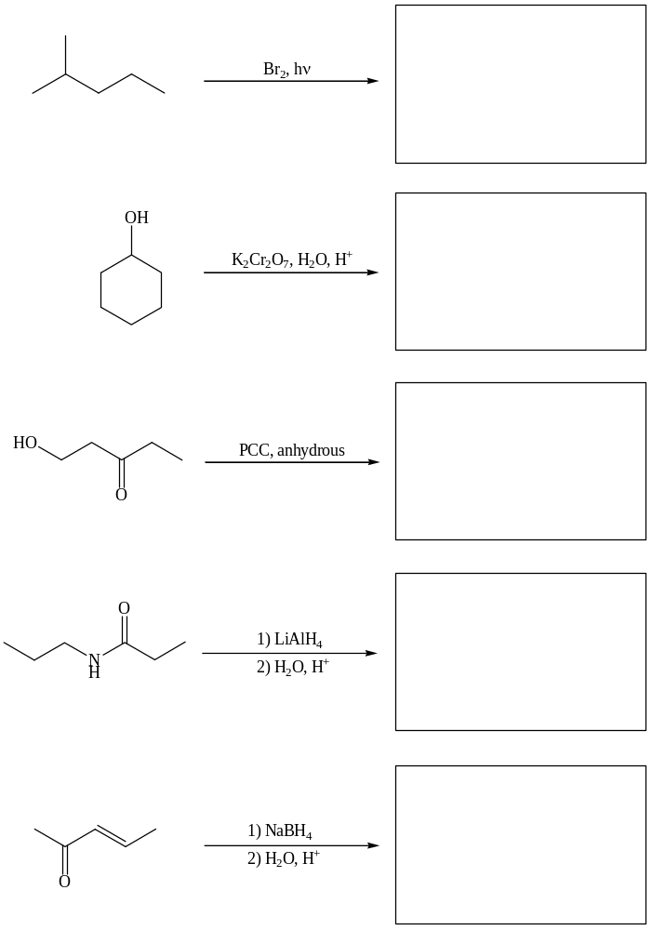
10. Reagents
Provide the reagents necessary to perform the following reactions in the boxes provided. Be explicit when showing multi-step reactions.

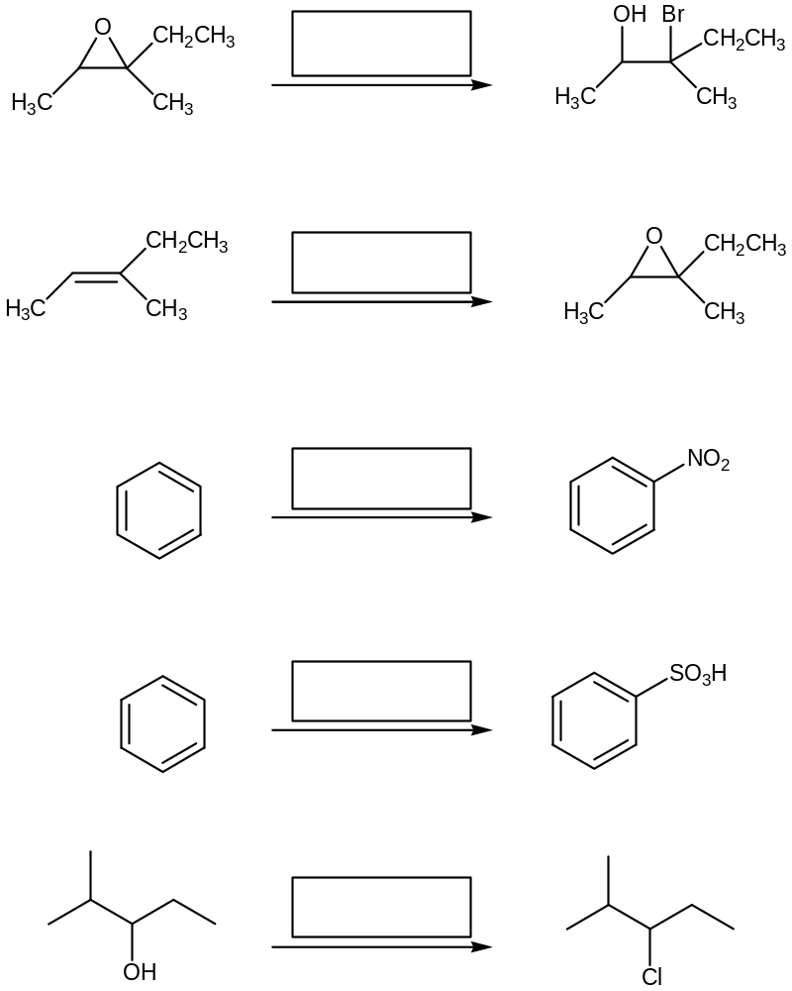

11. More Reactions
In addition to providing products, also describe each of the following reactions as S_{N}1, S_{N}2, E1 or E2. Show stereochemistry for stereoselective reactions.

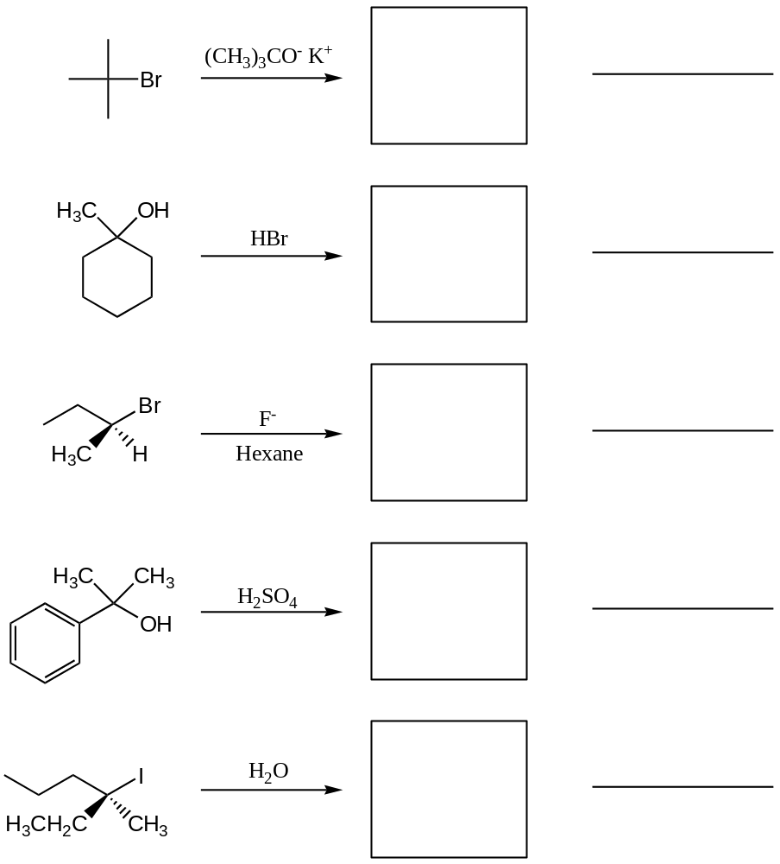

12. Resonance
Draw Lewis structures for all of the remaining resonance structures for each of the following molecules in the boxes provided.



