Distillation and Gas Chromatography

Introduction
Distillation is a technique often used to purify a liquid or to separate liquid components of a mixture. Essentially, it is the process of converting a liquid (called the distilland) to vapor by heating it to the boiling point and condensing the vapor back to a liquid (called the distillate). If applied to a mixture of liquids, the vapor (and thus the distillate) will be enriched in the more volatile component in the early part of the distillation. If the components of the mixture have sufficiently different boiling points, they can be separated by distillation.
Gas chromatography (GC) is a method of analysis that separates the components of a mixture based on their relative boiling points. A sample is vaporized and carried through a column containing a liquid stationary phase by a gaseous mobile phase (usually He). For most GC analyses, partitioning between the stationary liquid phase and the gaseous mobile phase is based on the boiling point of the material (more volatile materials move faster through the column), and therefore the separation of a mixture by GC is usually based on the relative boiling points of the components. Lower boiling compounds generally travel through the column faster than higher boiling compounds. Thus, lower boiling compounds generally have lower retention times than higher boiling compounds.
In this experiment, you will be assigned an unknown mixture consisting of two of the liquids from the table below. You will separate the mixture by both simple and fractional distillation, and in the process, determine the boiling point of each component in your unknown mixture. In addition, you will analyze distillate samples at the beginning and the end of the distillation by gas chromatography. Using this data, you will determine the identity of the components of your unknown mixture, and comment on the effectiveness of each distillation technique.

Compound | Boiling Point
Hexane | 69.0 °C
Cyclohexane | 80.7 °C
Heptane | 98.4 °C
Toluene | 110.6 °C
Ethylbenzene | 136.0 °C

Required Reading:
Padías:
Distillation (pp. 129 – 145)
Chromatography, general (pp. 150 – 151)
Gas Chromatography (pp. 167 – 175)

Special Safety Notes:
- The unknown samples are mixtures of flammable solvents. Keep away from spark sources and open flames.
- Do not distill to dryness! A dry flask may crack if heated to hot.
- The steel wool used as the column packing can cut into skin. Handle with care.
- Use a boiling chip when heating liquids to prevent “bumping”
- Injector ports on a gas chromatograph are hot! Avoid contact with the GC injector ports.

Procedure:
Simple and Fractional Distillation of the Unknown Mixture
NOTE: This laboratory is to be done in groups of 3 or 4 students. Each group will be assigned an unknown sample, and half the group will perform the simple distillation, and the other half will perform the fractional distillation. Students must share their procedure, observations, and data will all members of the group. Each student is then required to write an individual lab report.
Assemble the appropriate distillation apparatus (simple or fractional) using a 10-mL round bottom flask, distillation column (for fractional distillation only), distillation head, thermometer adapter, thermometer, and condenser as shown in the figures below. Be sure to note the position of the thermometer. The top of the bulb should be even with a line formed by the bottom of the side arm of the distillation head. Place a boiling chip in the round bottom flask and add 7.0 mL of the unknown mixture. Turn on the cooling water to the condenser, and using the hotplate and an aluminum heating block, heat the mixture to a boil. The hot vapors will begin to heat the glassware, and you should begin to see a “reflux ring” of condensing vapors begin to rise slowly into the distillation head. When the “reflux ring” reaches the thermometer bulb, you will see a rapid rise in temperature up to the boiling point of the distillate. The vapor will condense in the condenser, and you will see drops of distillate falling into the graduated cylinder. Adjust the heat control so that the rate of distillation is about 1 drop every 4 – 5 seconds. Beginning with the first 0.5 mL of distillate, record the vapor temperature at every 0.5-mL interval, using the graduated cylinder to measure the volume.
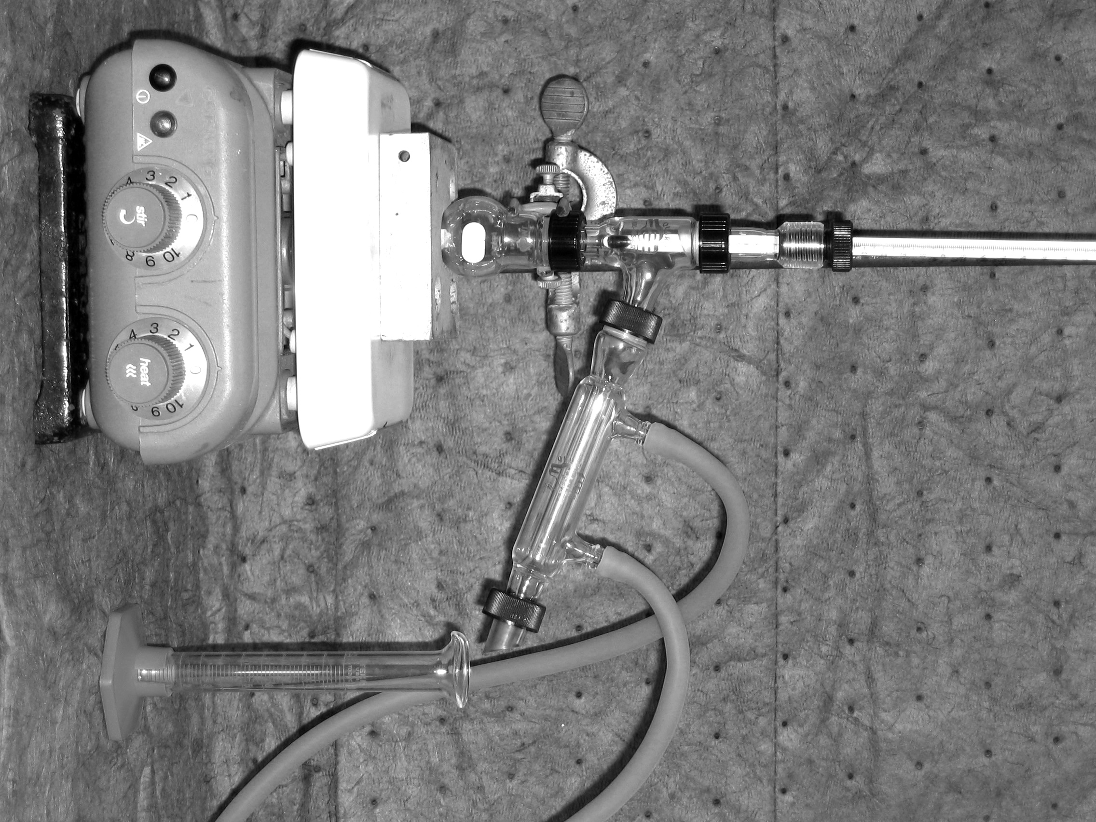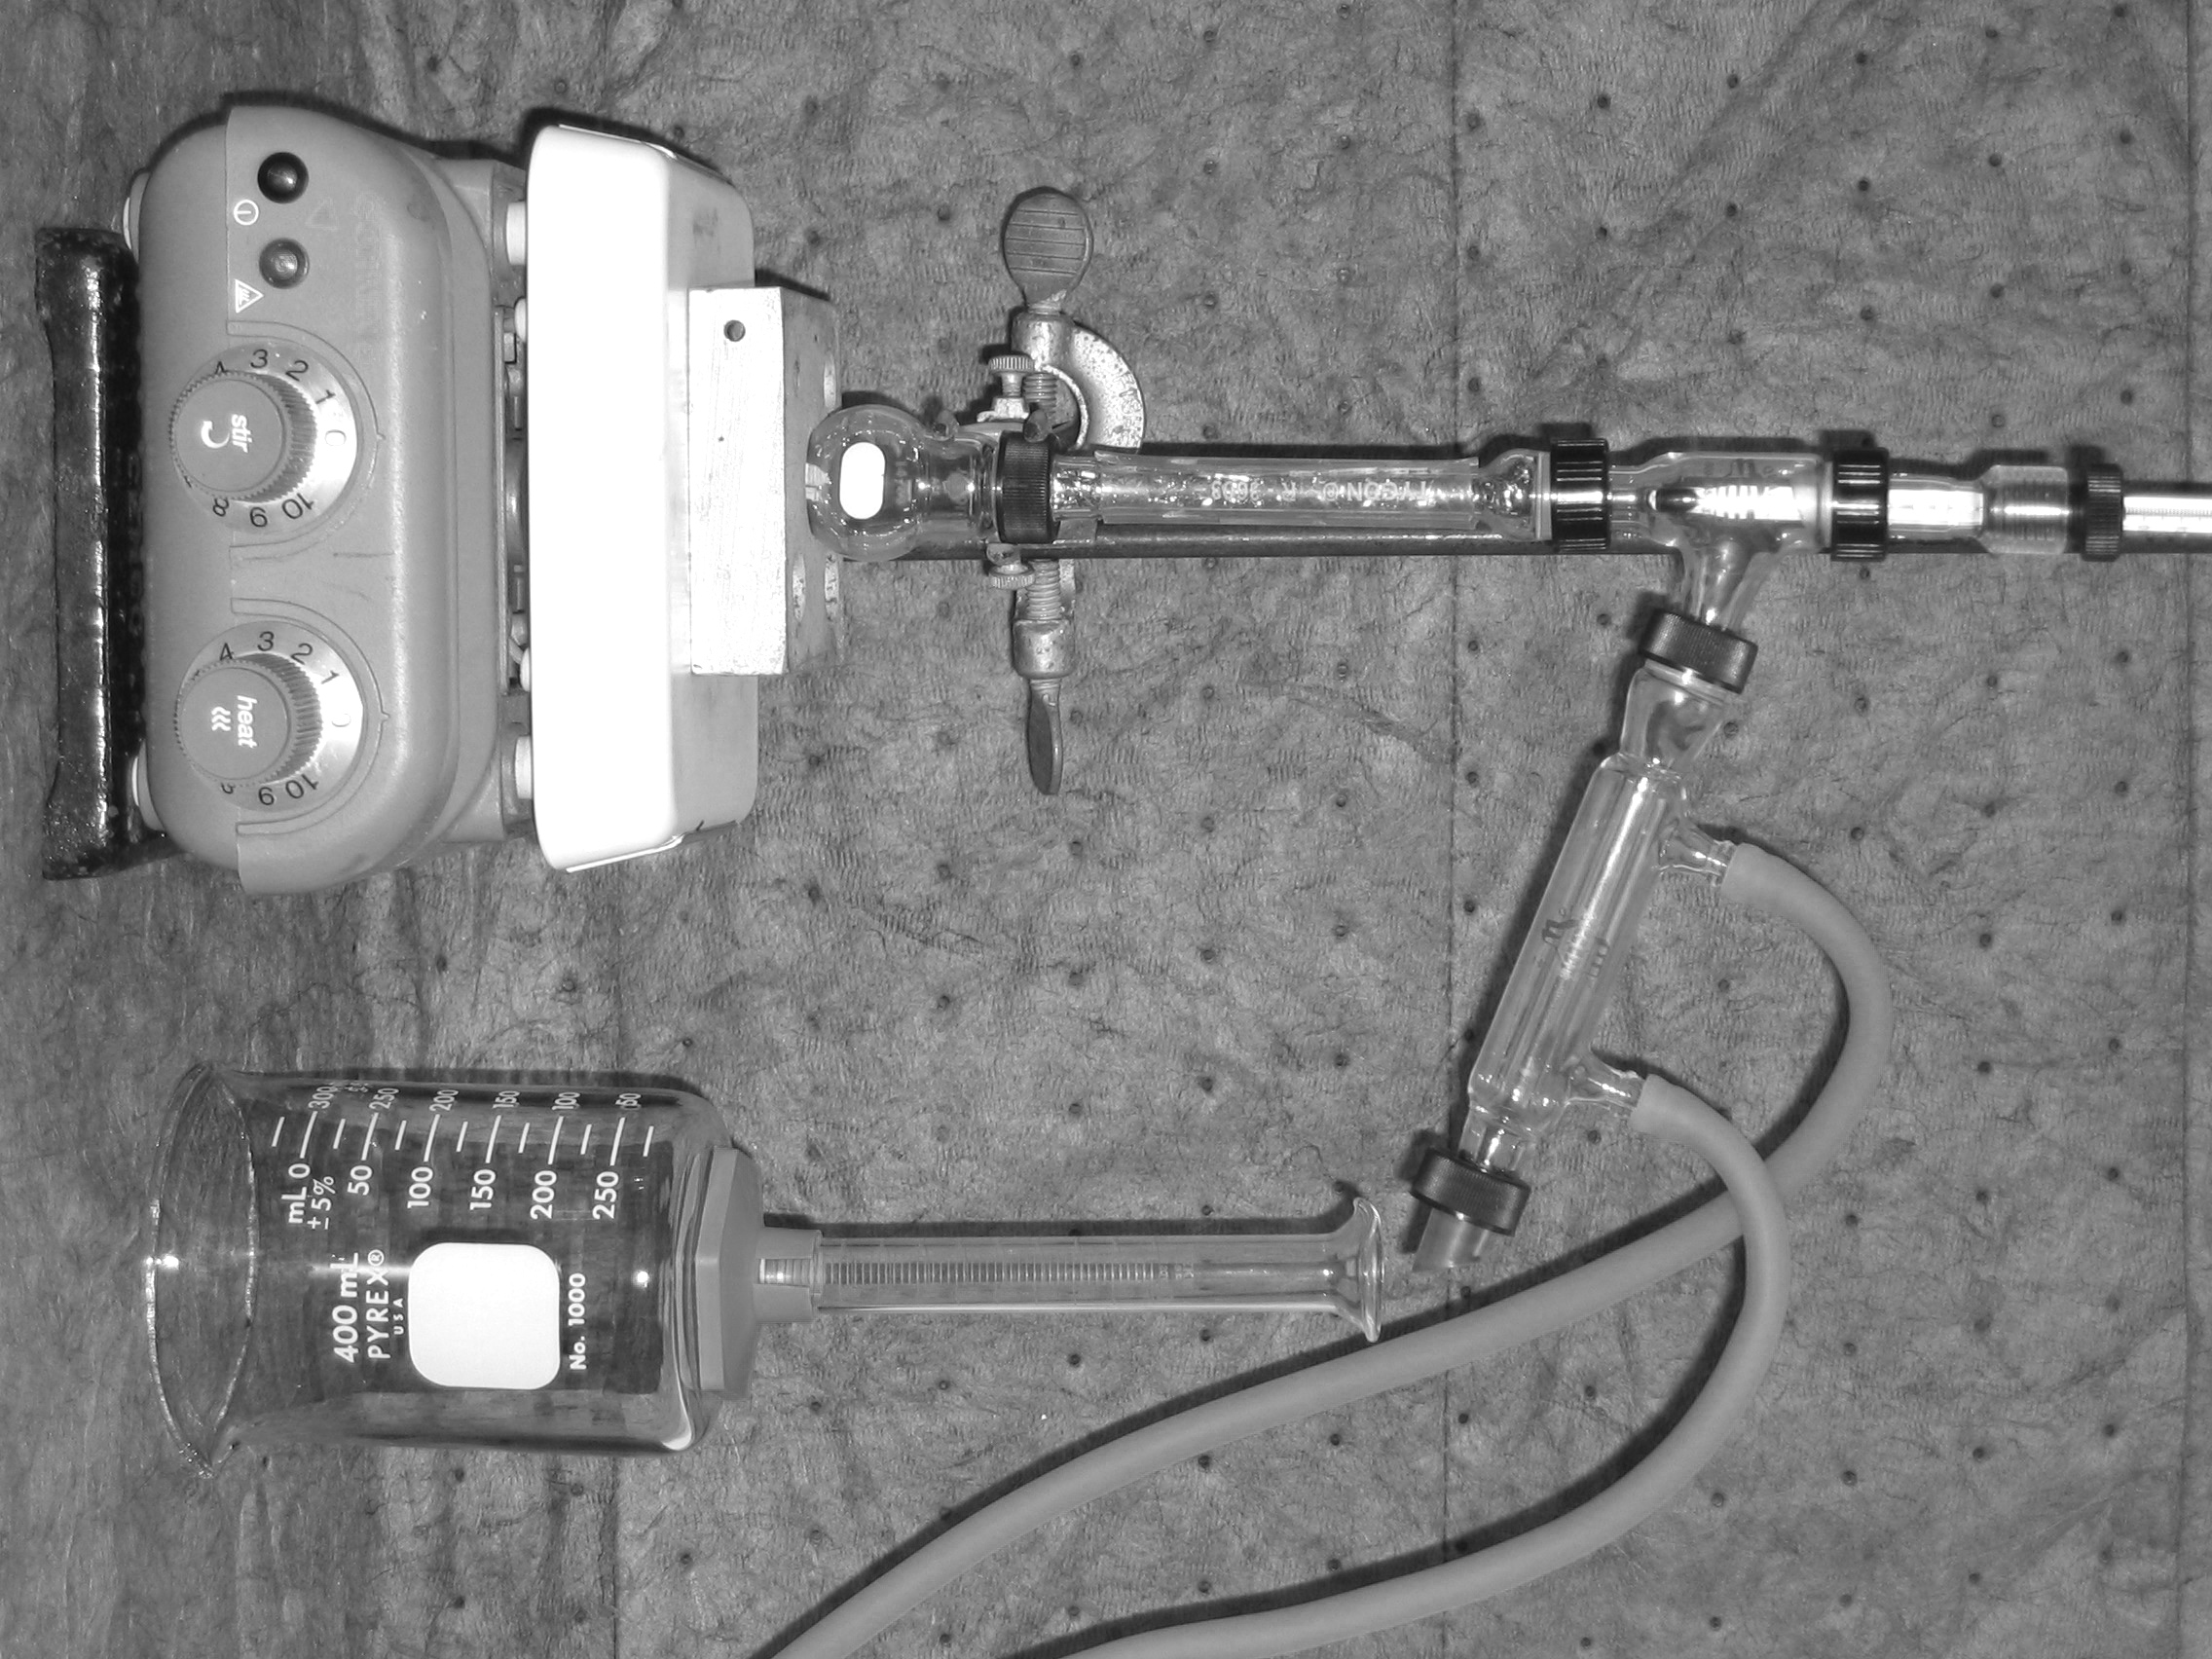
Simple Distillation Fractional Distillation

When you have collected 1.0 mL of distillate, transfer this liquid into a “snap cap” vial and label the vial with your names, section number, and “Initial Sample.” After you have collected a total of 4.5 mL of distillate, replace the graduated cylinder with a clean, dry conical vial and collect the remainder of the distillate (until about 0.5 mL is left in the distillation flask). Continue to record the vapor temperature after each 0.5 mL interval. Transfer this liquid into a “snap cap” vial and label the vial with your names and “Final Sample.”

Gas Chromatography
Inject 1 μL of sample into the gas chromatograph (your instructor will demonstrate). Depending on the effectiveness of the distillation, you may see either one or two peaks. Your instructor will provide you with a reference chromatogram to help you identify the components of your unknown by their retention time. Integrate the chromatogram to get the peak areas (your instructor will demonstrate the use of the software).
Since the detector response is different for different compounds, the peak areas from the chromatogram must be corrected by a response factor before quantifying the composition of your sample. To correct your peak areas, divide the peak area from the chromatogram by the appropriate response factor. Typical response factors for the possible components are as follows: hexane (1.50), cyclohexane (1.80), heptane (1.63), toluene (1.41), ethylbenzene (1.00).

References:
Pavia, D. L.; Lampman, G. M.; Kriz, G. S.; Engel, R. G. Introduction to Organic Laboratory Techniques, A Microscale Approach; 3rd ed.; Brooks/Cole: Pacific Grove, CA, 1999; pp. 51 – 56.
Results and Discussion

Distillation Data
1. Construct a graph of vapor temperature (y-axis) vs. volume of distillate (x-axis) for both the simple and the fractional distillations. Attach the graphs to this report.

2. Determine the boiling points for the components of your mixture using the fractional distillation graph. Indicate on the graph how you made your boiling point determination.

Boiling point (component 1): ___________ Boiling point (component 2): __________

3. Identify the components of your mixture based on their boiling points.

Component 1: ____________ Component 2: ____________

Gas Chromatography Data
4. Attach the GC chromatograms for each distillation sample to this report.

5. Indicate the retention times for the components in your mixture.

Retention time (component 1): __________ Retention time (component 2): __________

6. Identify the components of your mixture based on their GC retention times.

Component 1: ____________ Component 2: ____________

7. Calculate the % composition for each distillation sample.

Distillation Sample | % ________ (Comp. 1) | % ________ (Comp. 2)
Simple – Initial Sample
Simple – Final Sample
Fractional – Initial Sample
Fractional – Final Sample
Show detailed calculations for the % compositions:

8. Provide a detailed explanation of how you identified the products in your mixture. If the boiling point data and GC retention time data gave conflicting results, discuss any potential reasons for this inconsistency. Discuss in detail which distillation method provided better separation of your components.

Conclusion
1. Provide short paragraph (1 – 3 sentences) that summarizes what happened in the experiment, and whether or not your purpose was achieved.

Questions
1. Consider the following pairs of compounds. For which pairs can simple distillation be used, and for which ones would fractional distillation be more suitable? Explain your reasoning.
a) Hexyl acetate and butyl acetate
b) Hexan-1-ol and cyclopentanol

2. A mixture of 1-bromobutane, 2-bromobutane and 2-chlorobutane was injected into a gas chromatograph and gave the chromatogram below. Identify the peaks and explain how you made your identification. Determine the approximate composition of the sample (assume the three compounds have equal response factors). Show all calculations.
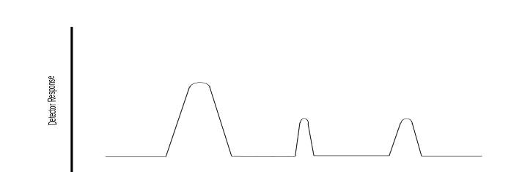

3. Vacuum distillation a technique often used to purify compounds with high boiling points, because the boiling point of a compound is lower when a vacuum is applied than it is at atmospheric pressure. (a) Why are boiling points lower under vacuum than at atmospheric pressure? (b) If a compound boils at 300 °C at atmospheric pressure, what is its boiling point at 1.0 torr? Explain how you determined your answer.

