1. Reactions
Draw the major product or products of each of reaction in the boxes provided. If multiple organic products are equally likely, show each. For stereoselective reactions, be certain that your structures clearly indicate stereochemistry.

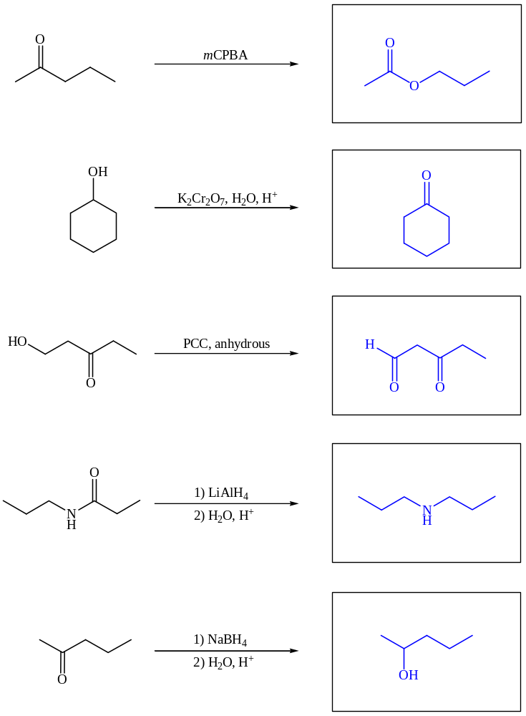

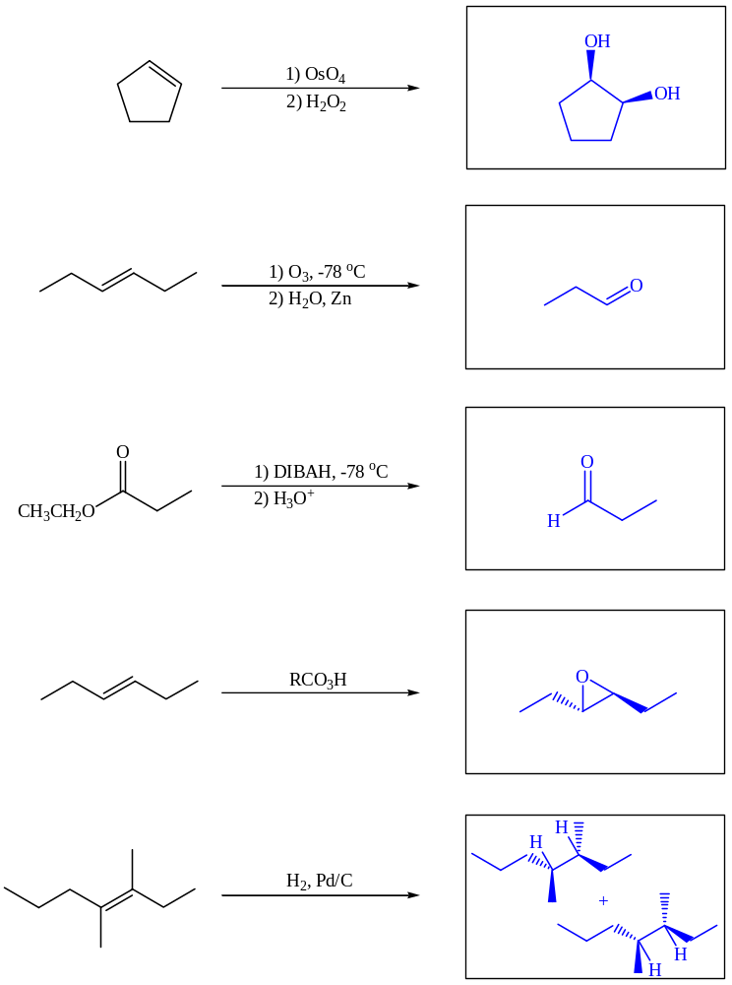

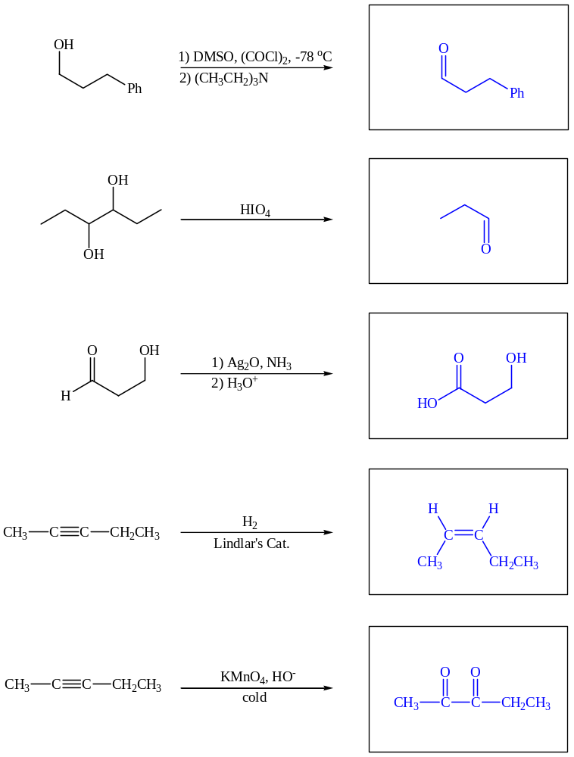

2. Reagents
Provide the reagents and conditions necessary to perform the transformations below.

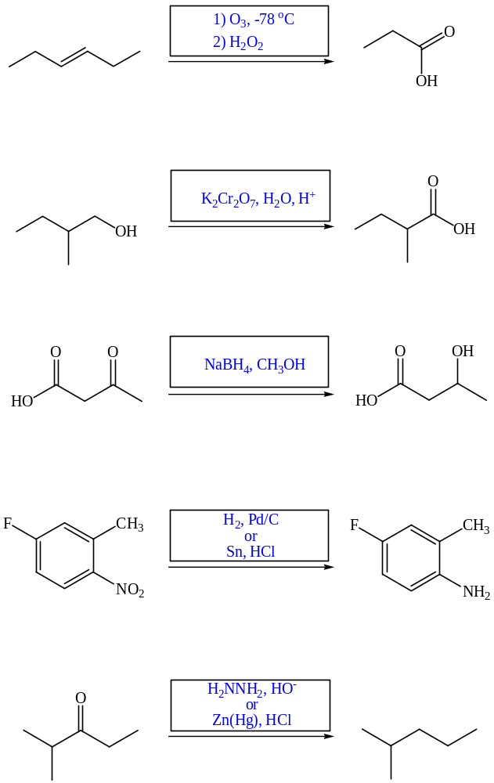

3. Synthetic Strategies
a. Show how perform the following functional group inter-conversions.

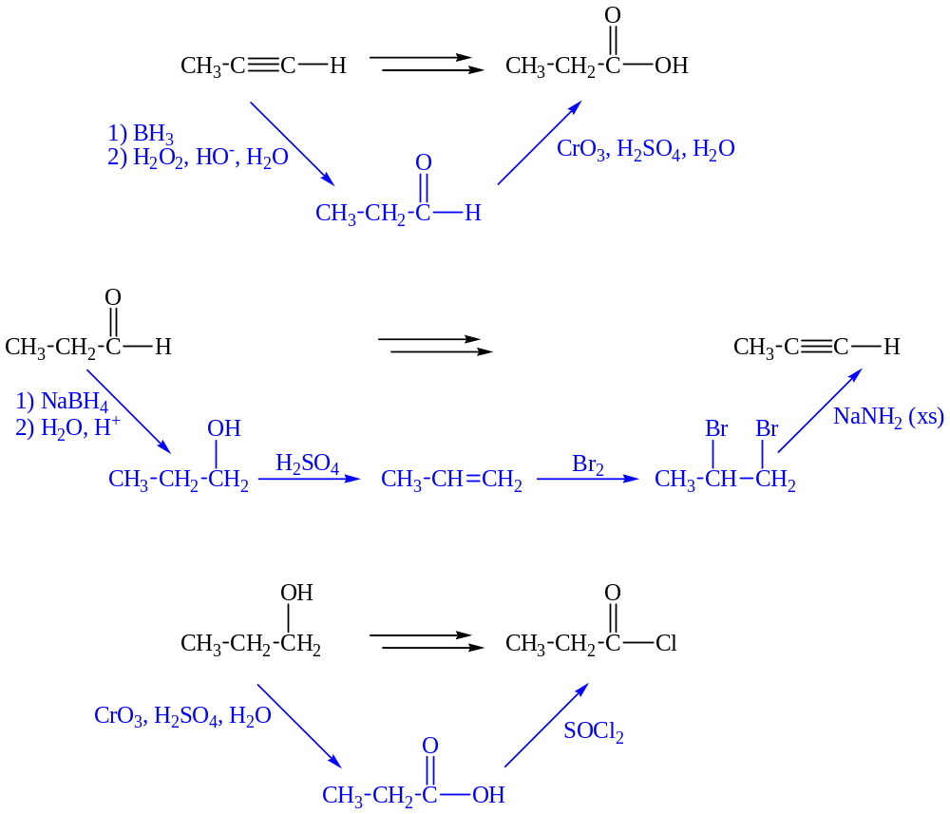

b. Draw a line through the C-C bond that would be easiest to form to provide each molecule. Describe the type of C-C bond forming reaction that would be used.
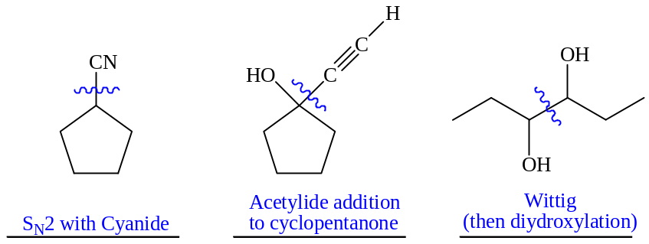
4. Synthesis
Propose a selective multi-step synthesis of each target molecule starting with the compound provided. Show the necessary reagents and products for each step.
a.
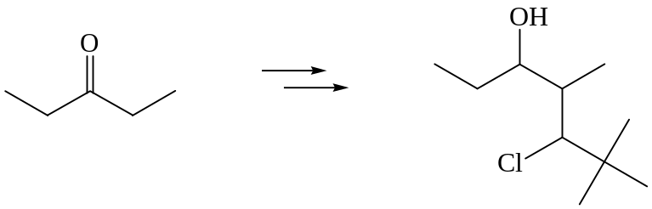
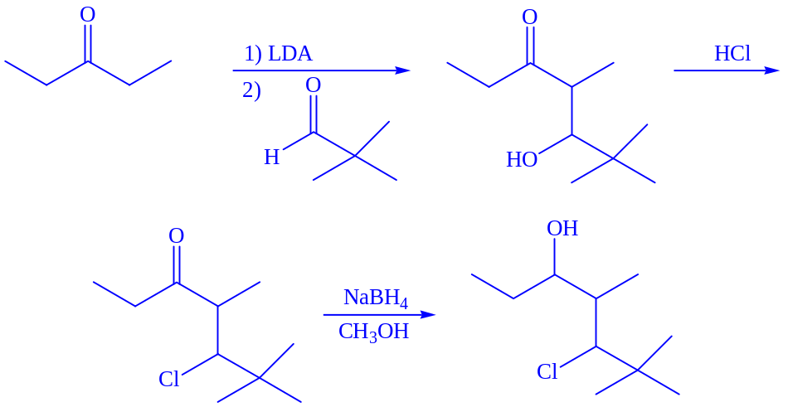

b.
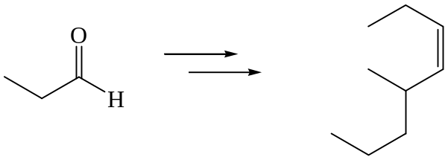
(all carbon sources must be made from propanal)


