Try to do these independently. Don’t look at the answer on the key until you have finished the problem. If you get really stuck, then collaborate on one or two and try the rest on your own.

Start by looking at the formula, and keep in mind at all times the number of carbons and the presence of any heteroatoms. Look at the IR data next to determine the presence or absence of certain functional groups. Next, use the ¹³C-NMR to determine if there is any symmetry in the molecule (fewer peaks than carbons in the formula) and also to confirm the presence of some functional groups indicated by the IR data. Spend most of your time looking at the ¹H-NMR. Do this after looking at the other spectra types, as it will be easier to interpret the ¹H-NMR after knowing some things about the compound already. Look for interesting peaks (in the π or electronegative regions) and what they tell you (keep in mind the decisions made based on IR and ¹³C-NMR, as well as the formula). Look at each peak, and its multiplicity to determine what may be on the atom next to it. Assemble the parts into a meaningful structure. Check proposed answer for impossible things like carbons with five bonds. Make sure the formula of your proposed structure matches the one given. Work your way through the structure and check that it is consistent with the spectral data. If everything checks out, you hopefully have the correct answer. If not, revise and recheck.

Problem 1
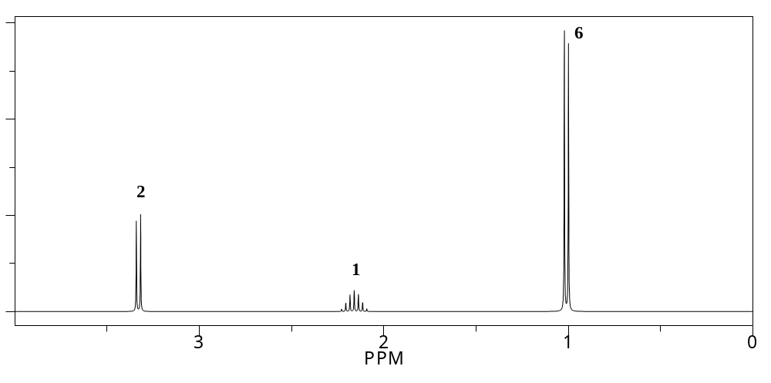
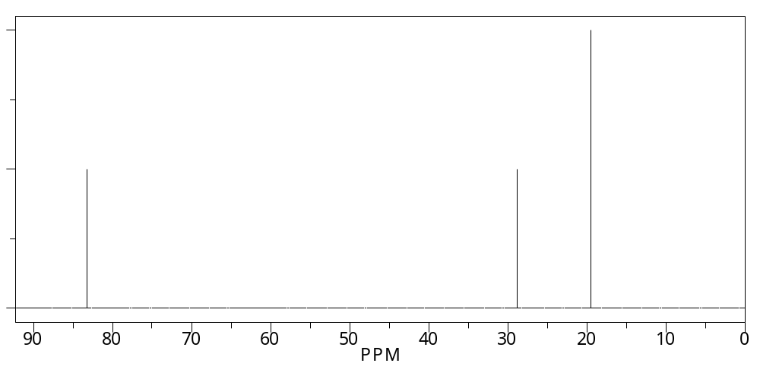
HRMS gives a mass of 130.1358 which corresponds to C₈H₁₈O.
IR shows peaks at 2900 and 1060 cm⁻¹.
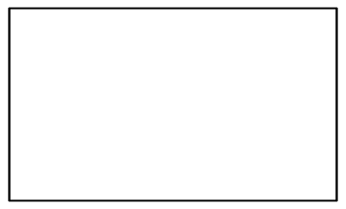
Problem 2
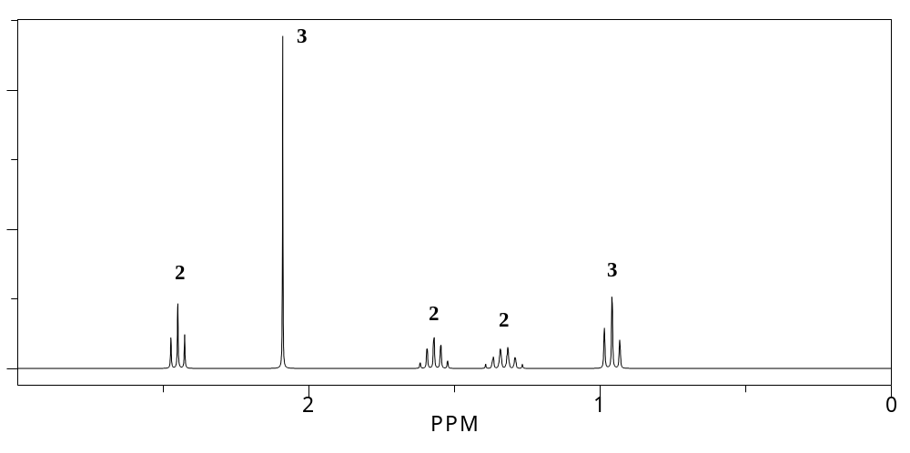
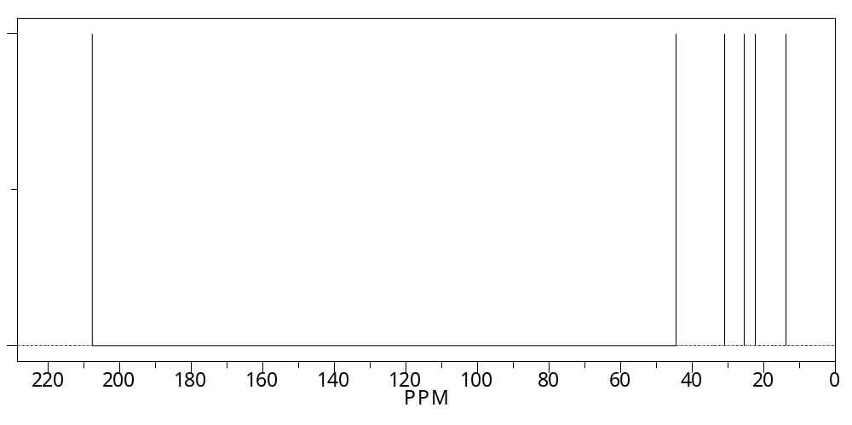
HRMS gives a mass of 100.0888 which corresponds to C₆H₁₂O.
IR shows peaks at 2900 and 1710 cm⁻¹.
Problem 3
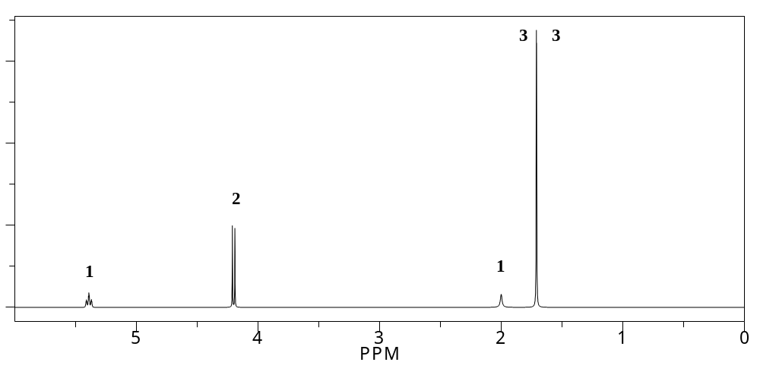
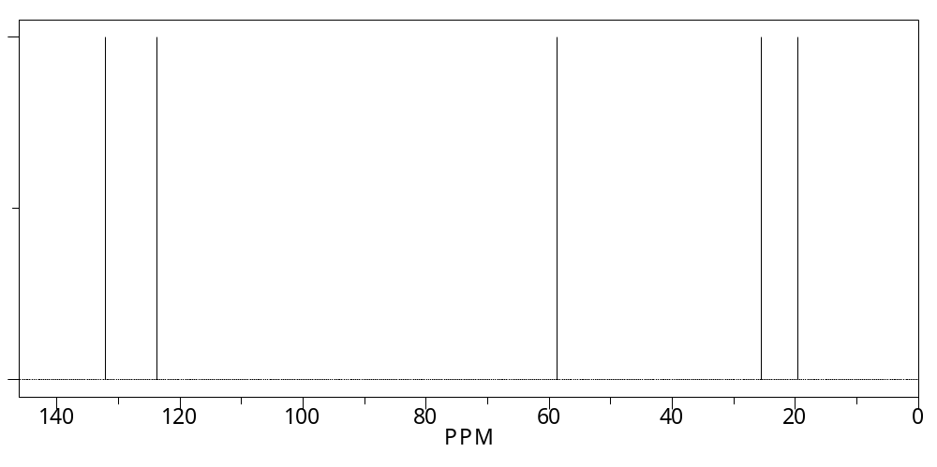
HRMS gives a mass of 86.0732 which corresponds to C₅H₁₀O.
IR shows peaks at 3300, 3100, 2900, 1640 and 1060 cm⁻¹.
Problem 4
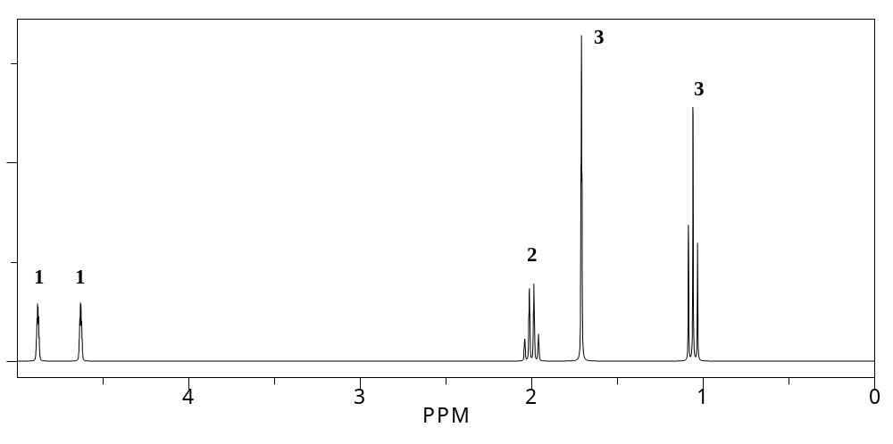
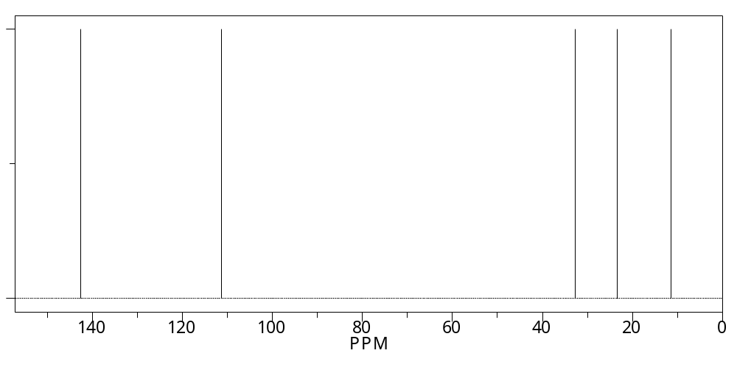
HRMS gives a mass of 70.0783 which corresponds to C₅H₁₀.
IR shows peaks at 3110, 2900 and 1640 cm⁻¹.
Problem 5
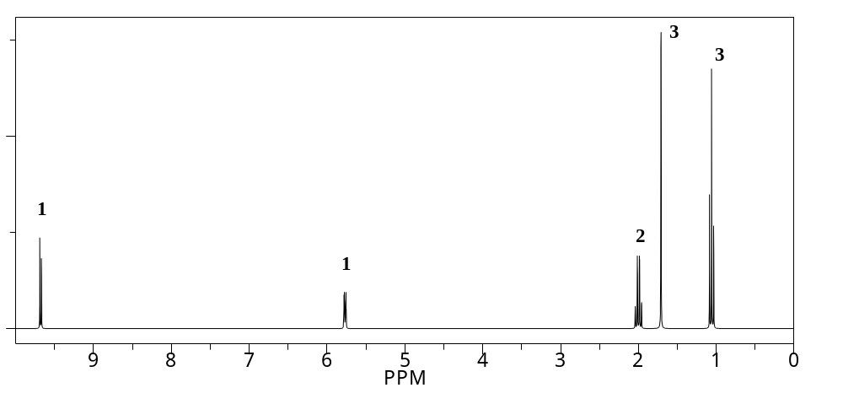
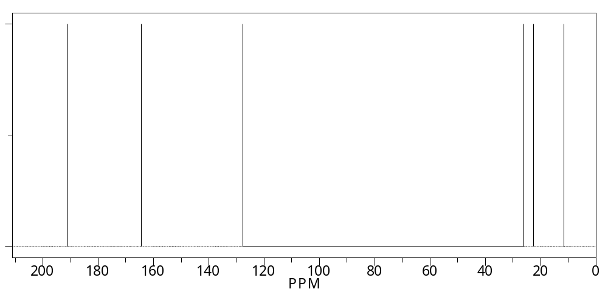
HRMS gives a mass of 98.0732 which corresponds to C₆H₁₀O.
IR shows peaks at 3100, 2900, 2820, 2720, 1700 and 1610 cm⁻¹.
Problem 6
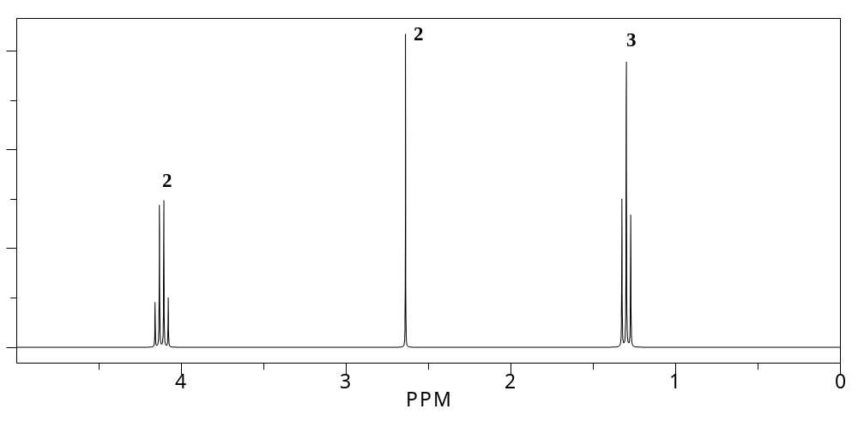
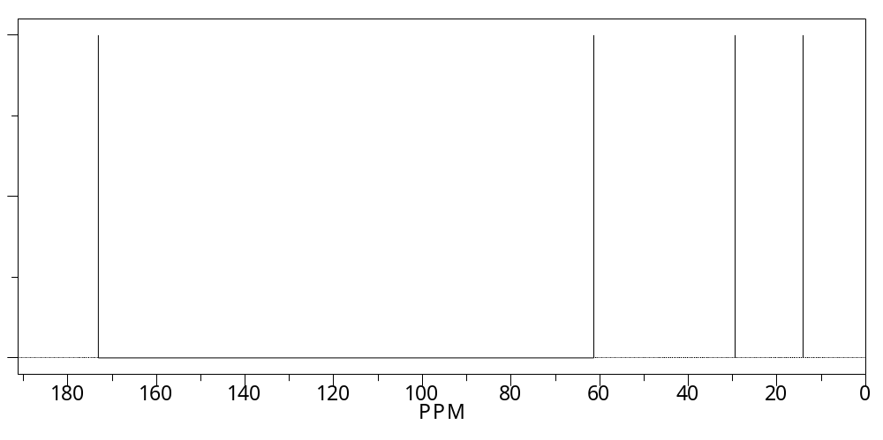
HRMS gives a mass of 174.0892 which corresponds to C₈H₁₄O₄.
IR shows peaks at 2900, 1720 and 1060 cm⁻¹.
Problem 7
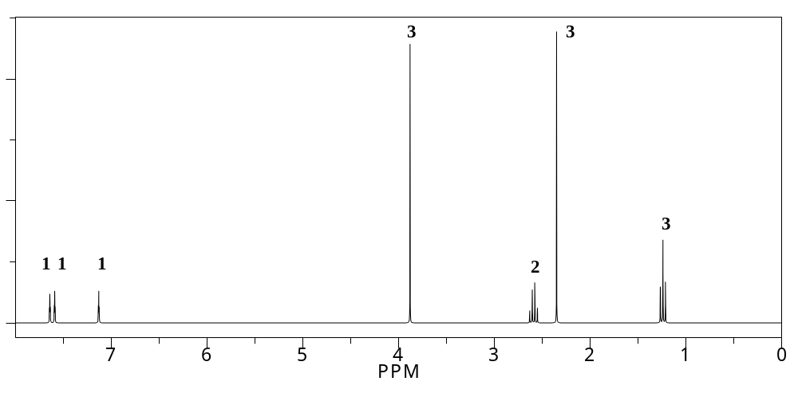
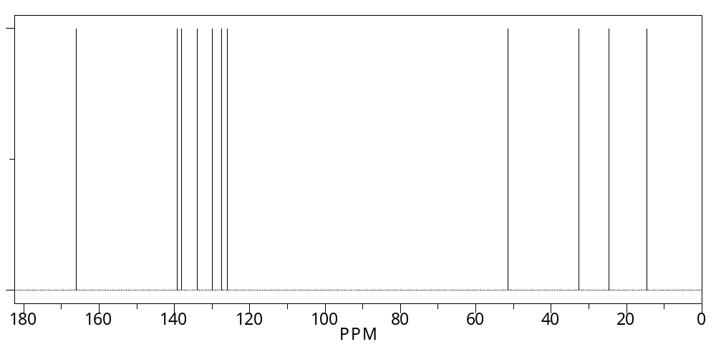
HRMS gives a mass of 178.0994 which corresponds to C₁₁H₁₄O₂.
IR shows peaks at 3100, 2900, 1710, 1600, 1500 and 1060 cm⁻¹.

