Free Rotation

Energy Diagram of Ethane Rotation

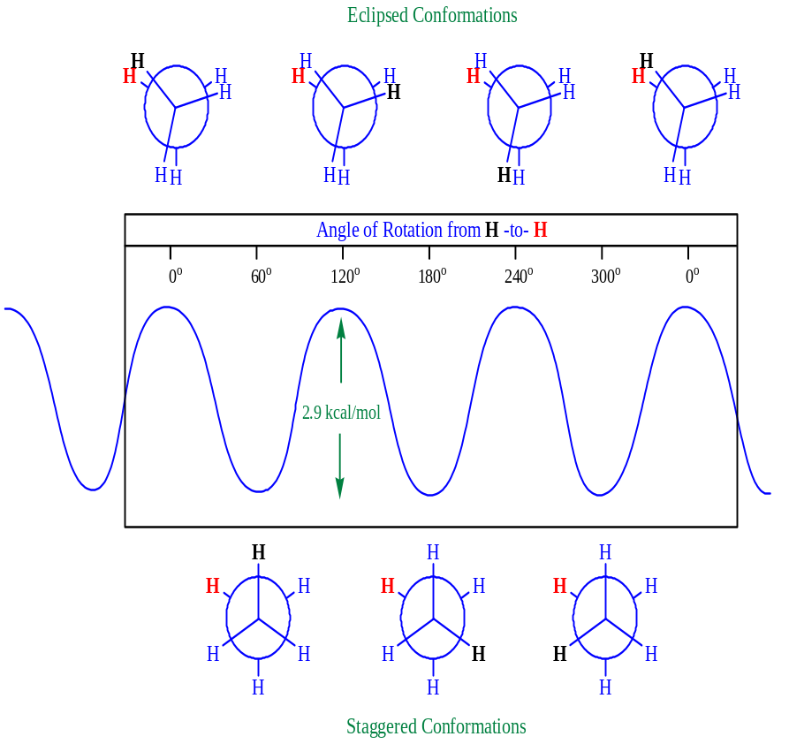

Energy Diagram of Butane Rotation (C2 –C3)

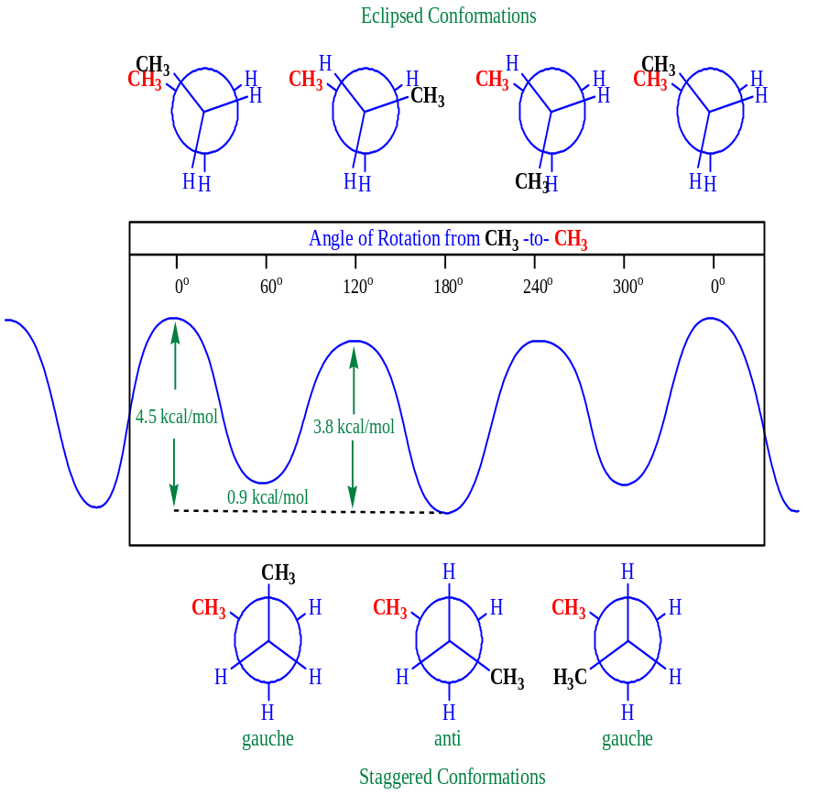

Angle Strain (Ring Strain)

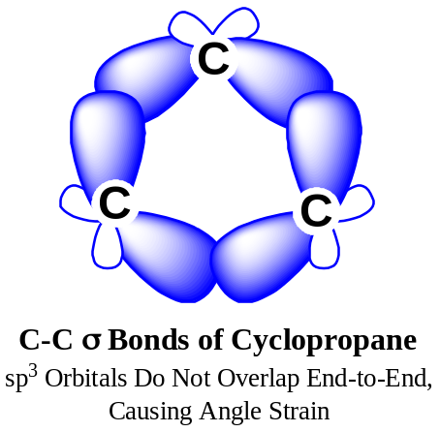
Cyclohexane Chair Conformations

Energy Diagram of Conformational Inversion of Cyclohexane

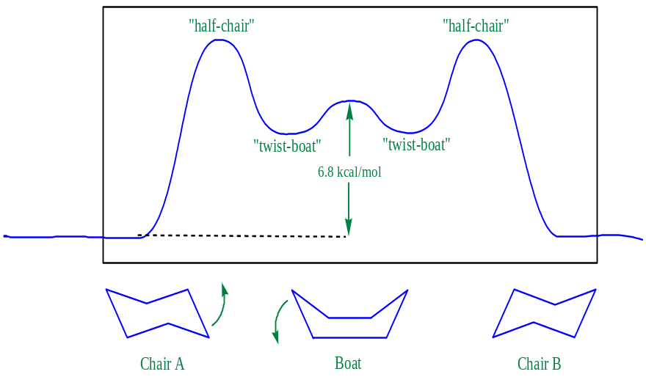

Stereochemistry

Enantiomers

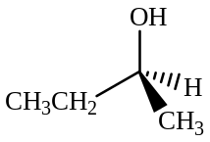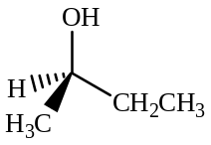

S and R 2-Butanol are Non-identical Mirror Images

Optical Rotation

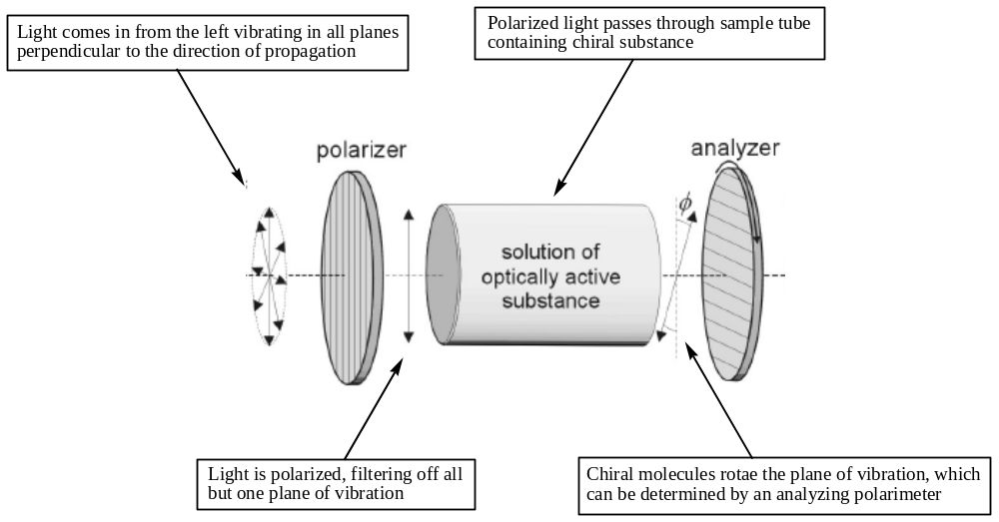

A Polarimeter

