Single component systems
- A single component system is one composed of a single substance with definite properties.
  - Ex. Pure water, although consisting of hydrogen and oxygen, is a distinct substance having none of the properties of the individual elements comprising it
- We can also consider the phase of a substance.
  - The phase of a substance depends on all the conditions of the system: P,V,T and n.
  - A phase change occurs when the conditions change in such a way as to make one phase more stable than another
    - Under most conditions of P,V,T and n, a single component system has a unique state
      - Ex. H₂O(L): (1 atm, 1L, 25ºC, 1 mol), H₂O(g): (1 atm, 1L, 125ºC, 1 mol)
  - Transitions can also occur within the same phase. Ex. Graphite Diamond. This is known as polymorphism.
- For a single component system at fixed V and n in an isolated system, more than one phase can exist simultaneously at a given T and P (ex. Solid and liquid at the MPº, or liquid and gas at the BPº)
  - In the more reasonable case of a closed system, in which heat is readily transferred between system and surroundings, the relative amounts of each phase will gradually change
    - Ex. Ice at 0ºC in a closed container sitting on a counter top will gradually melt, so the change in the amount of liquid is equal but opposite to that of ice. However, as long as both phases exist, the system is in equilibrium
- At fixed V and n, the temperature at which a phase change occurs varies with pressure. We must set a standard condition.
  - The normal boiling point (NBPº) and normal melting point (NMPº) are the temperatures at which two phases co-exist at 1 atm.
    - NMPº is only affected by large changes in pressure. The NBPº is very sensitive to pressure.

Variation of Gibbs Free Energy with Pressure
- The molar Gibbs free energy is phase dependent. If, at certain values of T and P, the solid has a lower value of G than the liquid, then the solid phase is thermodynamically more stable and the substance will be solid.
  - At constant T, when the pressure changes, G changes as:
$∆G=V_{m}∆P$ Eq. 6.1 Dependence of G on P

    - Because all molar volumes are positive, we see from eq 6.1 that an increase in pressure results in an increase in G
    - We also see that the sensitivity of ΔG to pressure is greatest for substances with high molar volumes….GASES!
      - For most substances, the slope of ΔG vs ΔP increases as phase changes: g>L>s. Water is a notable exception because its solid phase has a higher molar volume than its liquid phase.

- A substance will convert into the state of lowest G. The graph above shows, at constant T, how the phase depends on P. Because V_{m} changes dramatically with P for a gas, the gas-curve is exponential. Liquids and solids do not compress significantly.

Variation of Molar Gibbs Free Energy with Temperature
- At constant P:
$∆G= -S∆T$ Eq. 6.2 Dependence of G on T

  - Again, like molar volume, the absolute molar entropy of a substance must be positive. This means that an increase in temperature lowers G. As you would expect, molar entropy, and thus, the slope of ΔG vs ΔT increases as follows: g >> L > s. The graph below shows how the phase of a typical substance changes with T.
  - Thus, the transition temperature, or the value of T at which a phase change occurs, is the temperature at which the molar Gibbs free energies of two phases are equal at a given P.

Equilibrium condition
- Since the co-existence of two phases represents an equilibrium, we can consider an infinitesimal change dG. Recall the natural variable expression for dG, which includes a chemical potential summation:
  - $dG= -SdT+VdP+ \sum_{phase}{μ} dn_{phase}$
  - At the transition temperature, assuming constant pressure: dT = 0, dP = 0
  - $\sum_{phase}{μ} (dn_{phase})=0$
    - Ex. H₂O(s) ⇌ H₂O (L)
    - $μ_{s}dn_{s}+μ_{L}dn_{L}=0$
    - Because $dn_{s}=-dn_{L}$, $μ_{s}$=$μ_{L}$
    - The chemical potentials of two phases at the transition temperature are equal!

- We can define characteristic enthalpy terms.
  - $∆_{fus}H$, or the heat of fusion, is the heat needed to convert sL at NMPº
  - $∆_{vap}H$, or the heat of vaporization, is the heat needed to convert Lg at NBPº
    - These values are positive and correspond to the endothermic direction. For the opposite process, the values are opposite in sign.
    - The amount of heat absorbed during a transition is proportional to the amount by:
$q_{trans}=n∆_{trans}H$ Eq. 6.3 (6.5) Heat transferred during an isothermal phase transition
- Recall that for a certain phase being heated or cooled from some initial temperature to some final temperature at constant pressure, the heat transferred is calculated as:

$q=nC_{p,i}∆T$ Eq. 6.4 (2.9) q needed to cause ΔT at constant P
- The heat capacity of phase i must be known.

- Since ΔG = 0 for the isothermal phase transition:
$T∆_{trans}S=∆_{trans}H$ Eq. 6.5 (6.7) Entropy change of a phase change

    - This equation can be used to tabulate the entropy change associated with a phase change.
- Group ex. Book problem 6.11, 6.13b

Clapeyron Equation
- Going back to our natural variable expression for dG and consider two phases in equilibrium:
$$dμ=-\frac{S}{dn}dT+\frac{V}{dn}dP= -S_{m}dT+ V_{m}dP$$

  - The subscript m is used here to define a molar value as opposed to the absolute value. As previously discussed, changes in T or P will shift the equilibrium one way or another. However, we see that, say, for a change in P, equilibrium can be maintained if there is a simultaneous change in T. This means that $dμ_{1}=dμ_{2}$, where 1 and 2 represent different phases.
$$-S_{m,1}dT+ V_{m,1}dP=-S_{m,2}dT+ V_{m,2}dP$$
$$\left(V_{m,2}-V_{m,1}\right)dP=\left(S_{m,2}-S_{m,1}\right)dT$$
$\frac{dP}{dT}=\frac{ΔS_{m}}{ΔV_{m}}$ Eq. 6.6 (6.9) Clapeyron Equation
    - This is a powerful equation that allows you to determine the pressures needed to shift phase equilibria to other temperatures.
    - Class ex. 6.4 What pressure is required to shift the melting point of water to -10ºC?
      - $∆_{fus}S=22\frac{J}{mol K} (from table 6.2), V_{m,L}=18.01\frac{mL}{mol}, V_{m,s}=19.64\frac{mL}{mol}$
$$\frac{dP}{-10 K}=\frac{22\frac{J}{mol K}}{\left(-1.64\frac{mL}{mol}x\frac{L}{1000 mL}\right)}$$

$$dP=134, 146\frac{J}{L} x \frac{L atm}{101.325 J}=1324 atm$$

$$P_{F}=1325 atm$$

      - How do we justify this physically?
        - Water is unique in the sense that it expands upon freezing, so its solid state has a higher molar volume than the liquid, which is very unusual.
        - The increased external pressure is needed to prevent the molecules from expanding into the solid phase.

  - This equation can be simplified to exclude molar entropy terms:
$$T∆_{trans}S=∆_{trans}H$$
$$T\left(\frac{dP}{dT}∆V_{m}\right)=∆_{trans}H$$
$\frac{dP}{dT}=\frac{∆_{trans}H}{T∆V_{m}}$ Eq. 6.7a Modified Clapeyron Equation

$∆P= \frac{∆_{trans}H}{∆V_{m}}\ln\left(\frac{T_{F}}{T_{I}}\right)$ Eq. 6.7b (6.12)

- Class Ex. Book problem 6.28
First we need to calculate the molar volumes of Ga(s) and Ga(l): REFER TO TABLE 6.2
Use density of each phase to calculate molar volume in L/mol
Find ΔV_{m} for s L = 0.0114 - 0.0118 = -.0004 L/mol
ΔT = -4.8 K
$dP=\frac{{∆S}_{m}}{{∆V}_{m}} dT$
Approximately 2490 atm of pressure is required to only slightly change the melting point of the solid.

Gas-Phase Effects
- If a gas is formed, we can assume that the molar volume of the gas is so much larger than that of the liquid that ΔV_{m} ≈ V_{m}(g)
  - For evaporation or sublimation under ideal conditions, V_{m}(g) = RT/P
$dP=\frac{{∆S}_{m}}{\left(\frac{RT}{P}\right)} dT$
$\frac{dP}{P}=\frac{{∆S}_{m}}{RT} dT$

$\ln\left(\frac{P_{2}}{P_{1}}\right)= -\frac{∆_{trans}H}{R}\left(\frac{1}{T_{2}}-\frac{1}{T_{1}}\right)$ Eq. 6.8 (6.14) Clausius-Clapeyron Equation
  - This equation is useful for L/g and s/g equilibria, and is a very good approximation even for real gases!!!! All liquids have a characteristic vapor pressure that varies with temperature. The changes in that vapor pressure are commonly calculated from this equation.
  - Class Ex. Example 6.8 pg 166, book problem 6.34
    - The previous examples shows how well the Clausius-Claperyron equation works despite the assumptions made. If you review book example 6.7 on pg 166, you will see that Δ_{vap}H can vary with temperature! In most instances, we will apply these equations over a small enough range of temperatures to allow us to assume the enthalpy change to be constant.
Phase Diagrams
- Phase diagrams are graphical representations of what phases are stable at P,V,T. The diagram is composed of lines that indicate the values of T and P at which phase equilibria occur. At any point along the boundaries, the system is in phase equilibrium. A phase diagram is simply a plot of the Clapeyron equation (dP/dT) for a given substance.

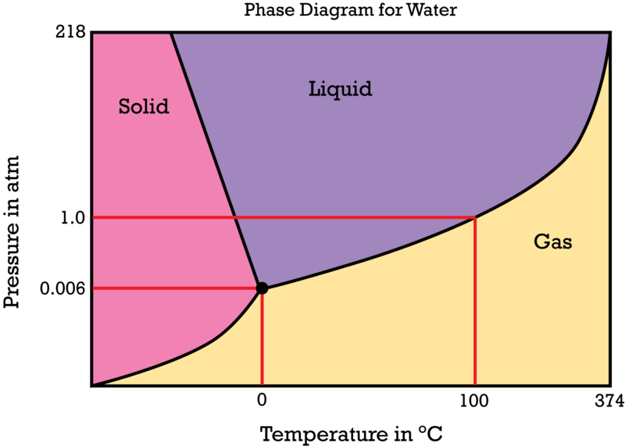
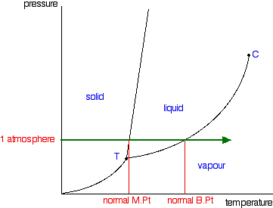

- The figure on the left is a phase diagram of a typical substance. The one on the right is for water.
  - In a typical substance, we see that as pressure increases, temperature must also increase in order to maintain equilibrium, as is predicted by the Clapeyron equation. The slope of the s/L boundary is $\frac{∆_{fus}H}{T∆V_{m}}$, which is a positive value. The slope of the L/g boundary is $\frac{∆_{vap}H}{T∆V_{m}}$, which shows a strong pressure dependence as would be expected for a process involving gases.
  - Using water as a special case, the slope of the s/L boundary is negative because ΔV_{m} is negative. However, in both plots the L/g boundary is steep and positive, but non-linear due to the dependence of V_{m}(g) on pressure.
    - By reading the phase diagram, we can determine, at a given T and P, which phase is thermodynamically favored.
    - At any point along a line, the system maintains equilibrium.
    - See figure 6.3 in book (pg 169)
    - The s/g line represents the conditions where sublimation occurs.

Special Points of Interest
- Beyond a certain point, the liquid and gas phase become indistinguishable. This point is called the critical point, and is the highest point on the L/g boundary. The pressure and temperature at this point are the critical temperature and pressure.
  - YOUTUBE search for “supercritical fluids”. You will see a demonstration of CO₂
  - Beyond the critical temperature, no amount of pressure can force a substance to condense.

- The triple point represents the temperature and pressure at which all three phases of matter have the same chemical potential and can exist all at once.
  - YOUTUBE search for “triple point of cyclohexane”

Chemical Potential
- We are dealing primarily with changes in the system as T and P change. Thus, we need expressions for $\frac{∂μ}{∂T}$ and $\frac{∂μ}{∂P}$.
  - We have established that:
$$dμ= -S_{m}dT+ V_{m}dP$$

  - Since the expression above is a total differential, and because it must be exact:
$${\left[\frac{∂\left(∆μ\right)}{∂T}\right]}_{P}=-∆S_{m}{ \left[\frac{∂\left(∆μ\right)}{∂P}\right]}_{T}=∆V_{m}$$

    - We can use these expressions to justify the way an equilibrium shifts as T and P are changed. For example, going from sL involves an increase in entropy. Thus, as T increases, the change in chemical potential would have to decrease. This would mean that the process would shift right (ΔG < 0). Phase transitions occurring with an increase in temperature must always accompany a decrease in chemical potential (ex. A horizontal line across a phase diagram).
    - For a normal substance undergoing a Lg transition, the molar volume increases. Thus, adding pressure requires the change in chemical potential to increase. This positive value implies that the process would shift left and the liquid would be favored. Increasing pressure always favors the phase with the lower molar volume.

