Kinetics

When we describe the rate of a reaction, we are describing how quickly the reactant becomes product.
$$rate= \frac{∆ (amount)}{∆ (time)}$$

However, rate is a respective term. For example, consider the reaction:
$$2H_{2}\left(g\right)+O_{2}\left(g\right)→2H_{2}O(g)$$

The rate at which H₂ is consumed can be expressed in terms of moles as:
$$rate_{H_{2}}=\frac{∆[n_{H_{2}}]}{∆t}$$
We can relate the formation of H₂O to the rate of consumption of H₂, or the consumption of O₂ to that of H₂. We can base this on the stoichiometry. Since water is a product, the change in moles of water is positive, whereas the change in the moles of reactant would be negative.

$\frac{∆[n_{H_{2}O}]}{∆t}=-\frac{∆[n_{H_{2}}]}{∆t}$ $\frac{∆[n_{O_{2}}]}{∆t}=\frac{1}{2}\frac{∆[n_{H_{2}}]}{∆t}$

In terms of molarities, for any reaction aA + bB ⇌ cC + dD, rate is

$$rate= \frac{-∆\left[A\right]}{∆t}= \frac{-∆\left[B\right]}{∆t}= \frac{∆\left[C\right]}{∆t}……$$

*Rate values are instantaneous. As the concentrations of the reactants decrease, the rate of the reaction slows down. The plot below shows reactant concentration as a function of time. The slope of the plot is the rate. As time increases, the slope, and thus, the rate, decreases.
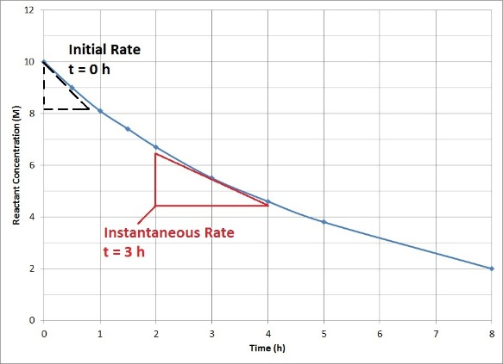

We can derive a rate law in terms of the reactant concentrations, which allows us to determine the rate of the reaction at any point in time. The rate law has the form:
$$rate=k[{A]}^{m}[B]^{n}…..$$

- The rate of the reaction after some time t can be calculated if we know the concentrations of the reactants at time t. k is the rate constant, which is the characteristic value for a reaction at a specific temperature.
    - This value is inversely proportional to the activation energy of the reaction by the Arrhenius equation, $k=Ae^{\frac{-E_{a}}{RT}}$
    - Low E_{a} = High k.
    - High k = fast reaction
- m and n are reaction orders that describe the dependence of the rate on a given reactant; these values define the number of a given species involved in the rate determining step

Rate laws must be determined empirically. This can be done using:
- Method of initial rates
  - Ex. 20.2 in chapter
- Graphical analysis
  - First order kinetics
    - Consider a simple 1st order reaction: A B
$$Rate=k[A]^{1}= -\frac{d\left[A\right]}{dt}$$
$-kdt=\frac{d\left[A\right]}{\left[A\right]}$
$\int_{0}^{t}{-kdt=\int_{{[A]}_{0}}^{[A]_{t}}{\left(\frac{d\left[A\right]}{\left[A\right]}\right)}}$
$\ln{{[A]}_{t}=-kt+\ln{{[A]}_{o}}}$ Time-dependent expression for a 1st order reaction

- The equation above is a linear equation in y=mx+b form. For data that follows 1st order kinetics, a plot of ln [A]_{t} vs t yields a linear trace with a slope of –k. If the reaction is not 1st order, the equation fails and the plot will be curved. Here, k has units of s⁻¹.
- Ex. 20.3 in chapter

- Second order kinetics
  - Consider a simple 2nd order reaction: A B
    - $Rate=k[A]^{2}= -\frac{d\left[A\right]}{dt}$
    - $-kdt=\frac{d\left[A\right]}{[{A]}^{2}}$
    - $\int_{0}^{t}{-kdt=\int_{{[A]}_{0}}^{[A]_{t}}{\left(\frac{1}{{\left[A\right]}^{2}}d[A]\right)}}$
    - $\frac{1}{{\left[A\right]}_{t}}{ =kt+\frac{1}{{\left[A\right]}_{o}}}$ Time-dependent expression for a 2nd order reaction

- For data that follows 2nd order kinetics, a plot of 1/[A]_{t} vs t yields a linear trace with a slope of k. If the reaction is not 2nd order, the equation fails and the plot will be curved. Here, k has units of M⁻¹s⁻¹.
- Ex. 20.3 in chapter

- Diffusion-Control
  - 1st and 2nd order reactions depend on concentration, and are examples of diffusion-controlled reactions. In other words, the maximum rate of the reaction is restricted by the time required for reactant molecules in solution to diffuse toward each other, collide with energy greater than E_{a}, and form products. At high reactant concentration, there are more molecules in solution, which means that there is a higher rate of collision. As the reactant molecules are depleted, the molecules have to travel longer distances before colliding with each other, which lowers the rate.
- Zeroth-Order Reactions
  - Zeroth order reactions are not diffusion controlled. For example, this can happen when a reaction proceeds on a catalytic surface in which reactant molecules are adsorbed (no diffusion). Therefore, the rate is independent of concentration.
    - Consider a simple 0th order reaction: A B
    - $Rate=k[A]^{0}= -\frac{d\left[A\right]}{dt}$
    - $d\left[A\right]= -kdt$

Pseudo rate constants
Rate laws can become complex to determine unless simplifications are made. One simple route is to use a very large excess of a particular reactant. Consider the reaction A + B C:
  - Rate = k [A]^{m}[B]^{n}
  - If [B] >> [A], then the change in the concentration of [B] during the course of the reaction is negligible and can be approximated as a constant. If we let k[B]^{n} = k’ :
    - Rate ≈ k’[A]^{m} k’ is referred to as the pseudo rate constant. Then, the approximated order of the reaction is m.

Equilibrium
As we know, reactions do not go fully to completion, but rather reach a thermodynamically preferred equilibrium state.
A ⇌ B
${rate}_{F}=k_{F}\left[A\right]$; ${rate}_{B}=k_{B}[B]$

At equilibrium, the forward and reverse rates are equal. We define the equilibrium constant as:
$$K= \frac{k_{F}}{k_{B}}$$
When K is greater than 1, the forward rate constant is larger, and thus, the equilibrium state consists of mostly products. The opposite is true when K < 1.

Predicting Equilibrium Concentrations of Simple 1st Order Reactions
- Since [B] = -Δ[A]:
$$\frac{k_{F}}{k_{B}}=\frac{{\left[B\right]}_{E}}{{\left[A\right]}_{E}}=\frac{-∆\left[A\right]}{ {\left[A\right]}_{E}}= \frac{{\left[A\right]}_{o}-{[A]}_{E}}{{[A]}_{E}}$$
- Cross multiplying the above expression:
$$\frac{k_{F}}{k_{B}}{\left[A\right]}_{E}= {\left[A\right]}_{o}-{[A]}_{E}$$
$$\frac{k_{F}}{k_{B}}{\left[A\right]}_{E}+{\left[A\right]}_{E}= {\left[A\right]}_{o}$$
  - Given that 1 = k_{B}/k_{B}

$$\frac{k_{F}}{k_{B}}{\left[A\right]}_{E}+{\frac{k_{B}}{k_{B}}\left[A\right]}_{E}= {\left[A\right]}_{o}$$
$$\frac{k_{F}+ k_{B}}{k_{B}}[A]_{E}={\left[A\right]}_{o}$$
${\left[A\right]}_{E}=\frac{k_{B}}{k_{F}+k_{B}}{[A]}_{o}$ Equilibrium concentration of reactant for 1st order process
Parallel Reactions
For some reactions, more than one product is possible. When a single reactant produces multiple products, and the products are not formed from one another, the reactions are said to be parallel.
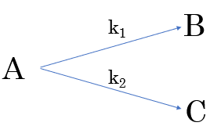
- If both reactions are 1st order, and we are not at equilibrium:
$$-\frac{d\left[A\right]}{dt}=k_{1}{\left[A\right]}_{t}+k_{2}{[A]}_{t}$$
$$d\left[A\right]= -\left(k_{1}+ k_{2}\right){\left[A\right]}_{t} dt$$
$$\ln{\frac{{\left[A\right]}_{t}}{{\left[A\right]}_{o}}= -}\left(k_{1}+ k_{2}\right) t$$
$${\left[A\right]}_{t}={\left[A\right]}_{o}e^{-\left(k_{1}+ k_{2}\right)t}$$
$$\frac{d\left[B\right]}{dt}=k_{1}{\left[A\right]}_{t}; \frac{d\left[C\right]}{dt}=k_{2}{\left[A\right]}_{t}$$
$$\frac{[{B]}_{t}}{{[C]}_{t}}=\frac{k_{1}}{k_{2}}$$

  - Kinetic vs Thermodynamic Control
    - If we are at equilibrium, the math becomes complex because, for example, when a molecule of B undergoes the back reaction to form A, that newly formed molecule of A does not have to reform B (it may instead form C)
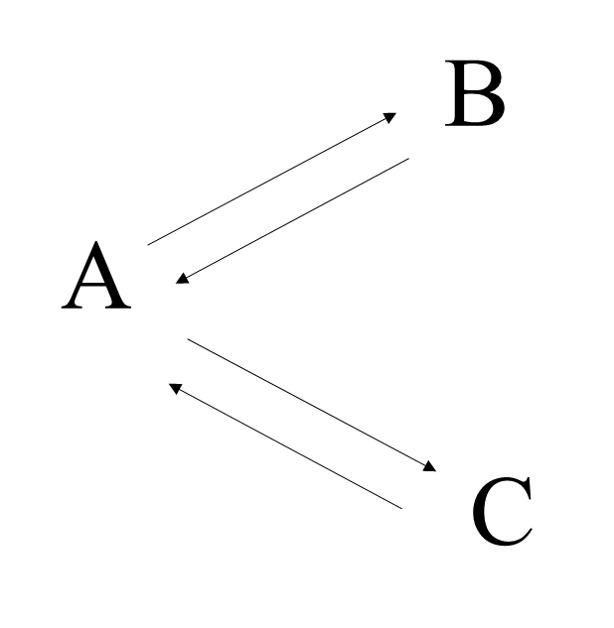
k₁
k₋₁

k₂
k₋₂

    - Initially, the reaction with the higher rate constant proceeds faster. Thus, the initial ratio of the the products is equal to the ratio of the rate constants. Thus, the initial ratio of products is kinetically controlled.
    - At longer durations, the ratios are dictated by the equilibrium constants, which are dictated by ΔG, so they are thermodynamically controlled.

- In the plot below (concentration vs time), k₁ > k₂ and K₂ > K₁. We can see that the initial formation of B is faster than that of C. The region where [B] > [C] represents the time region of kinetic favorability.
- However, since K₂ > K₁, C is favored at equilibrium over B. B is then depleted to produce C, which explains the shape of the B-curve. The region where [C] > [B] represents the region of thermodynamic favorability.

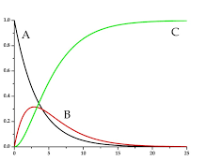

Consecutive Reactions
- In consecutive reactions, the product of one reaction is the reactant of a separate one. For 1st order reactions:
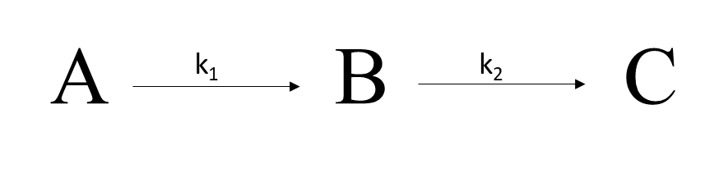

- Since species B and C derive from A, we can assert that:
$${[A]}_{o}={\left[A\right]}_{t}+{\left[B\right]}_{t}+{[C]}_{t}$$
$${[A]}_{t}={[A]}_{o}e^{-k_{1}t}$$
$$\frac{d\left[B\right]}{dt}=k_{1}{\left[A\right]}_{t}-k_{2}{\left[B\right]}_{t}$$
$${\left[B\right]}_{t}=\frac{k_{1}}{k_{2}-k_{1}}\left(e^{-k_{1}t}-e^{-k_{2}t}\right){[A]}_{o}$$
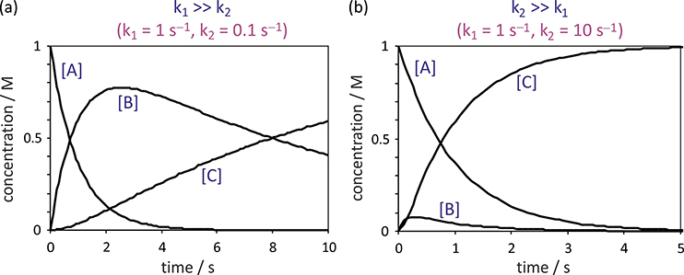

Shown above are plots of concentration vs time. The formation of C is delayed since C can not form until B is formed. The values of k₁ and k₂ affect the relative values of [B] and [C] at equilibrium.

