Kinetic Theory

* Much of gas-phase behavior is modeled by classical physics. The kinetic theory of gases is the basis of all mathematical gas laws. This lecture focuses primarily on the motion of gas molecules.
* Kinetic theory of gases is as follows:
  + 1. A gas consists of molecules in ceaseless, random motion. The molecules collide with each other and with the walls of their container elastically, such that kinetic energy is conserved (frictionless).
    2. The size of gas molecules is considered negligible, such that their average diameters are much smaller that the distances traveled between collisions
    3. Gas molecules do NOT interact and have no significant intermolecular attractions.
  + Based on the assumption that the molecules do not interact, the potential energy of the molecules is independent of their separation, and is thus set equal to zero. Therefore, the total energy of a gas sample is kinetic.

$E_{k}=\frac{3}{2}RT$ (Kinetic theory) (1.34)

* + - The equation above is linear. We see that kinetic energy is a function of temperature. The slope of the plot of Ek vs cT is the gas constant R.

Derivation of the Ideal Gas Law

* + In the image below, a gas particle moving along the forward direction collides with a wall at velocity vi and bounces off in the negative direction at velocity vF. The *magnitudes* of the initial and final velocities are equal (postulate #1 of kinetic theory)

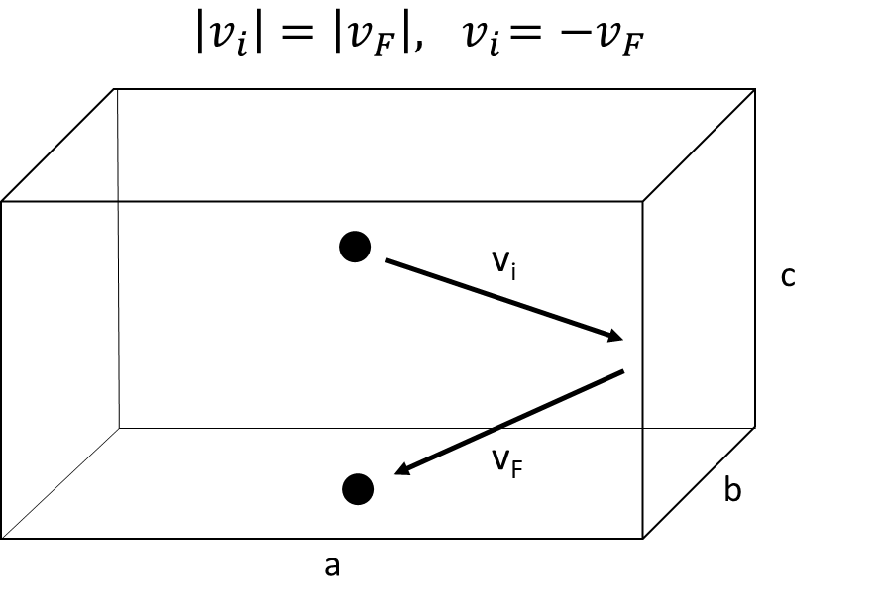

* If the kinetic energy of the particle is given by Ek = ½ mv2, we can describe the 3-dimensional energy by expressing v2 as the sum of the squares of the x, y, and z components of the velocity (recall that velocity is a vector)
 $$v^{2}=v_{x}^{2}+v_{y}^{2}+v_{z}^{2}$$

 + We can see from the figure above that, although the magnitude of v is the same, the sign changes. Therefore, we can calculate the acceleration of the particle:
 $$A=\frac{dv}{dt}$$

 + The force of impact of a single particle on the wall is:
 $$F=m\frac{dv}{dt}$$

 + For a macroscopic sample, N particles collide with the wall during time t. Because of this, the force on the wall varies with time, and is thus described as a function of t. *The average force exerted on the wall is described as*:

$〈F_{avg}〉=N\frac{\sum{F(t)}}{t}=N\left(\frac{1}{t}\right)\int{F\left(t\right) dt}=\frac{N}{t}\int{m\frac{dv}{dt} dt}=\frac{Nm}{t}\int{dv}=\frac{Nm ∆v}{t}$ Eq. 19.1 (19.5)

* + To simplify the expression, we can assume that the particle travels along a one-dimensional path (x-axis). We can analyze the change in velocity in x:
 $$∆v_{ x}={v_{F}}_{x}-{v_{i}}_{x}= 2v_{ x}$$

 + If we select our time period, t, to be the time it takes for a particle to strike the wall, bounce elastically to the other wall, and travel back along the x-direction, then the total distance traveled is 2a.
 $$v_{ x}=\frac{2a}{t}; t=\frac{2a}{v_{x}}$$

 + Plugging our terms for Δv and t into 19.1, and evaluating in the x-axis:

${〈F〉}_{x}=\frac{Nm(2v_{x})}{\left(\frac{2a}{v_{ x}}\right)}=\frac{Nm(v_{x})^{2}}{a}$ Eq. 19.2 (19.7)

* + Since the particle is moving along x, it strikes the wall in the yz plane, which has area bc (refer back to figure). Given that P = F/A:
 $$P_{x}=\frac{\left(\frac{Nm(v_{ x})^{2}}{a}\right)}{bc}=\frac{Nm(v_{x})^{2}}{V}$$

 + The magnitude of the velocity is the same in all directions, so:
 $${v^{2}}_{avg}=v_{x}^{2}+v_{y}^{2}+v_{z}^{2}=3v_{x}^{2}$$

 $$\left(\frac{{v^{2}}_{avg}}{3}\right)=v_{x}^{2}$$

+ Therefore, we can expand our expression for pressure to all dimensions:

$P=\frac{Nmv_{avg}^{2}}{3V}$ Eq. 19.3a (19.8)

* + In terms of kinetic energy:

$$E_{k}=\frac{1}{2}mv^{2} ; 2E_{k}=mv^{2}$$

$P=\frac{2NE_{k}}{3V}$ Eq. 19.3b

$$P=\frac{2N\left(\frac{3}{2}RT\right)}{3V}$$

$PV=\left(n\right)RT$ For macroscopic samples, where n represents mole units of N

$PV=Nk_{B}T$ Applied to the molecular level (kB= R/NA)

Gas velocity distributions

* In terms of molar quantities: $\frac{3}{2}RT=\frac{1}{2}Mv_{avg}^{2}$ where M is the molar mass in SI units (kg/mol). We can express the square root of the average velocity, known as the root mean speed:

$v_{rms}=\sqrt{\frac{3RT}{M}}$ Eq. 19.4 (19.13) *Root mean speed of a gas*

* In chemistry, you often see the term RT in many equations. *This term represents the thermal contributions to the total energy of a system.*
* The probability of a molecule in a system at temperature T having some energy Ei is described by a *Boltzmann distribution*:

$p_{i}=e^{-\frac{E_{i}}{RT}}$ Eq. 19.5 (1.31) *Probability of a species having energy Ei at T*

* \*\*NOT ALL MOLECULES IN A SYSTEM HAVE THE SAME ENERGY!! ENERGY IS NON-UNIFORMLY DISTRIBUTED!! (Statistical mechanics). As T increases, molecules are more likely to have higher energies (for example, the relationship between reaction rate and activation energy is described by this relationship).

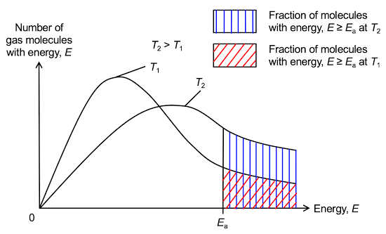

* + In terms of velocities, some molecules in the system are moving slow, until they collide with high-speed particles, at which point, elastic momentum transfer occurs. This complete re-distribution of velocities occurs endlessly on a very short timescale.
  + The probability of a gas having a velocity in the range v+dv, p(v) is given by:

$p\left(v\right)=4π{\left(\frac{M}{2πRT}\right)}^{\frac{3}{2}}v^{2}e^{-\frac{Mv^{2}}{2RT}}$ Eq. 19.6 (19.33) *Maxwell-Boltzmann distribution*

Note: p(v) is a density function with units of s/m. The total probability is the area under the curve of p(v) vs v, calculated by integrating p(v) over the range of velocities, which is unitless.

* + The most probable velocity of a gas is the velocity at which p(v) is a maximum, which is the value of v at which dp(v)/dv = 0:

$v_{most probable}=\sqrt{\frac{2RT}{M}}$ Eq. 19.7 (19.44) *Most probable speed of gas molecule*

* The average velocity is *not* the same as the root mean speed, because v can be positive or negative, whereas v2 can never be negative. The rms is more representative of the actual velocities in the system than the average, although the average velocity is employed in some calculations. The average velocity is given by:

$\overline{v}=\sqrt{\frac{8RT}{πM}}$ Eq. 19.8 (19.36) *Average velocity (not rms)*

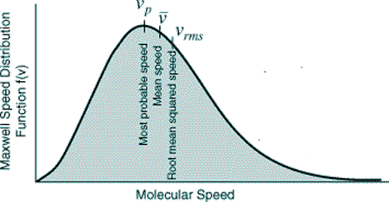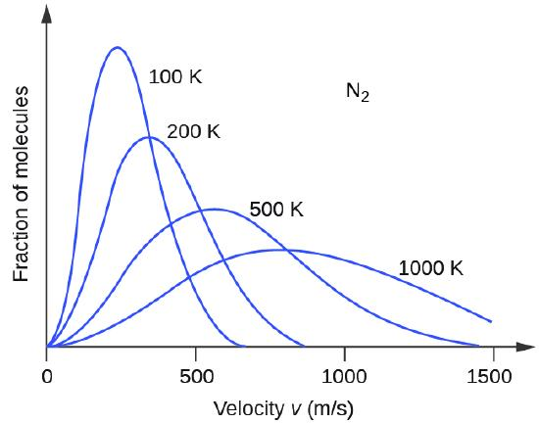

* Class work: Compare the most probable, average, and root mean speeds of H2 at 100oC.

Collision Frequencies

* Consider a particle moving along the x-direction through an area containing other particles. Any particle whose center is within d of the center of the particle will be struck.
* In three dimensions, the particle sweeps out a cylindrical volume with a cross sectional area of πd2.

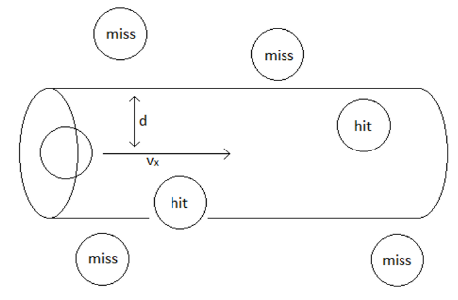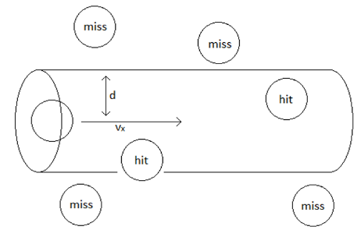

* The distance traveled by the particle between collisions is called the *mean free path, λ*, and depends on particle diameter, as well as the pressure and temperature of the volume element:

$λ=\frac{k_{B}T}{πd^{2}P\sqrt{2}}$ Eq. 19.9 (19.40) *Mean free path of a single gas molecule*

* + By knowing the mean free path, we can estimate the frequency of collision, which is essential to modeling reaction kinetics.
  + The collision frequency, z, defined as the average number of collisions of a particle per unit time, is given by:

$z=\frac{\overline{v}}{λ}=\frac{\sqrt{\frac{8RT}{πM}}}{\left(\frac{k_{B}T}{πd^{2}P\sqrt{2}}\right)}=\frac{\sqrt{\frac{8k_{B}T}{πm}}}{\left(\frac{k_{B}T}{πd^{2}P\sqrt{2}}\right)}=\frac{4πd^{2}P}{\sqrt{πk_{B}mT}}=\frac{4πd^{2}\left(\frac{Nk_{B}T}{V}\right)}{\sqrt{πk_{B}mT}}=\frac{4πd^{2}ρ\sqrt{k_{B}T}}{\sqrt{πm}}$ Eq. 19.10 (19.41)

*Collision frequency*

In the derivation above, the term N/V is set equal to ρ, which represents the density of molecules per unit volume (m-3), m is the mass of a single molecule, and z has typical frequency units (s-1).

* The total number of collisions per second per unit volume is depicted by an uppercase Z:

$Z=\frac{1}{2}zρ$ Eq. 19.11 (Eq. 19.42) *Total collisions per unit volume per unit time*

Note: The term ½ is applied to account for duplicate collisions. For example, when particle A strikes particle B, particle B also strikes particle A. Mathematically, this would correspond to two distinct events, although physically, we recognize this as a single collision.

* Example: pg 684 (ex 19.7)

$For 1 mole: ρ=\frac{N}{V}=\frac{N_{A}}{.02271m^{3}}=\frac{2.65 x 10^{25}}{m^{3}}$

$m=\frac{\left(\frac{.13129 kg}{mol}\right)}{N_{A}}=2.181 x 10^{-25}kg$

$z=\frac{4πd^{2}ρ\sqrt{k_{B}T}}{\sqrt{πm}}=3.94 x {10}^{9}s^{-1}$

$Z=\frac{1}{2}zρ=\frac{5.22 x 10^{34}}{m^{3}s}$

$Total collisions=Z*V=\frac{1.19 x 10^{33}}{s}$

Effusion

* Effusion is the rate of gas leakage out of a porous vessel (ex. A balloon). It is typically a very slow process, but it is affected by particle velocity (and thus, temperature). We define effusion as dN/dt, or the number of particles that pass through a hole of area A in time t. We can say that:

$\left(\frac{dN}{dt}\right)α$ $(\overline{v} )$

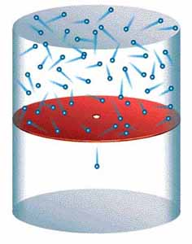

* We know that faster moving particles will escape more quickly out of a system. If we apply the Maxwell-Boltzmann distribution to molecules moving in one-dimension (x):

${f(v)}_{x}=\sqrt{\frac{m}{2πk_{B}T}}{e }^{\frac{-mv_{x}^{2}}{2k_{B}T}}$ Eq. 19.11 (19.32) *One-dimensional speed distribution function*

* + The average velocity is then the integral of the function times the velocity from 0 to ∞, which yields:
 $$\overline{v_{x}}=\sqrt{\frac{k_{B}T}{2πm}}$$

 + We can therefore evaluate the effusion rate of a gas in terms of either density or pressure for molecules escaping through a hole of area A

$\frac{dN}{dt}=Aρ\sqrt{\frac{k_{B}T}{2πm}}$ Eq. 19.12a (19.50) *Effusion rate of a gas as a function of molecular density*

$\frac{dN}{dt}=A\left(\frac{N}{V}\right)\sqrt{\frac{k_{B}T}{2πm}}=A\left(\frac{P}{k_{B}T}\right)\sqrt{\frac{k_{B}T}{2πm}}=AP\sqrt{\frac{1}{2πmk_{B}T}}$ Eq. 19.12b (19.51) *Effusion as a function of P*

* + Graham’s law of effusion allows us to compare the rates of effusion between different gases. In short:

$\left(rate of effusion\right)∝1/\sqrt{M}$ Eq. 19.13 (19.57) *Relative Effusion rates of gases*

* Group problem: 19.56. Then, use Graham’s law to predict the rate at which oxygen gas would effuse from the same container under the same condition.



That is, 2.02×1014 mercury atoms are escaping per second.

$\frac{rate Hg effusion}{rate O_{2} effusion}=\frac{\left(\frac{1}{√200.59}\right)}{\left(\frac{1}{√32}\right)}$ $\frac{2.02 x 10^{14}}{x}=\frac{√32}{√200.59}$ $x=5.05 x 10^{15}s^{-1}$

Diffusion

* Diffusion is the passage of particles from one part of a system to another due to a concentration gradient.

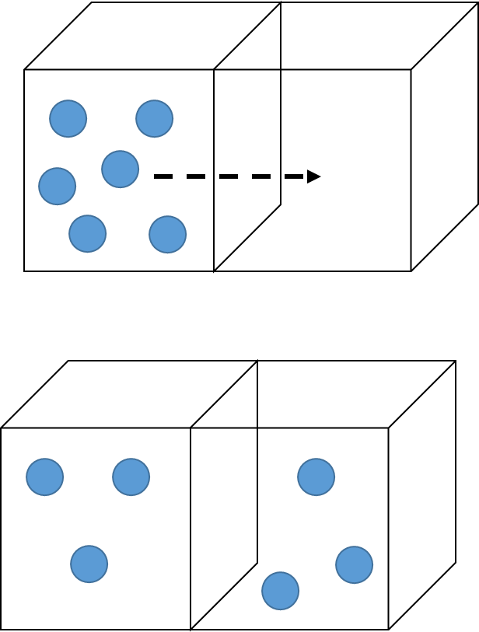

* Diffusion is an example of a transport property, which describes the net movement of matter through a non-uniform medium. Using the image above, let’s consider motion along the x axis through a barrier plane with area A. We can describe the flow of particles by:

$\frac{dN_{1}}{dt}=-DA\frac{dc_{1}}{dx}$ Eq. 19.14 (19.52) *Fick’s first law of diffusion*

* + - In the expression above, D is known as the diffusion coefficient and dc1/dx is the concentration gradient of particles P1 in the x-dimension. The negative sign shows that diffusion occurs in the direction of decreasing concentration. In other words, particles flow from high to low concentration.
    - There are two types of diffusion coefficients: self-diffusion and mutual-diffusion coefficients.
      * Self-diffusion describes a gas diffusing through itself. Mutual diffusion is the diffusion of two different gases into each other.

$D_{sd}=\frac{3}{8d^{2}ρ}\sqrt{\frac{RT}{πM}}$ Eq. 19.15 (19.53) *Self-diffusion coefficient*

$D_{md}=\frac{3}{8}\sqrt{\frac{RT}{2πμ}}\left(\frac{1}{{(r}_{1}+r_{2})^{2}ρ_{tot}}\right)$ Eq. 19.16 (19.54) *Mutual-diffusion coefficient*

In eq 19.16, the value of µ represents the reduced mass of P1 and P2 and ρtot is the total particle density per unit volume.

* As gas particles diffuse, they do not travel in a straight path. During the diffusion process, there are many collision which cause changes in trajectory. However, the particles will eventually end up moving in the direction of lower concentration.
  + This path of motion is called the *random walk*. Einstein determined an expression for the average displacement of a particle due to collisions and mean free paths.
  + While the average displacement in a given dimension is zero due to the equal likelihood of a particle moving in the positive or negative direction, the average of the square of the displacement is not zero because a squared value can never be negative.

$(Δx)_{avg}^{2}=2Dt$ Eq. 19.17a (19.55) *Einstein-Smoluchowski equation in 1D*

$\left(net displacement\right)=6Dt$ Eq. 19.17b (19.56) *In 3 dimensions*

* Example: 19.9 pg 690.
* Group work: 19.67. Referring back to the previous example, what percentage of the total distance traveled is actual displacement from the starting position?