Electrochem

Charge
- Attractive or repulsive interactions between charged species are dictated by the type of charges involved
  - Like charges repel. Opposites attract
  - Magnitude of the interaction is also inversely proportional to the square of the distance between the charges
  - We can express the force of interaction:
$F=\frac{q_{1}q_{2}}{4πε_{o}r^{2}}$ Eq. 8.1 (8.3) Coulomb’s law
      - Here, ε_{o} is the permittivity of free space, 8.854 x 10⁻¹² C²/Jm. This constant relates electrical force to mechanical force.
      - Positive F values correspond to repulsion.
      - Eq. 8.1 applies to vacuum only! If the charges are moving through a medium, a correction called the dielectric constant, ε, is added:
$F=\frac{q_{1}q_{2}}{4πεε_{o}r^{2}}$ Eq. 8.2 (8.4)

- The electric field, E, of some charge q₁ interacting with another q₂ is defined as the ratio of the force between the charges to the charge itself:
$E=\frac{F}{q_{1}}$ Eq. 8.3

  - In this case, E is a vector, since the force is directional. The magnitude of E is the derivative with respect to r of the electric potential, ɸ:
$\left|E\right|=-\frac{∂ϕ}{∂r}$ Eq. 8.4

  - The electric potential represents the energy that the charged particle acquires as it moves through the electric field.
$ϕ=-\int{\left|E\right|} dr= -\int{\frac{F}{q_{1}}dr= -\int{\frac{q_{1}q_{2}}{4πε_{o}r^{2}q_{1}}dr}=\frac{q_{2}}{4πε_{o}r}}$ Eq. 8.5 (8.6) Electrical potential (vac)

    - The units of electrical potential are J/C, which is the SI unit VOLT, V. Thus, ɸ is voltage!

Electrical Work
- dw_{electrical} = ɸ dQ
  - The change in the amount of charge, dQ, moving through a voltage ɸ represents electrical work.
  - Electrical work is performed when charges move. However, during normal chemical reactions, only electrons move around. Protons are localized in the nucleus.
  - The magnitude of the charge of electrons/protons is 1.602 x 10⁻¹⁹ C. This value is known as e.
  - f = eN_{A} = 96, 485 C/mol. This is Faraday’s constant and is the total charge in one mole of electrons.
    - We can define dQ: dQ = fz dn
      - z is the relative charge of an ionic species. (Ex. A sodium ion, Na+, has an excess proton. The absolute charge of the ion is +1.602 x 10⁻¹⁹ C, or 1e. Relative to the value e, the charge would simply be +1) In a process where there is a transfer of charge, the number of species having charge z is changing, so we represent this change with the term dn.
      - For multiple charge particles, the amount of work required to change the number of charged species i is:
${dw}_{electrical}=\sum_{i}{ϕ_{i}z_{i}f{dn}_{i}}$ Eq. 8.6 (8.10)

  - In terms of dG, and using a modified version of the natural variable equation:
$$dG= -SdT+VdP+\sum_{i}{μ_{i}{dn}_{i}}+\sum_{i}{ϕ_{i}z_{i}f{dn}_{i}}$$
- At constant T, P
$dG= \sum_{i}{(μ_{i}+}ϕ_{i}z_{i}f) {dn}_{i}$ Eq. 8.7a (8.12)

  - The term in parentheses is the electrochemical potential of charged species i, µ_{i, EL}

$dG= \sum_{i}{μ_{i, EL}{dn}_{i}}$ Eq. 8.7b (8.15)
At equilibrium, Eq. 8.7b is equal to zero.

Redox
- Because oxidation and reduction must occur together, we can use a Hess’ law approach to evaluate each half reaction individually then sum them.
  - For a species A being oxidized: A A^{z+} + ze⁻
  - For a species B^{n+} being reduced: B^{z+} + ze⁻ B
  - The net reaction is: A + B^{z+} A^{z+} + B
    - Using eq 8.7:

$$0=\left(μ_{A}+ϕ_{A}z_{A}f\right){dn}_{A}+\left(μ_{B^{n+}}+ϕ_{B^{n+}}z_{B^{n+}}f\right){dn}_{B^{n+}}+ \left(μ_{A^{n+}}+ϕ_{A^{n+}}z_{A^{n+}}f\right){dn}_{A^{n+}}+ \left(μ_{B}+ϕ_{B}z_{B}f\right){dn}_{B}$$

- A and B have 0 charge, so z_{A} = z_{B} = 0. The number of electrons being transferred between A and B^{z+} is simply equal to the magnitude of z.
- The stoichiometry is 1:1:1:1. The magnitudes of the dn terms are the same. However, the reactants are disappearing, so the sign of the dn terms for these species is negative.
- Since A is being oxidized, we will call the electrical potential of A ɸ_{oxid}. Conversely, B^{z+} is being reduced, so we will call the electrical potential of B^{z+} ɸ_{red}.

$$0=-\left(μ_{A}\right)-\left(μ_{B^{z+}}+ϕ_{red}(z)f\right)+ \left(μ_{A^{n+}}+ϕ_{oxid}(z)f\right)+ \left(μ_{B}\right)$$

$$zf\left(ϕ_{oxid}-ϕ_{red}\right)= μ_{A^{z+}}+μ_{B}-μ_{A}-μ_{B^{z+}}$$

$$-zf\left(ϕ_{red}-ϕ_{oxid}\right)= μ_{A^{z+}}+μ_{B}-μ_{A}-μ_{B^{z+}}$$

- The right-hand side is the difference between the total chemical potential of the products and the reactants, which is simply $Δ_{rxn}G$. The term inside parentheses on the left is known as the electromotive force (emf), E, which is the driving force of an electrochemical reaction.

$Δ_{rxn}G^{o}=-zfE^{o}$ Eq. 8.8 (8.21)

- As we see, we can relate changes in electrical potential to changes in energy. A positive emf means that the electron transfer is spontaneous. In the equation above, z represents the number of electrons transferred during the redox process.

- As we know, ΔGº represents the max electrical work that can be extracted from the system under standard conditions, but how do we extract this work?
- Consider the spontaneous reaction between elemental zinc and Cu²⁺:
Zn(s) + Cu²⁺(aq) Zn²⁺ + Cu(s) Eº = 1.1V

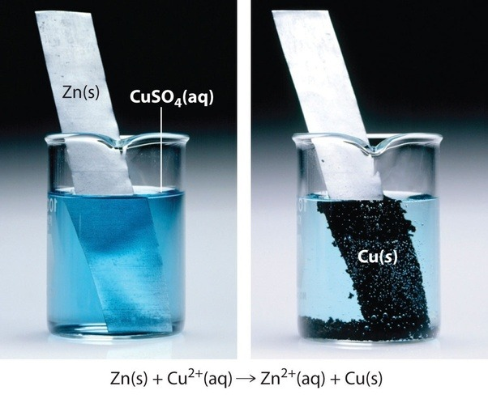
  - In this process, Zn is oxidized via electron transfer to Cu²⁺ is reduced. If we simply drop a sample of Zinc metal into a solution of Cu²⁺(aq), the reaction proceeds spontaneously, and no work is extracted. The image below shows the blue Cu²⁺(aq) ions in solution being reduced to Cu(s) and depositing on the surface of the Zn foil, while the Zn atoms on the surface of the foil are oxidized to the colorless Zn²⁺ which diffuses into solution.
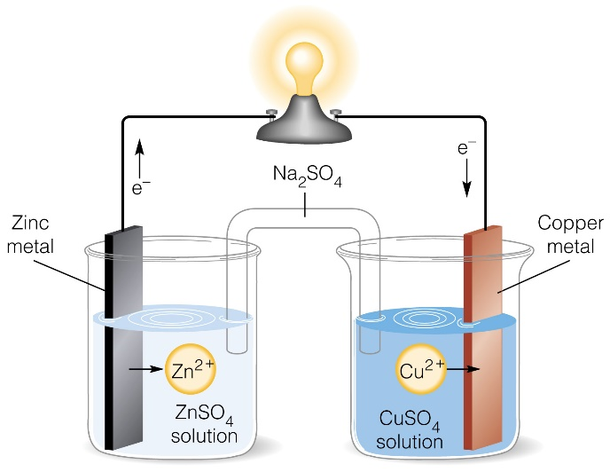
- However, if we physically separate the two half-reactions, we can force the electrons to flow across an external circuit, which enables the electrical work of the electrons to be extracted. This specific reaction, separated into compartments as shown above, is called the Daniel cell.

- As electrons flow from Zn(s) into Cu²⁺, Zn²⁺ is created at the surface of the Zn(s) electrode. Contrastingly, as electrons arrive at the Cu(s) electrode, Cu²⁺(aq) ions in solution are reduced to Cu(s). This elemental Cu will deposit on the surface of the Cu(s) electrode. A salt bridge containing Na₂SO₄ trapped in a gel connects the two solutions electrically. When Zn²⁺ forms in the leftmost cell, the charge of the left side increases by 2. A SO₄²⁻ anion will diffuse from the salt bridge into this compartment. Because this electrode attracts anions, it is called the anode (oxidation occurs at anode). Simultaneously, as Cu²⁺ are pulled out of solution and deposited on the Cu electrode in the rightmost cell, the charge of the right side decreases by 2. Two Na⁺ ions will diffuse into this compartment. Thus, the Cu(s) electrode is called the cathode because it attracts cations (reduction occurs at the cathode).

  - This is the basis of batteries! These types of cells, driven by spontaneous reduction, fall into a class of cells known as galvanic cells. Non-spontaneous reactions, therefore, require external work (current) to proceed. These are called electrolytic cells (ex. Electroplating).
  - The EMF of this process is +1.1V. This means that the potential energy of an electron in the occupied valence orbital of Zn is 1.1V higher than it would be in the unoccupied valence orbital of Cu²⁺. Thus, the electron transfer is favorable (spontaneous).
e⁻ e⁻
Cu²⁺ + 2e⁻ Cu
Zn Zn²⁺ + 2e⁻

Electrical Potential energy, V

Standard potentials
- Similar to U and H, it is impossible to know the absolute potential of a process. We must compare differences in potential from some reference process. The following conventions are used:
- Standard half reactions are written as reductions. To consider an oxidative process, a reduction must be written in reverse with opposite sign of Eº.
- Standard condition: 25ºC, a = 1 bar or 1m for dissolved species
- Standard potentials are relative to the hydrogen reduction reaction, which as a potential set equal to 0 V
2H⁺(aq) + 2e⁻ H₂ Eº = 0.00V

- Eº values are only additive (Hess’s Law) if the electrons cancel! A reaction can be multiplied by some constant to ensure this. Multiplying by a constant DOES NOT change the value of Eº.
  - However, energies such as ΔGº and ΔHº are additive, even if the electrons are unbalanced regardless.

Class Ex. #8.10a end of chapter (use table 8.2)
R: F₂ + 2e⁻ 2F⁻ Eº = +2.866V
O: Co Co²⁺ + 2e⁻ Eº = +0.28
$E_{cell}^{0}=3.146 V$
${∆G}^{o}=-zfE^{o}= -6.07x{10}^{5}J$

Class Ex. #8.18a end of chapter
Class Ex 8.3 in chapter

Nonstandard Reactions
- Real reactions never take place under standard conditions, which requires all reactant and products to be at 1m/1bar at 25ºC.
- Similar to ΔG, we can calculate an instantaneous, nonstandard EMF, E, from Eº.
$$∆G={∆G}^{o}+RT lnQ$$
$$-zfE=-zfE^{o}+RT\ln{Q}$$
$E=E^{o}-\frac{RT}{zf}\ln{Q}$ Eq. 8.9 (8.25) Nernst Equation

Class Ex. 8.4 in chapter

- The Nernst equation is typically used for reactions at 25ºC because Eº varies with T.
$${\left(\frac{∂{∆G}^{0}}{∂T}\right)}_{P}=\frac{∂}{∂T}{(-zfE^{o})}_{P}$$

$$-{∆S}^{o}=-zf{\left(\frac{∂E^{o}}{∂T}\right)}_{P}$$
$\frac{∆S^{o}}{zf}={\left(\frac{∂E^{o}}{∂T}\right)}_{P}$ Eq. 8.10 (8.26) Temperature Coefficient
- The derivative of the standard EMF with respect to temperature is known as the temperature coefficient, which allows you to determine the deviation of the potential from Eº based on the change in T from standard temperature.

Class Ex. #8.5 in chapter
O: (H₂ 2H⁺ + 2e⁻) x 2 Eº = 0 V
R: O₂ + 4H⁺ + 4e⁻ 2H₂O Eº = 1.229 V
$E_{cell}^{o}=1.229V$

$$∆_{rxn}S^{o}=2mol\left(188.83\frac{J}{mol K}\right)-\left[2mol\left(130.68\frac{J}{mol K}\right)-1mol \left(205.14\frac{J}{mol K}\right)\right]= -88.85\frac{J}{K}$$
$\frac{-88.84\frac{J}{K}}{4 mol \left(96485\frac{C}{mol}\right)}=\frac{dE^{o}}{(202 K)}$

$dE^{o}=-0.0465V$
$E=1.183V$

- Eº also varies with P.
  - Most electrochemical cells are based in liquid, so pressure changes have a negligible impact on Eº. However, if a gas phase component exist, pressure changes induce large changes in the volume which alters Eº.
$${\left(\frac{∂{∆G}^{0}}{∂P}\right)}_{T}=\frac{∂}{∂P}{(-zfE^{o})}_{T}$$

$$∆V=-zf{\left(\frac{∂E^{o}}{∂P}\right)}_{T}$$
$-\frac{∆V}{zf}={\left(\frac{∂E^{o}}{∂P}\right)}_{T}$ Eq. 8.11 (8.31) Pressure-dependence on EMF

Equilibrium Constant
- The equilibrium constant of an electrochemical reaction can be calculated from standard values

$${∆G}^{o}=-zfE^{o}$$
$$-RT\ln{K= -zfE^{o}}$$
$E^{o}=\frac{RT}{zf}lnK$ Eq. 8.12 (8.32) Determining the equilibrium constant of a redox reaction

Ionic Solutions
- Ions in solution are not ideal. The presence of oppositely charged ions affects the properties of the solution.
  - The charge of the ion is also significant, as indicated from Coulomb’s law.
    - Zn²⁺ and SO₄²⁻ interact 4x more strongly than Na⁺ and Cl⁻
  - Recall that $μ_{i}=μ_{i}^{o}+RT ln a_{i}$ and $a_{i}= γ_{i}\frac{m_{i}}{m^{o}}$
    - γ is the activity coefficient, which decreases as the molality increases
    - At high concentrations, particles experiences many interactions, which causes the apparent concentration to be much lower than the actual concentration. The activity coefficient corrects for this

- For an ionic solution, we can define the mean ionic activity, $a_{±}$, which is an average of the cation and anion activities:
$a_{±}={\left(γ_{±}*\frac{m_{±}}{m^{o}}\right)}^{n_{±}}$ Eq. 8.13 (8.46) Mean ionic activity
n± = n₊ + n₋ where n represents the coefficients of the cations and anions
m± = ${({m_{+}}^{n_{+} }∙ {m_{-}}^{n_{-} })}^{\frac{1}{n_{+} +{ n}_{-}}}$ m is molality

- Class Ex. 8.9 in chapter
m± = (.2¹ * .6³)^{1/4} = 0.456 m
a± = (0.285 * 0.456m/1m)⁴ = 2.85 x 10⁻⁴ * Solution behaves as if its molality is 700 times lower than it actually is!!!

- Ionic strength, I, is a measure of the total ionic molality of a solution, which is different from activity, which describes the apparent/effective molality. Depending on charge, different ions contribute differently to the ionic molality:
$I=\frac{1}{2}*\sum_{i}{m_{i}z_{i}^{2}}$ Eq. 8.14 (8.47) Ionic Strength

Class Ex. 8.10 in chapter
  - Ionic strength is important because we can use it to derive expressions that are independent of the actual identities of the ions themselves

Debye Huckel Theory (DHT)
- The DHT theory of dilute ionic solutions defines the relationship between activity and ionic strength:
$\ln{γ_{±}}={\left(2πN_{A}ρ_{solv}\right)}^{\frac{1}{2}}{\left(\frac{e^{2}}{4π(ε_{solv})ε_{o}kT}\right)}^{\frac{3}{2}}z_{+}z_{-}I^{1/2}$ Eq. 8.15a (8.50) DHT
  - The expression ${\left(2πN_{A}ρ_{solv}\right)}^{\frac{1}{2}}{\left(\frac{e^{2}}{4π(ε_{solv})ε_{o}kT}\right)}^{\frac{3}{2}}$ is a constant referred to as A. We can simplify this expression by plugging in the standard constants N_{A}, π, ε_{o,} k, e
$A=\frac{132669\sqrt{ρ_{solv}}}{{\left(\left(ε_{solv}\right)T\right)}^{3/2}}$ Units of A: molal^{-1/2}
  - DHT should be used for solutions in which I < 0.04m
  - In DHT, the activity coefficient is always less than one because the product $z_{+}z_{-}$ is always negative, meaning that no ionic solution is ideal. The activity coefficient is also shown to depend very strongly on the solvent!
    - DHT fails at higher molalities because:
      - It assumes ions to be point charges
      - It ignores the enhancement of attractive and repulsive interactions as molality increases
      - It ignores that the density of solvent near an ion differs from that of the bulk due to structural rearrangement of the solvent to make solvation spheres
  - In lieu of average activities, the extended DHT can be used to calculate individual activity coefficients for the anion and cation
$\ln{γ}= \frac{-Az^{2}I^{1/2}}{1+{\left(\frac{e^{2}N_{A}ρ_{solv}}{ε_{solv}ε_{o}kT}\right)}^{1/2}\dot{a} I^{1/2}}$ Eq. 8.15b. (8.52) Extended DHT

    - The term $\dot{a}$ is the diameter of the ion. The term ${\left(\frac{e^{2}N_{A}ρ_{solv}}{ε_{solv}ε_{o}kT}\right)}^{1/2}$is a constant referred to as B. Substituting in the solvent and temperature-independent terms:
$B=1.125 x 10^{10}\sqrt{\frac{ρ_{solv}}{ε_{solv}T}}$ Units: ${molal}^{-1/2}/m$

γ± = ${({γ_{+}}^{n_{+} }∙ {γ_{-}}^{n_{-} })}^{\frac{1}{n_{+} +{ n}_{-}}}$ Eq. 8.15 c. Mean activity coefficient in terms of individual activities

- Class example: Find E for the following reaction at 25ºC:
2Fe(s) + 3Cu²⁺(aq, 0.04m) 2Fe³⁺ (aq, 0.027m) + 3Cu(s)
*Assume that nitrate salts are used as the sources of the metal ions, and that the diameters of Fe(III) and Cu(II) are 9 and 6 angstroms, respectively. The dielectric constant of water is 78.
- Calculate ionic strength of each salt solution
- Use extended DHT to find activity coefficient of each cation
- Plug into expression for Q

Conductance
- Ionic solutions conduct electricity, hence the term “electrolyte”.
  - The conductivity of ionic solutions is due to the movement of both cations and anions, which move in opposite directions. Let’s consider ions moving through some cross-sectional area A. In molar amounts, we recognize that the total charge equals the magnitude of the charge, e, times the moles of ions times z. We define the current, i

$$i= \frac{∂Q}{∂t}=e\left|z_{i}\right|\frac{∂N_{i}}{∂t}$$

- The voltage and current across a conductor are proportional by a value called the resistance, R, according to Ohm’s law:

$V=iR$ Eq. 8.16 (8.62) Ohm’s Law

  - R is reported in units of Ohm. The electrical resistance is a measure of the difficulty to pass current through that conductor. It is, in essence, the electronic analogy of friction.
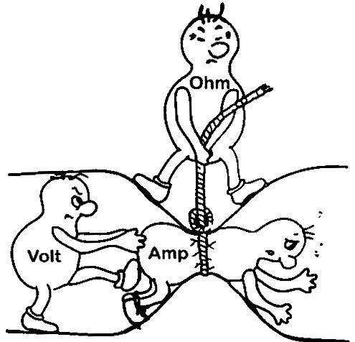

  - Current flowing through a conductor is like water flowing through a pipe, and the voltage drop across the wire is like the pressure drop that pushes water through the pipe.
    - Geometry is important because it is more difficult to push water through a long, narrow pipe than a wide, short pipe. In the same way, a long, thin copper wire has higher resistance (lower conductance) than a short, thick copper wire.
    - Similarly, electrons can flow freely and easily through a copper wire, but cannot flow as easily through a steel wire of the same shape and size, and they essentially cannot flow at all through an insulator like rubber, regardless of its shape. The difference between copper, steel, and rubber is related to their microscopic structure and electron configuration, and is quantified by a property called resistivity, ρ.
- As described, resistance is not an intrinsic property. However, resistivity is.
$ρ=R\frac{A}{l}$ Eq. 8.17 (8.63) Resistivity
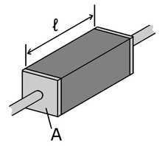

- Electrical resistivity, ρ, is an intrinsic property that quantifies how strongly a given material opposes the flow of electric current. A low resistivity indicates a material that readily allows the flow of electric current. The SI unit of electrical resistivity is the ohm-meter (Ω⋅m).
  - Many resistors and conductors have a uniform cross section with a uniform flow of electric current, and are made of one material.
  - Every material has a characteristic resistivity. For example, all copper wires, irrespective of their shape and size, have approximately the same resistivity. This is not true of resistance.
    - If we are considering an electrolyte solution as opposed to a metal, we can treat the solution itself as a conductor. In this instance, the resistivity will depend on the charges of the ions in solution and the molality.
- The conductivity, which is the inverse of the resistivity, serves as a measure of the ease in which charge flows through a conductor.
$κ=1/ρ$ Eq. 8.18 (8.64) Conductivity

