Supplementary Material
Control of copper resistance and inorganic sulfur metabolism by paralogous regulators in Staphylococcus aureus

Nicholas Grossoehme, Thomas E. Kehl-Fie, Zhen Ma, Keith W. Adams, Darin M. Cowart, Robert A. Scott, Eric P. Skaar, and David P. Giedroc

This file contains Supplementary Methods, Supplementary Results, Table S1-S3, Figures S1-S13.

Supplementary Methods

Cu(I) binding experiments with CsoR and CstR. For CsoR, 250 µL aliquots of 22 µM CsoR monomer in buffer S were prepared in an anaerobic glovebox. Different amounts of CuCl (Sigma, MO) were added to each aliquot and the UV-vis absorption spectrum was taken. The copper concentration was determined by atomic absorption spectroscopy. Absorption at 240 nm was plotted against total Cu concentration. To determine the Cu(I) binding affinity (K_{Cu}) 10 to 15 μM CsoRs were mixed with 50, 250 and 500 μM bathocuprione disulfonate (BCS) in buffer S anaerobically. 20 μM Cu(I) was then added to the mix in a total volume of 250 μL. The mixtures were incubated at ambient temperature (≈22 ºC) for 3 h before the absorption spectrum of each sample was taken. The Cu(I)(BCS)₂ concentration in these samples was determined by comparing the absorbance at 483 nm with 20 μM Cu(I)(BCS)₂ complex in the same buffer. The CsoR-Cu(I) affinity constant which assumes identical and independent sites on the CsoR oligomer (K_{Cu}) was then calculated using the following equation :
Here β₂=10^{19.8} M⁻² is the overall formation constant of Cu(I)(BCS)₂ complex . The average and standard deviation of the binding constants at three different BCS concentrations is reported. The same anaerobic titration protocols carried out the apo-CstR resulted in precipitation of the protein in the absence of BCS, and no observable competition with BCS in the presence of the chelator (data not shown).

Analytical size exclusion chromatography. This was accomplished using Tricorn Superdex75 or Superdex 200 columns (GE Lifesciences). 100 μL of ~50 μM protein (subunit) was loaded and separated at 0.25 mL min⁻¹ in 25 mM Hepes, pH 7.0, 1 mM DTT and 1 M NaCl (for CstR) or 10 mM HEPES, 0.4 M NaCl, 2 mM DTT, pH 7.0 (for CsoR) using fully deoxygenated buffers on an Äkta-10 purifier. The elution profile was monitored by UV absorbance at 220 nm, 260 nm and 280 nm simultaneously.

Sedimentation velocity experiments. These experiments were carried out as described previously on a Beckman model Optima XL-I analytical ultracentrifuge equipped with an An-60 Ti rotor in the Physical Biochemistry Instrumentation Facility at Indiana University. All samples were prepared in buffer 10 mM Hepes, 0.2 M NaCl, pH 7.0 and loaded into centerpieces inside the anaerobic glovebox. 450 µL samples were loaded into a two-channel aluminum centerpiece with 1.2 cm path length. The rotor speed was 60,000 rpm at 20 ºC and intensity data at 230 nm were collected as a function of time. Sample concentrations were 8 µM and 20 µM Sau CsoR monomer (≈0.3 and 0.7 OD₂₃₀ initially). Data were analyzed using Ultrascan software interfaced with a genetic algorithm and Monte Carlo analysis package essentially as described .

Electrophoretic mobility shift assays (EMSA) and fluorescence anisotropy experiments with CsoR. Different amounts of Sau CsoR (1-10 μM monomer) were mixed with 0.5 μM 39 bp DNA centered near the predicted cop operator site (CopO) [5’-CGATTGACTTATATACCTAT AGGGGGTACATTAGACGTG-3’; the pseudo-palindromic inverted repeat and GC-base pairs (see Fig. S9) are highlighted] derived from the 5' untranslated region of the S. aureus copA gene in Buffer S containing 2 mM DTT. For Cu(I)-bound samples, Sau CsoRs were pre-loaded with 1.0 mol equiv Cu(I) before adding to the DNA. After incubating for 30 min at room temperature, the mixtures were loaded onto a 6% TBE polyacrylamide gel (Invitrogen, CA) and run at 120 V for 45 min before staining with ethidium bromide. The gel was then scanned by a Typhoon Imager (GE Healthcare, NJ) in the Physical Biochemistry Instrumentation Facility at Indiana University. Fluorescence anisotropy experiments were carried out with a 5'-fluorescein-labeled copA operator duplex DNA (corresponding to the same sequence shown above) as described previously and analyzed using a non-dissociable two tetramer binding model . A stoichiometry of two tetramers per DNA is consistent with the overall change in anisotropy measured for Sau CsoR relative to other CsoRs and facilitates a quantitative comparison with these CsoRs ; however, we note that this DNA binding model has not been rigorously established for Sau CsoR.

Copper toxicity assay. S. aureus wild-type and ∆csoR were grown for 16 h in 5 mL tryptic soy broth (TSB) at 37 ºC with shaking at 180 RPM. Overnight samples were subcultured into 100 μL RPMI media containing varying concentrations of CuSO₄ added exogenously (0, 31.25 μM, 125 μM, and 500 μM). Samples were incubated at 37 ºC with shaking at 180 RPM and bacterial growth was monitored as a function of optical density (600 nm) over time.

Sulfur utilization assays. For sulfur utilization assays S. aureus strains were grown overnight in 15 mL screw top conical tubes in HHWm media + 0.5 mM L-cysteine at 37˚C shaking at 180 rpm. The overnight culture was back diluted 1/50 into 5 mL of HHWm – cysteine, + indicated alternative sulfur source in 15 mL screw top conical tubes. The cultures were grown at 37˚C shaking at 180 rpm and growth was followed by measuring OD₆₀₀.

Table S1. Cu(I) binding affinities of Sau CsoRs compared to that of other CsoRsª
CsoR | log K_{Cu} | reference
Wild-type Sau | 18.1 ±0.5 | this work
C41A Sau | 15.3 ±0.3 | this work
H66A Sau | 14.5 ±0.1 | this work
Wild-type Mtb | 18.0 ±0.2
H61A Mtb | 14.7 ±0.4
Wild-type Bsu | ≥19.0
ªDetermined using BCS or bicinchoninic acid (BCA) competition experiments essentially as described previously (see Experimental Procedures).

Table S2. X-ray absorption spectroscopy (XAS) fitting parameters for Sau CsoRª.
Sample | Fit | Shell | R_{as} | σ_{as}² | ΔE₀ | f'^{b}
(k range)
 | Fit | Shell | (Å) | (Å²) | (eV)
Sau CsoR, CS08A | 1 | Cu-S₂ | 2.20 | 0.0028 | -5.420 | 0.102
(k=2-13 Å⁻¹) |  | Cu-N₁ | 2.01 | 0.0016 | [-5.420]^{c}
 |  | Cu-C₁ | [2.99] | [0.0032] | [-5.420]
 |  | Cu-C₁ | [3.04] | [0.0033] | [-5.420]
 |  | Cu-N₁ | [4.17] | [0.0020] | [-5.420]
 |  | Cu-C₁ | [4.22] | [0.0020] | [-5.420]
ª Shell is the chemical unit defined for the multiple scattering calculation. Subscripts
denote the number of scatterers per metal. R_{as} is the metal-scatterer distance. σ_{as}² is a
mean square deviation in R_{as}. ΔE₀ is the shift in E₀ for the theoretical scattering
functions.
^{b} f' is a normalized error (chi-squared):
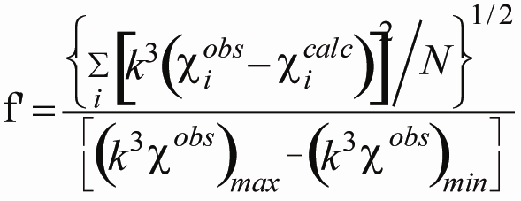
^{c} Numbers in square brackets were constrained to be either a multiple of the above value (σ_{as}²) or to maintain a constant difference from the above value (R_{as}, ΔE₀).

Table S3. Primers used for RT-PCR experiments.
16S rRNA-F |  | GCTGCAGCTAACGCATTAAGCACT
16S rRNA-R |  | TTAAACCACATGCTCCACCGCTTG
CopA RT Left |  | gcattgggacttgctacacc
CopA RT Right |  | Gtgtgcgttcaacaaactcg
Nwmn_0026 RT Left |  | gcaccacctgcacctactatac
Nwmn_0026 RT Right |  | tgaaacctagttccgaaaagtc
Nwmn_0028 RT Left |  | agcgcgaaacaaatgtatga
Nwmn_0028 RT Right |  | ctttaccacaagggcttcca
Nwmn _0029 RT Left |  | tgtgatatatgcaacgccaaa
Nwmn_0029 RT Right |  | ccgtcgatttcaacaaggtt

Fig. S1. Multiple sequence alignment of known and projected Cu(I)-sensing CsoRs from various bacteria compared to Sau CsoR (Newman NWMN_1991). Only the CsoRs from B. subtilis (Bsu) and M. tuberculosis (Mtb) have been biochemically and functionally characterized , although in L. monocytogenes and M. marinum, genes encoding putative CsoRs are adjacent to genes involved in copper homeostasis . Filled orange circles, Cu(I)-coordinating residues; open orange circles, residues important for allosteric switching in CsoRs .
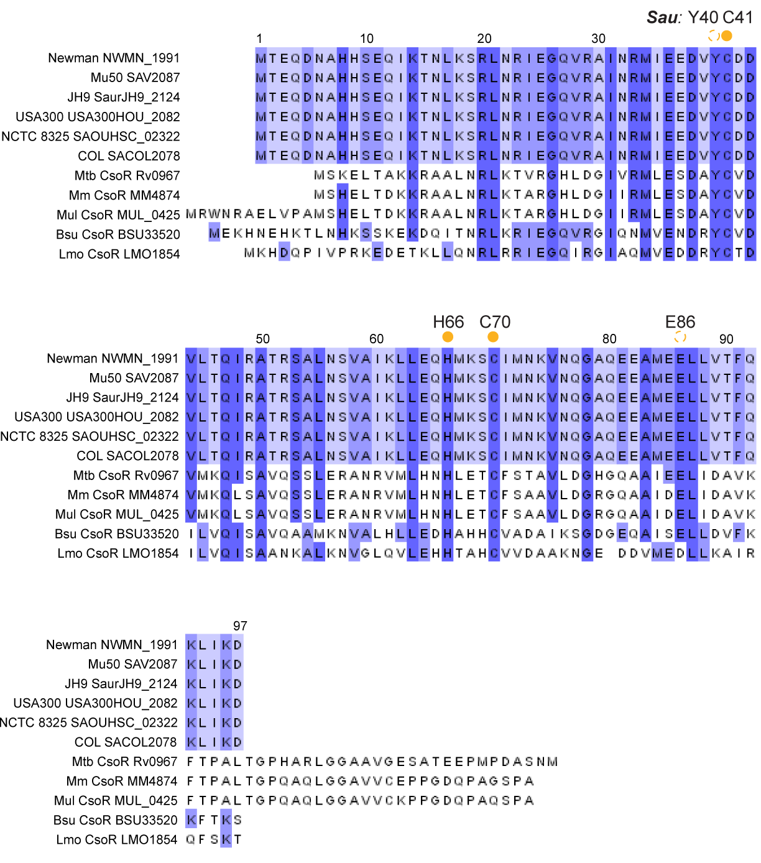

Fig. S2. Sensitivity of S. aureus wild-type and ΔcsoR to the addition of the indicated total CuSO₄ added to the growth medium, carried out as described by Smaldone et al. . *, p<0.05 via two tailed t-test.
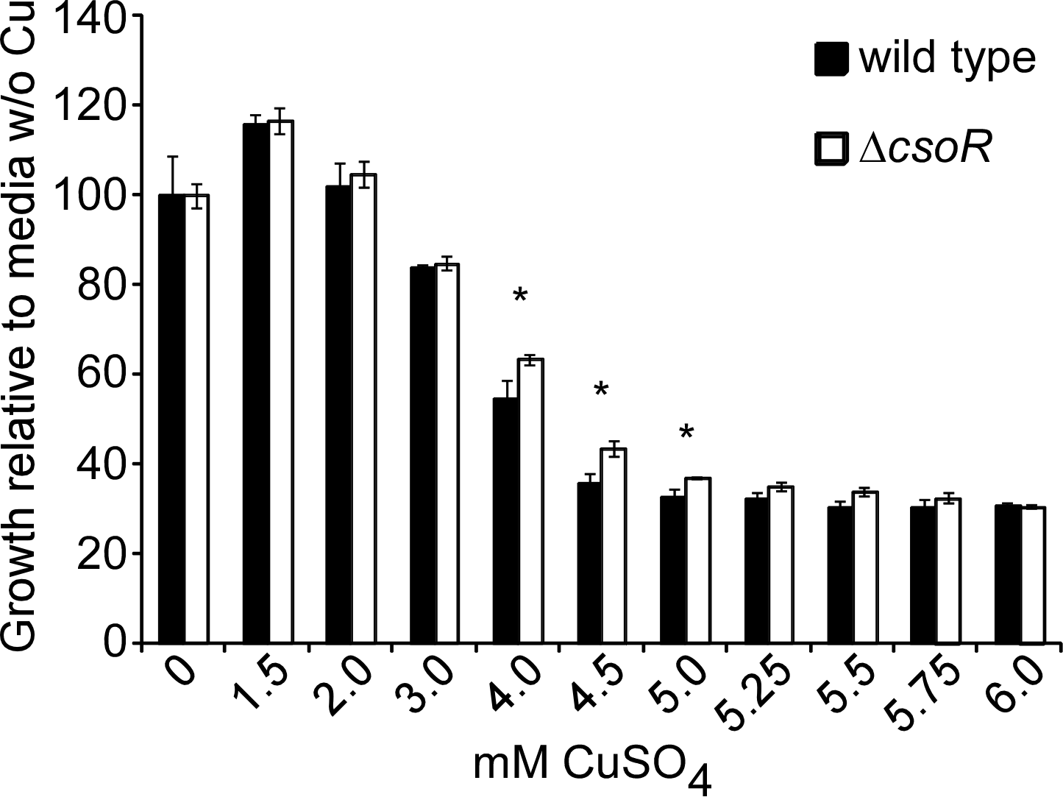

Fig. S3. Sau CsoR binds 1 monomer mol equiv of Cu(I) with high affinity. Apoprotein-subtracted molar absorptivity spectrum of Cu(I):Sau CsoR mixture at 1:1 molar ratio. Inset: the binding isotherm of anaerobic titration of CuCl into 22 μM Sau CsoR monomer. Conditions: 10 mM Hepes, 0.2 M NaCl, pH 7.0.

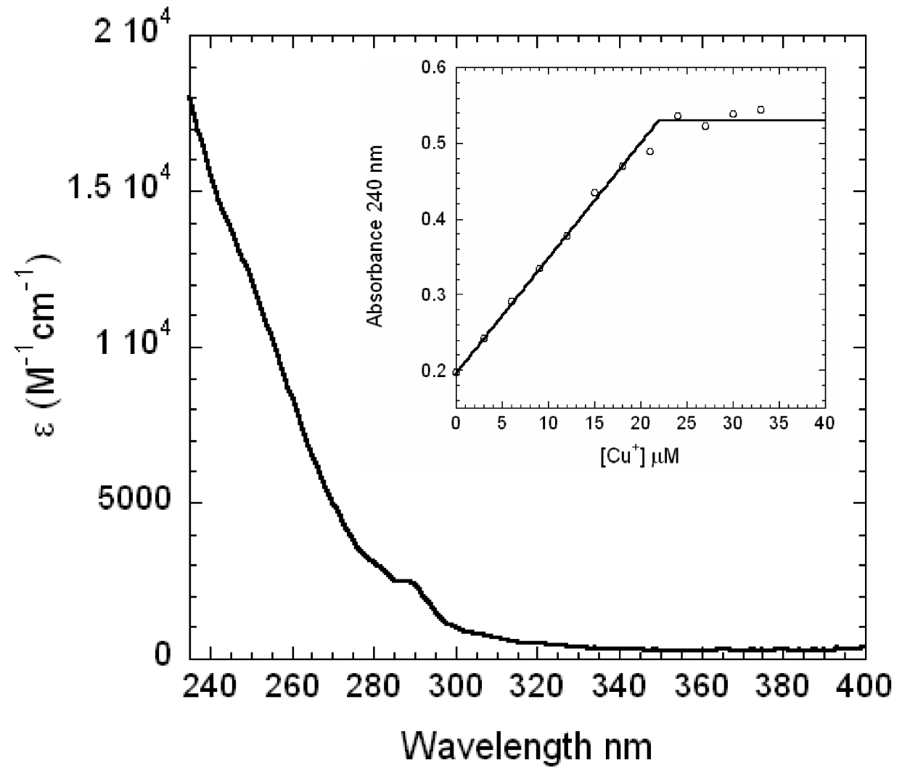
Fig. S4. DNA binding of wild-type Sau CsoR (panels A, B) and H66A and C41A mutants (panel C) in the absence or presence of saturating Cu(I) as monitored by fluorescence anisotropy (panel A) and EMSA (panels B, C). The continuous line drawn through the data in panel A represents a nonlinear least squares fit to a two nondissociable tetramer binding model previously described for other CsoRs with parameters complied in Table 1 (main text). A possible non-specific H66A CsoR-DNA complex may form under the high DNA concentration (0.5 μM) used here as indicated by the arrow in panel C. Conditions: 10 mM Hepes, 0.2 M NaCl, 2 mM DTT, pH 7.0, 25.0 ºC.
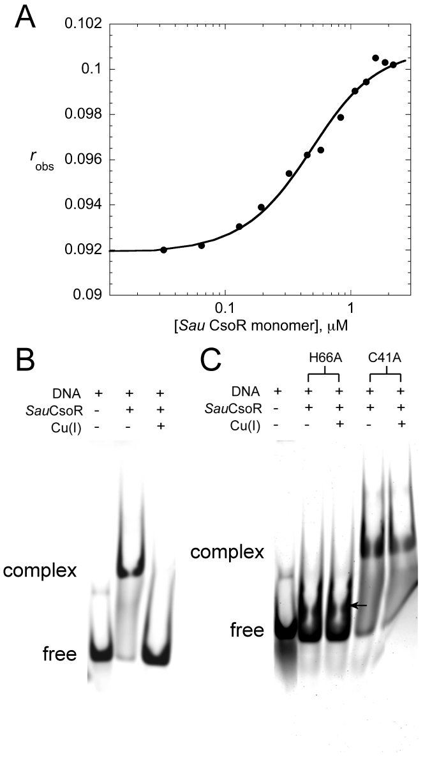

Fig. S5. Locus tag NWMN_0026.5 is a conserved novel CsoR-like protein that lacks requisite features of Cu(I)-sensing CsoR. A, A schematic representation of the W-X-Y-Z fingerprint of individual CsoR/RcnR family repressors. The X-Y-Z region of the fingerprint is defined by the ligands to the Cu(I) ion in Cu(I)-sensing CsoRs, corresponding to Cys36, His61’ and Cys65’ in opposite protomers of M. tuberculosis CsoR (shaded red and blue, respectively) . W corresponds to His3 in E. coli RcnR which must occupy the third position relative to the Met1 αNH₂ group . The invariant Cys in the X position is shaded red. B, Multiple sequence alignment of NWMN_0026.5 with other CsoR-like proteins that conform to the "W-X-Y-Z" x-Cys-x-Cys sequence from Staphylococcal strains and from S. pneumoniae D39. Residues required for the Cu(I)-dependent allosteric switch in Cu(I)-CsoRs but not conserved in this subfamily of CsoRs are italicized . They are Asp30, which is a Tyr is all Cu(I)-sensing CsoRs, Asn56 (His in Cu-CsoRs; Y in the fingerprint) and Asn76 (Glu in Cu-CsoRs) (see Fig. S1).
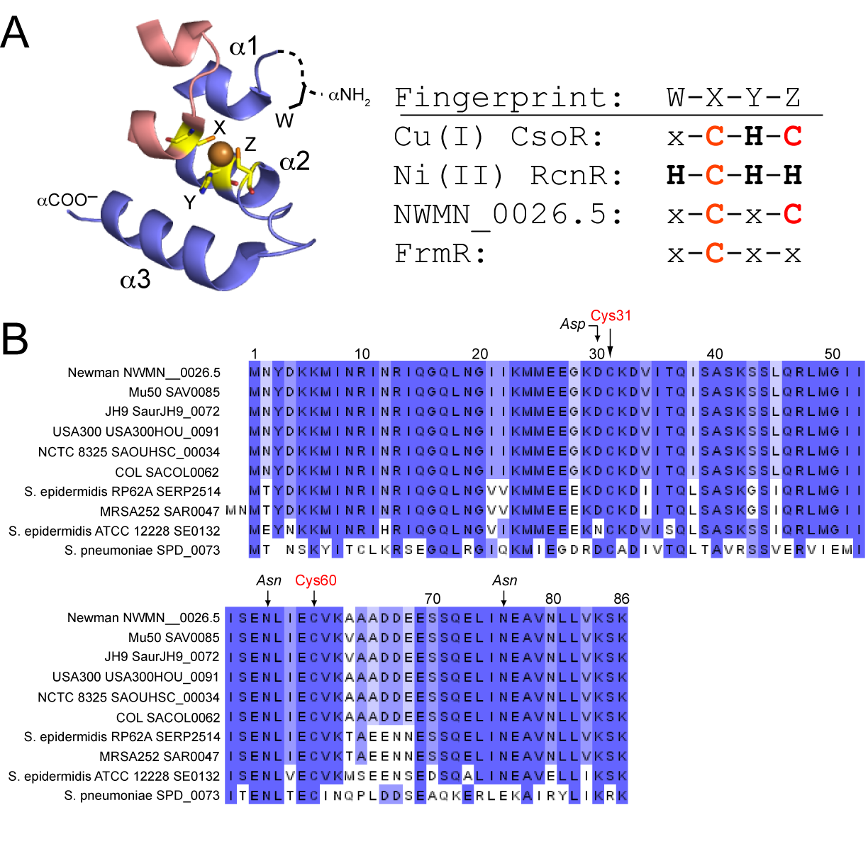

Fig S6. Analytical gel filtration chromatography indicates that reduced CstR exists as a mixture of oligomerization states. 100 μL of 75 μM CstR (monomer) was loaded on a Superdex 75 (GE) column in 20 mM Hepes pH 7.0 and 1 M NaCl with 1 mM DTT. All buffers were thoroughly degassed. Two major peaks with elution volumes of 8.4 (78 kDa) and 13.1 mL (21 kDa) correspond approximately to octameric and dimeric CstR. The black arrow indicates where tetrameric CstR is predicted to elute on this column assuming a spherical particle. The peak observed at V_{c} corresponds to the geometric column volume.

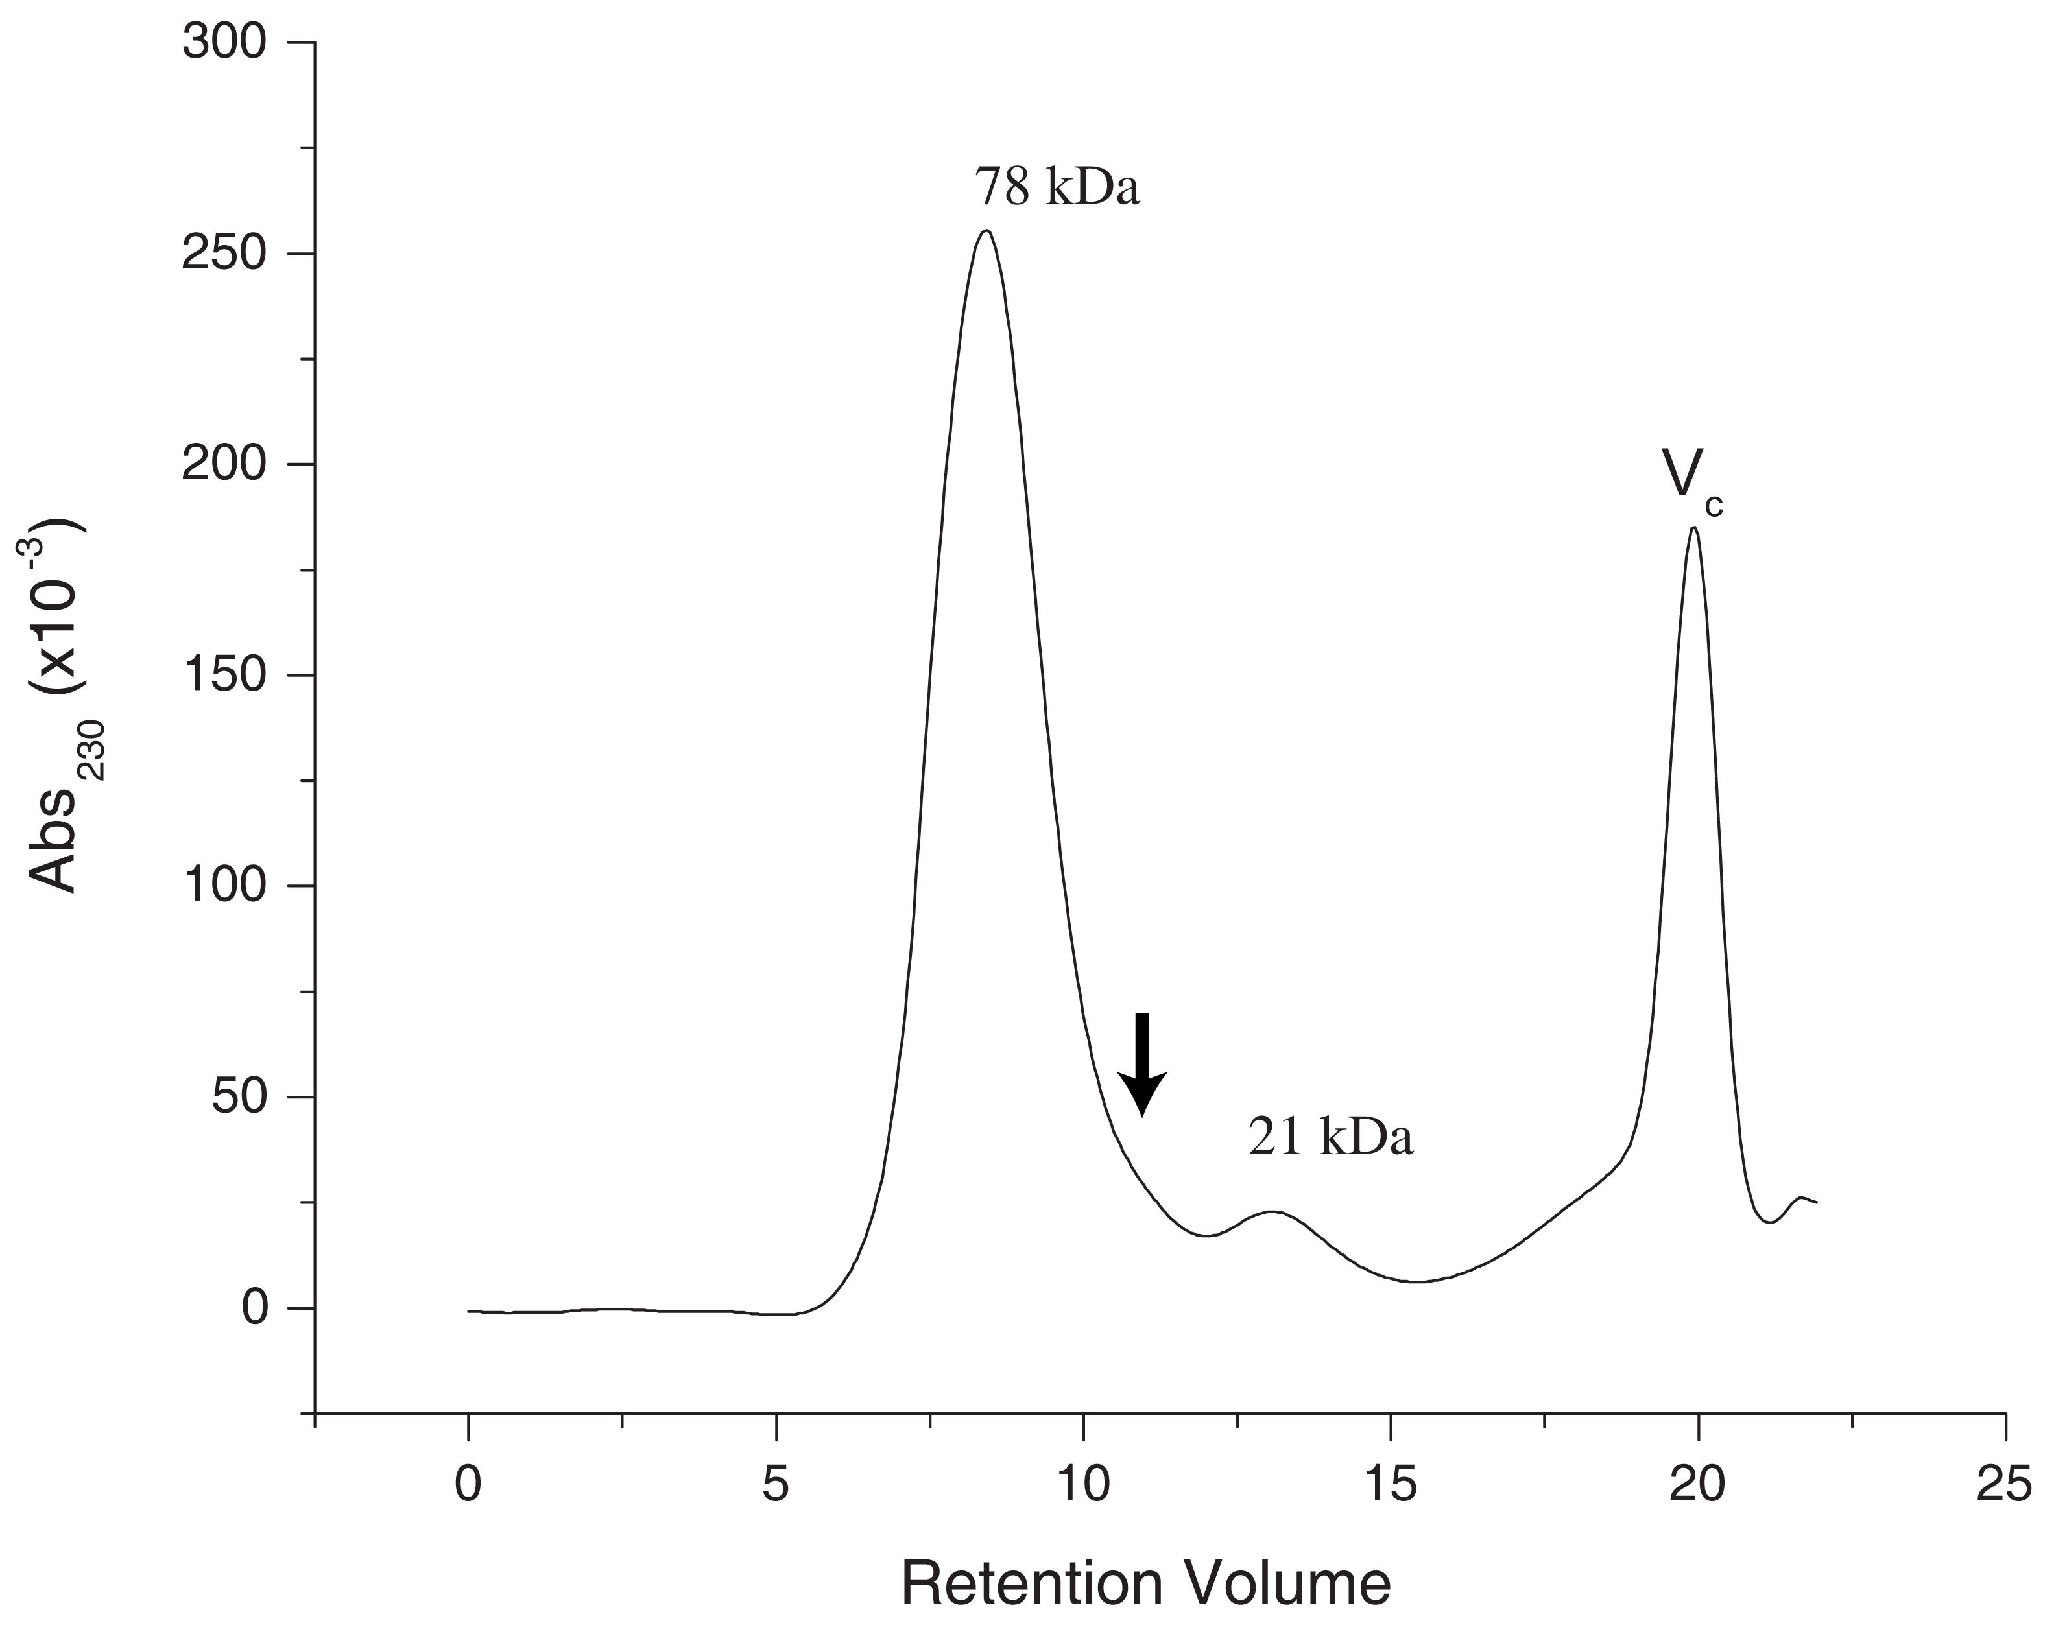

Fig. S7. Model-independent analysis of CstR binding to OP1. To determine the CstR:OP1 stoichiometry and coordination mechanism, a model-independent analysis was carried out. A. In this approach, [CstR] needed to generate an unsaturated CstR-OP1 complex (θ_{i}) is evaluated for two different [OP1] such that the number of ligands (CstR) bound per macromolecule (OP1) can be determined according to Σν_{i} = ([CstR]₂ – [CstR]₁)/ ([OP1]₂ – [OP1]₁) where OP1 = 5 nM (solid squares, ■) and OP2 = 10 nM (open squares, □). B. Repeating this evaluation for multiple θ_{i} values allows a Σν_{i} vs. [CstR] plot to be constructed and fit to a simple 2-site model (solid line) where K₁ = 2.2 ± 0.1 x 10⁷ M⁻¹ and K₂ = 1.5 ± 0.5 x 10⁸ M⁻¹ and Σν_{i} saturates at 2.3 tetramers per OP1. The dashed line is the best fit to a one-site model (one octamer per OP1) where K = 5 ± 1 x10⁸ M⁻¹ and Σν_{i} saturates at 1.13. In both cases, the x-axis was adjusted to number of nondissociable oligomers in each case (tetramers, left; octamers, right) units to enable a direct comparison.
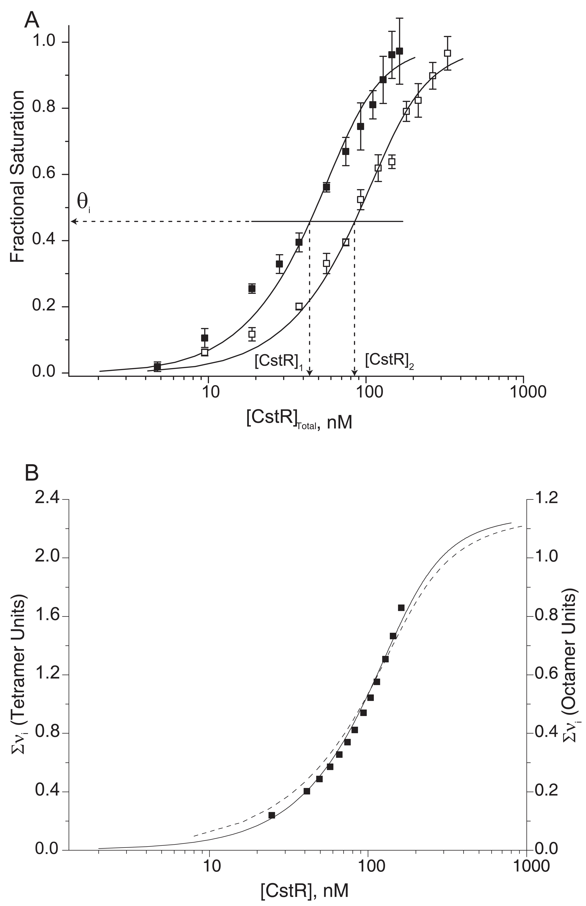

Fig. S8. Fully reduced S. aureus CsoR binds to OP1 (solid squares, ■) with higher affinity than the cognate copA operator sequence cso (open squares, □; reproduced from Fig. S4). The solid lines represent the best fit to the data according to a sequential two tetramer model. Average best fit values are summarized in Table 1 (main text). Conditions: 10 nM DNA, 10 mM Hepes, 0.2 M NaCl, 2 mM DTT, pH 7.0, 25.0 ºC (copA operator); 25 mM Hepes pH 7.0, 0.2 M NaCl, 25 °C (cst OP1). A similar experiment carried out with a non-specific oligonucleotide reveals no change in the anisotropy and thus A₂≤10⁸ M⁻² (data not shown).

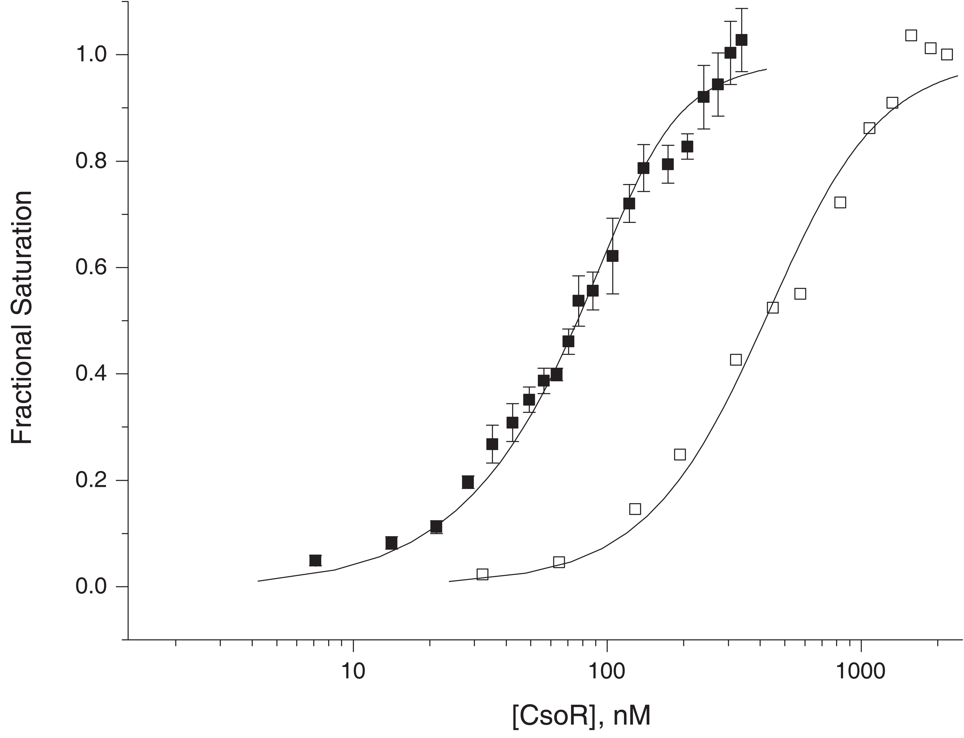
Fig. S9. Sequence comparison of the DNA operators for B. subtilis CsoR (Bsu cop) , S. aureus CsoR (Sau cop) (this work), S. aureus Cst operator-promoter sequences OP1 and OP2 (this work), followed by five M. tuberculosis RicR operators , and a putative operator in front of the csoR (GTNG_1533)-copA (GTNG_1534)-copZ (GTNG_1535) operon from Geobacillus thermodenitrificans (Geobac). A global, multiple sequence alignment of S. aureus CsoR (97 residues), S. aureus CstR (86 residues), B. subtilis CsoR (101 residues), Mtb RicR (96 residues) and Geobacillus CsoR (105 residues) reveals that the Geobacillus CsoR is 55% identical and 82% similar to Mtb RicR and 59% identical and 79% similar to Bsu CsoR. For comparison, S. aureus paralogs CsoR and CstR are 35% identical and 65% similar to one another.
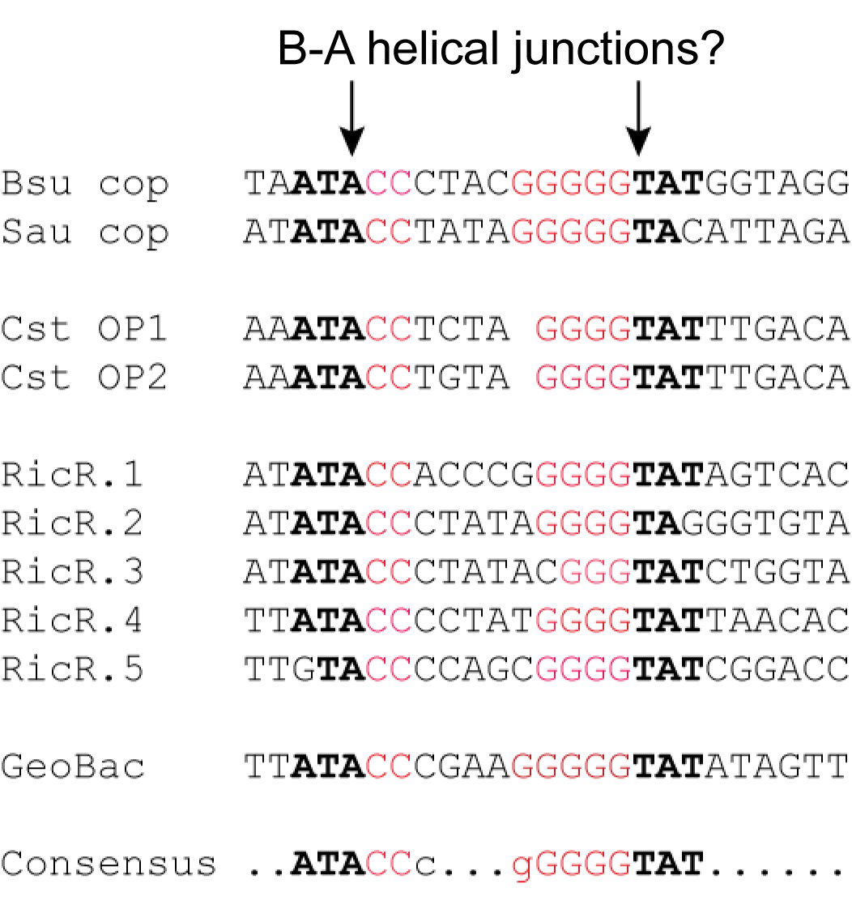
Fig. S10. S. aureus CsoR cysteine modifications result in significantly reduced affinity for OP1. CsoR binding isotherms for the fully reduced (solid squares, ■), Cu(I)-loaded (open squares, □), and MMTS modified (open triangles, Δ) are shown with the best fit to a sequential two tetramer binding model represented by solid lines, with the fitted values complied in Table 1 (main text). The isotherm obtained for Cu(I)-saturated CsoR could not be fit since the data failed to plateau; this is likely indicative of non-specific aggregation of CsoR on the DNA at high protein concentrations. Similar results were obtained with the copA operator DNA (data not shown). This may be related to the unique tendency of S. aureus CsoR to extensively aggregate (see Figs. S12-S13), but was not investigated further.
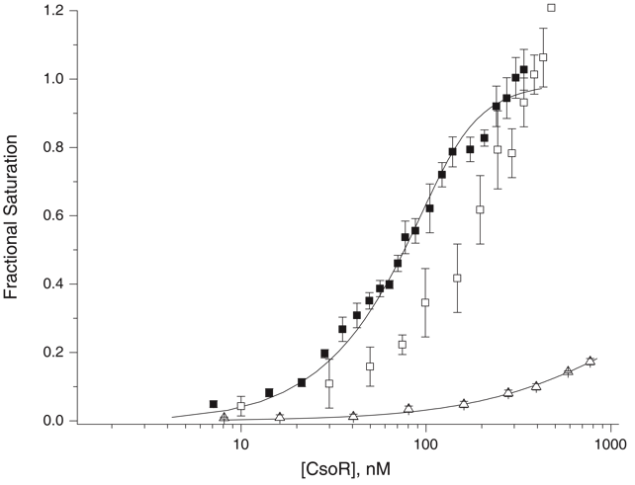
Fig. S11. Microaerobic growth curves of wild-type and ∆cstR S. aureus strain Newman on a chemically defined HHW medium at 37 ºC supplemented with 0.5 mM methionine and the indicated sulfur source (cysteine, thiosulfate, sulfide and sulfite) at 0.5 mM or no additions. These data indicate that thiosulfate supports a rate of growth after an initial lag similar to that of cysteine. They also reveal that the addition of methionine alone does not support growth, consistent with the idea that sulfur for cysteine biosynthesis cannot be obtained from methionine . Moreover, sulfite can not be assimilated as anticipated, and is in fact toxic at high concentrations (data not shown). Both wild-type and ∆cstR strains behave similarly in these assays.
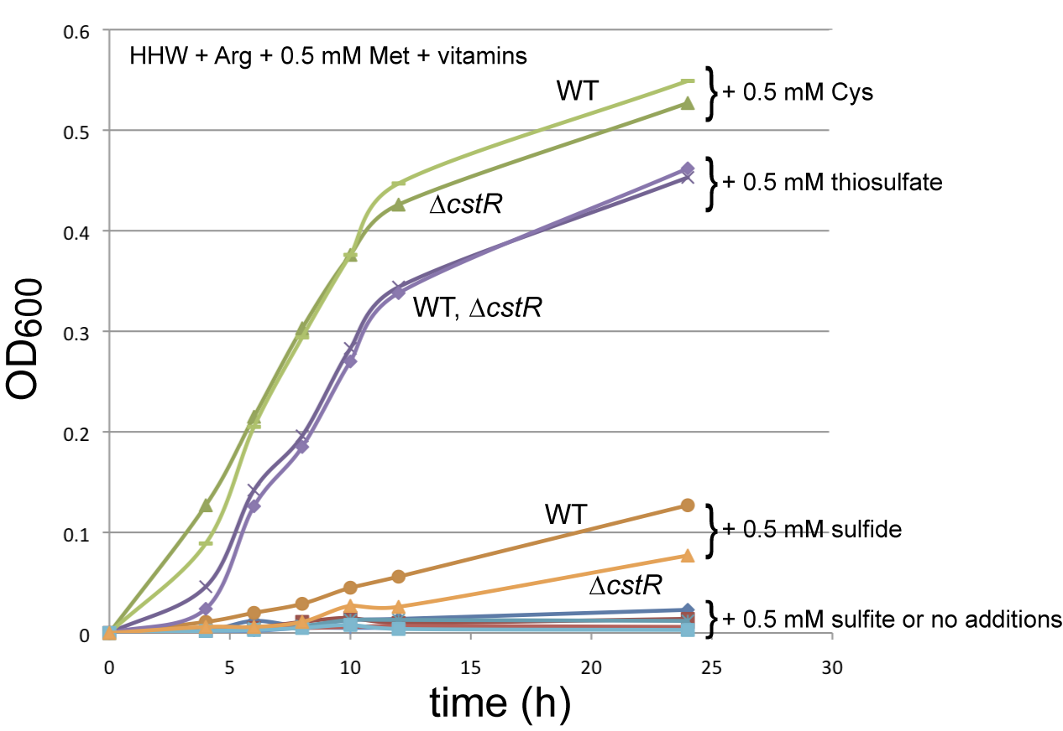

Supplementary Results

CsoR assembly state and DNA binding experiments. Gel filtration chromatography of reduced and metal-free Sau CsoR (10 mM Hepes, pH 7.0, 0.4 M NaCl, 2 mM DTT) reveals a highly asymmetric peak corresponding to a molecular weight in excess of 300 kDa (Fig. S12). This result is unlike that found for previously characterized CsoRs from Mtb and Bsu which either form stable tetramers (Bsu) or exist in a dimer-tetramer equilibrium (Mtb) . Such strong asymmetry suggests that there are multiple CsoR assembly states in the solution beyond that of tetramer. These clear trends towards higher oligomerization states are consistent with sedimentation velocity experiments acquired under the same conditions (20 and 50 µM) which reveal 8- and 16-mer complexes (Fig. S13). The solution conditions- and Cu(I)-dependence of the assembly state of Sau CsoR, as well as the functional relevance, is not yet known.

Fig. S12. Elution profile of 50 μM Sau CsoR monomer from a Superdex G200 column. Conditions: 10 mM Hepes, 0.4 M NaCl, 2 mM DTT, pH 7.0.

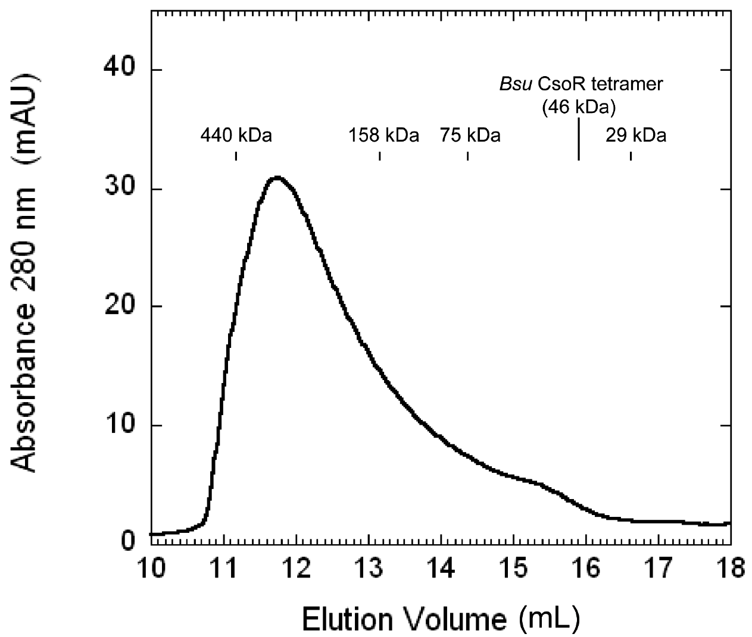
Fig. S13. Analytical sedimentation velocity ultracentrifugation of apo-CsoR from S. aureus compared to apo-CsoR from B. subtilis. Panels A-C represent model independent van Holde-Weischet plots; panels D-F, results of a Monte Carlo-genetic algorithm-based fit of the data, which optimizes values of the frictional coefficient (f/f_{o}) and molecular weight (MW) from the observed distribution of s values. A and D, 50 µM (monomer) Bsu CsoR; panels B and E, 8 µM (monomer) Sau CsoR; panels C and F, 20 µM (monomer) Sau CsoR. T, CsoR tetrameric species; T_{n}, n-mer of the tetramers in the species distribution. As reported earlier, Bsu CsoR is a monodisperse homotetramer of 3.3S at this concentration ; in contrast, Sau CsoR exhibits a propensity to self-associate beyond the tetrameric species even at the lower concentration. See Experimental Procedures (main text) for other details. Conditions: 10 mM Hepes, 0.2 M NaCl, pH 7.0, 20.0 ºC. The functional significance of this self-association behavior of Sau CsoR is unknown.
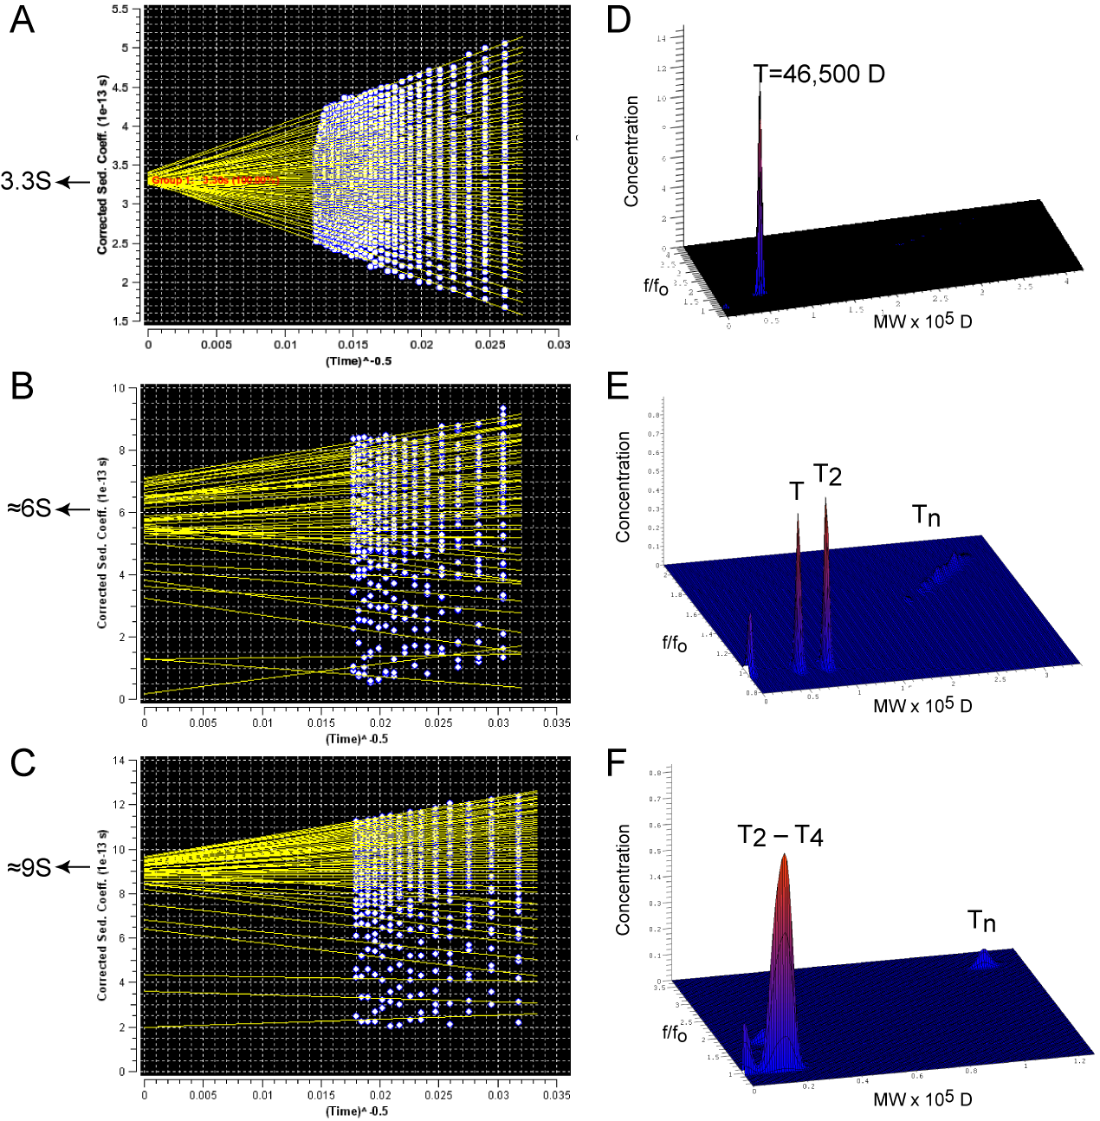

Supplemental Acknowledgement

We acknowledge Dr. Todd Stone in the Physical Biochemistry Instrumentation Facility, Indiana University, for assistance in analyzing the sedimentation velocity data and Justin Luebke for preparation of the chemically defined growth media used for Staphylococcus aureus cultures.

Supplementary References

1. Xiao, Z., Loughlin, F., George, G. N., Howlett, G. J., and Wedd, A. G. (2004) J Am Chem Soc 126, 3081-3090
2. Xue, Y., Davis, A. V., Balakrishnan, G., Stasser, J. P., Staehlin, B. M., Focia, P., Spiro, T. G., Penner-Hahn, J. E., and O'Halloran, T. V. (2008) Nat Chem Biol 4, 107-109
3. Ma, Z., Cowart, D. M., Scott, R. A., and Giedroc, D. P. (2009) Biochemistry 48, 3325-3334
4. Brookes, E., and Demeler, B. (2006) Genetic Algorithm Optimization for Obtaining Accurate Molecular Weight Distributions from Sedimentation Velocity Experiments. in Analytical Ultracentrifugation VIII. pp 33-40
5. Brookes, E., and Demeler, B. (2008) Colloid. Polym. Sci. 286, 139-148
6. Demeler, B., and Brookes, E. (2008) Colloid. Polym. Sci. 286, 129-137
7. Tan, X., Kagiampakis, I., Surovtsev, I. V., Demeler, B., and Lindahl, P. A. (2007) Biochemistry 46, 11606-11613
8. Ma, Z., Cowart, D. M., Ward, B. P., Arnold, R. J., DiMarchi, R. D., Zhang, L., George, G. N., Scott, R. A., and Giedroc, D. P. (2009) J Am Chem Soc 131, 18044-18045
9. Toledo-Arana, A., Merino, N., Vergara-Irigaray, M., Debarbouille, M., Penades, J. R., and Lasa, I. (2005) J Bacteriol 187, 5318-5329
10. Liu, T., Ramesh, A., Ma, Z., Ward, S. K., Zhang, L., George, G. N., Talaat, A. M., Sacchettini, J. C., and Giedroc, D. P. (2007) Nat Chem Biol 3, 60-68
11. Smaldone, G. T., and Helmann, J. D. (2007) Microbiology 153, 4123-4128
12. Iwig, J. S., Leitch, S., Herbst, R. W., Maroney, M. J., and Chivers, P. T. (2008) J Am Chem Soc 130, 7592-7606
13. Festa, R. A., Jones, M. B., Butler-Wu, S., Sinsimer, D., Gerads, R., Bishai, W. R., Peterson, S. N., and Darwin, K. H. (2011) Mol Microbiol 79, 133-148
14. Argyrou, A., and Blanchard, J. S. (2004) Prog Nucleic Acid Res Mol Biol 78, 89-142
15. Lithgow, J. K., Hayhurst, E. J., Cohen, G., Aharonowitz, Y., and Foster, S. J. (2004) J Bacteriol 186, 1579-1590

