Distillation and Gas Chromatography

Introduction
Distillation is a technique often used to purify a liquid, or separate liquid components of a mixture. Essentially, it is the process of converting a liquid (called the distilland) to vapor by heating it to the boiling point and condensing the vapor back to a liquid (called the distillate). If applied to a mixture of liquids, the vapor (and thus the distillate) will be enriched in the more volatile component in the early part of the distillation. If the components of the mixture have sufficiently different boiling points, they can be separated by distillation.
Gas chromatography (GC) is a method of analysis that separates the components of a mixture based on their relative boiling points. A sample is vaporized and carried through a column containing a liquid stationary phase by a gaseous mobile phase (usually He). For most GC analyses, partitioning between the stationary liquid phase and the gaseous mobile phase is based on the boiling point of the material (more volatile materials move faster through the column), and therefore the separation of a mixture by GC is usually based on the relative boiling points of the components. Lower boiling compounds generally travel through the column faster than higher boiling compounds. Thus, lower boiling compounds generally have lower retention times than higher boiling compounds.
In this experiment, you will be assigned an unknown mixture, which will consist of two liquids from the following table:
Compound | Boiling Point
Hexane | 69.0 °C
Cyclohexane | 80.7 °C
Heptane | 98.4 °C
Toluene | 110.6 °C
Ethylbenzene | 136.0 °C
You will separate the mixture by both simple and fractional distillation, and in the process, determine the boiling point of each component in your unknown mixture. In addition, you will analyze distillate samples at the beginning and the end of the distillation by gas chromatography. Using this data, you will determine the identity of the components of your unknown mixture, and comment on the effectiveness of each distillation technique.

Required Reading:
Padías:
Distillation (pp. 182 – 195, 208-221)
Gas Chromatography (pp. 244 – 255)
Special Safety Notes:

- The unknown samples are mixtures of flammable solvents. Keep away from spark sources and open flames.
- Do not distill to dryness! A dry flask may crack if heated to hot.
- The steel wool used as the column packing can cut into skin. Handle with care.
- Use a boiling chip when heating liquids to prevent “bumping”
- Injector ports on a gas chromatograph are hot! Avoid contact with the GC injector ports.

Procedure:
Simple and Fractional Distillation of the Unknown Mixture
NOTE: This laboratory is to be done in groups. Each group will be assigned an unknown sample, and half the group will perform the simple distillation, and the other half will perform the fractional distillation. Students must share their procedure, observations, and data will all members of the group. Each student is then required to write an individual lab report.
Assemble the appropriate distillation apparatus (simple or fractional) using a 10-mL round bottom flask, distillation column (for fractional distillation only), distillation head, thermometer adapter, thermometer, and condenser as shown in the figures below. Be sure to note the position of the thermometer. The top of the bulb should be even with a line formed by the bottom of the side arm of the distillation head. Place a boiling chip in the round bottom flask and add 7.0 mL of the unknown mixture. Turn on the cooling water to the condenser, and using the hotplate and an aluminum heating block, heat the mixture to a boil. The hot vapors will begin to heat the glassware, and you should begin to see a “reflux ring” of condensing vapors begin to rise slowly into the distillation head. When the “reflux ring” reaches the thermometer bulb, you will see a rapid rise in temperature up to the boiling point of the distillate. The vapor will condense in the condenser, and you will see drops of distillate falling into the graduated cylinder. Adjust the heat control so that the rate of distillation is about 1 drop every 4 – 5 seconds. Beginning with the first 0.5 mL of distillate, record the vapor temperature at every 0.5-mL interval, using the graduated cylinder to measure the volume.
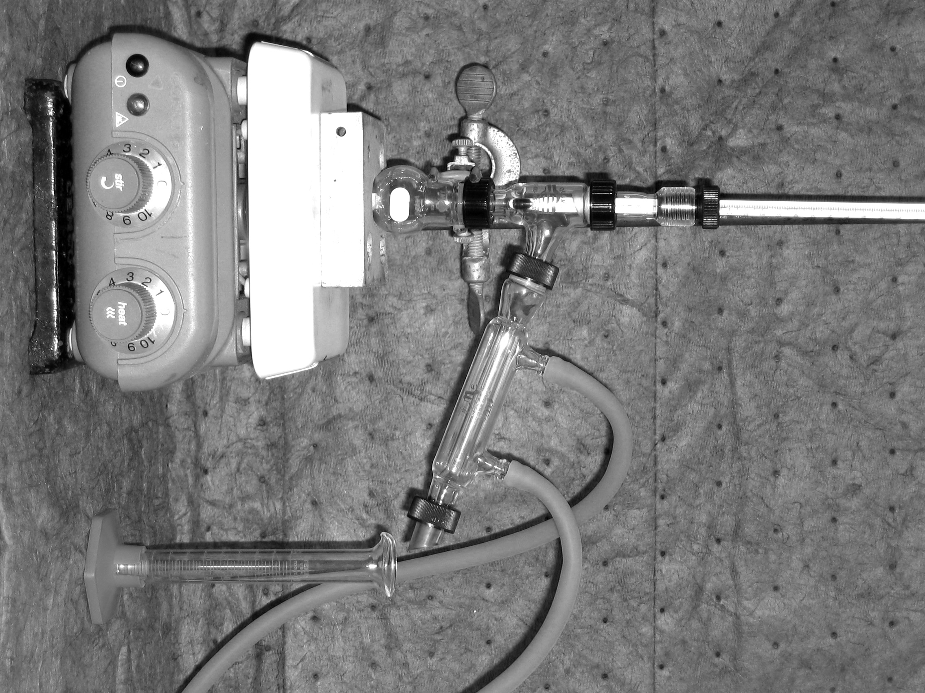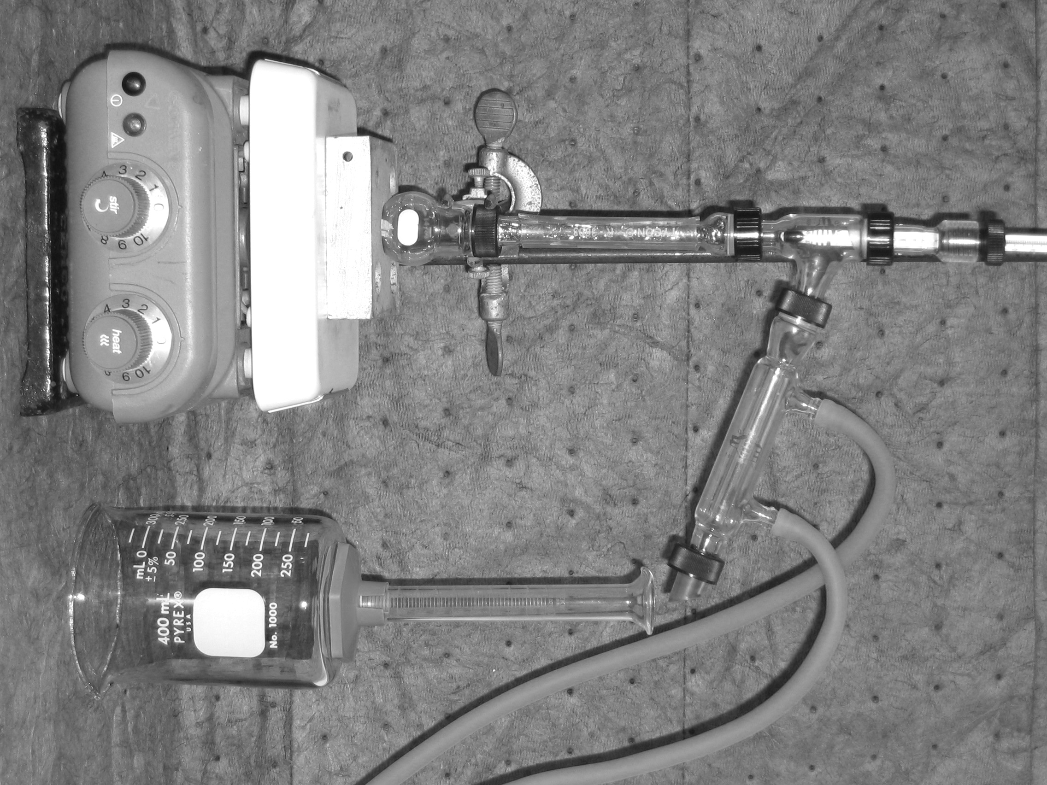
Simple Distillation Fractional Distillation

When you have collected 1.0 mL of distillate, transfer this liquid into a “snap cap” vial and label the vial with your names, section number, and “Initial Sample.” After you have collected a total of 4.5 mL of distillate, replace the graduated cylinder with a clean, dry conical vial and collect the remainder of the distillate (until about 0.5 mL is left in the distillation flask). Continue to record the vapor temperature after each 0.5-mL interval. Transfer this liquid into a “snap cap” vial and label the vial with your names, section number, and “Final Sample.”
Gas Chromatography
Inject 1 μL of sample into the gas chromatograph (your instructor will demonstrate). Depending on the effectiveness of the distillation, you may see either one or two peaks. Your instructor will provide you with a reference chromatogram to help you identify the components of your unknown by their retention time. Integrate the chromatogram to get the peak areas (your instructor will demonstrate the use of the software).
Since the detector response is different for different compounds, the peak areas from the chromatogram must be corrected by a response factor before quantifying the composition of your sample. To correct your peak areas, divide the peak area from the chromatogram by the appropriate response factor. Typical response factors for the possible components are as follows: hexane (1.50), cyclohexane (1.80), heptane (1.63), toluene (1.41), ethylbenzene (1.00).
Distillation and Gas Chromatography: Pre-Lab Worksheet

1. What is the purpose of this experiment?

2. Look up the structures and MSDS’s for the compounds used in this experiment (at the Fisher scientific website, for example) and complete the following table:

Compound | Structure/Formula | LD₅₀ | Flash Point | Corrosive?
Hexane
Octane

3. Look up the physical properties for the compounds used in this experiment (at the Fisher scientific website, for example) and complete the following table:

Compound | Molecular Weight | Melting Point | Boiling Point | Density
Hexane
Octane

4. What are the differences between doing a simple versus a fractional distillation in terms of the purification of a mixture?

5. Sketch the apparatus set-up showing all glassware for both a simple and fraction distillation, what are the differences?

Distillation and Gas Chromatography: Post-Lab Worksheet

Include a table that shows temperature versus amount of distillate collected for each distillation.

1. Unknown letter: _________________

Distillation Data

2. Temperature Range for Component One (SD): ______________

3. Suggested Identity for Component One (SD): ________________________________
4. Temperature Range for Component Two (SD): _______________

5. Suggested Identity for Component Two (SD): ________________________________

6. Temperature Range for Component One (FD): ______________

7. Suggested Identity for Component One (FD): ________________________________
8. Temperature Range for Component Two (FD): _______________

9. Suggested Identity for Component Two (FD): ________________________________

Gas Chromatography Data - Simple

10. Retention Time for 1st Component Peak in first aliquot (SD): ___________________

11. Retention Time for 2nd Component Peak in first aliquot (SD): ___________________

12. Area of 1st Component Peak in first aliquot (SD): ____________________

13. Area of 2nd Component Peak in first aliquot (SD): ____________________

14. Percent Composition for 1st Component Peak in first aliquot (SD):________________
(show calculation)

15. Percent Composition for 2nd Component Peak in first aliquot (SD):________________
(show calculation)

16. Retention Time for 1st Component in second aliquot (SD): ___________________

17. Retention Time for 2nd Component in second aliquot (SD): ___________________

18. Area of 1st Component Peak in second aliquot (SD): ____________________

19. Area of 2nd Component Peak in second aliquot (SD): ____________________

20. Percent Composition for 1st Component Peak in second aliquot (SD):________________
(show calculation)

21. Percent Composition for 2nd Component Peak in second aliquot (SD):________________
(show calculation)

Gas Chromatography Data - Fractional

22. Retention Time for 1st Component Peak in first aliquot (FD): ___________________

23. Retention Time for 2nd Component Peak in first aliquot (FD): ___________________

24. Area of 1st Component Peak in first aliquot (FD): ____________________

25. Area of 2nd Component Peak in first aliquot (FD): ____________________

26. Percent Composition for 1st Component Peak in first aliquot (FD):________________
(show calculation)

27. Percent Composition for 2nd Component Peak in first aliquot (FD):________________
(show calculation)

28. Retention Time for 1st Component in second aliquot (FD): ___________________

29. Retention Time for 2nd Component in second aliquot (FD): ___________________

30. Area of 1st Component Peak in second aliquot (FD): ____________________

31. Area of 2nd Component Peak in second aliquot (SD): ____________________

32. Percent Composition for 1st Component Peak in second aliquot (SD):________________
(show calculation)

33. Percent Composition for 2nd Component Peak in second aliquot (SD):________________
(show calculation)
Questions

8. Predict the order of increasing retention time for the following four compounds:
Hexane, Octane, Heptane, 2-Methylpentane
How is this order determined?

9. Which distillation produced a better separation of components, justify your answer with your data?

10. Plot the volume of liquid collected (x-axis) versus the temperature for each distillation?

