**Name: ______Justin Arthur Student__________ Date: ___**08/28/2014**___ Exp. #:** JAS-14**_**

**Title: _______Preparation of N,N-Diethyl-m-toluamide (DEET)** ____________________________

**Purpose: _____ *To prepare N,N-diethyl-m-toluamide (DEET) and characterize it by IR and ____________* _**

**__________________proton NMR spectroscopy**______________________________________________________

**Chemical & Safety Data:**

|  |  |  |  |  |  |  |
| --- | --- | --- | --- | --- | --- | --- |
| **Substance** | **Structure** | **MW (g/mol)** | **m.p. (oC)** | **b.p. (oC)** | **Density (g/mL)** | **Role** |
| **Name:** *m-Toluic Acid* | MTA | *136.15* | *108-112* | *236* | 1.05 | Reactant |
| **Formula:** *C8H8O2* | **Safety:** *Causes eye, skin, & respiratory tract irritation* | | | | |
| **Name:** *Thionyl Chloride* | N/A | 118.97 | -105 | 76 | 1.63 | Reactant |
| **-Formula:** *SOCl2* | **Safety:** *May be fatal if inhaled. Causes burns by all exposure routes. Water-reactive. Contact with water liberates toxic gas. Lachrymator.* | | | | |
| **Name:** *Diethylamine* | (CH3CH2)2NH | 73.13 | -50 | 55 | 0.7 | Reactant |
| **Formula:** *C4H11N* | **Safety:** *Harmful if absorbed through the skin. Causes eye & skin burns. Causes digestive and respiratory tract burns. Extremely flammable.* | | | | |
| **Name:** *Diethyl Ether* | (CH3CH2)2O | 74.12 | -116 | 35 | 0.7 | Solvent |
| **Formula:** *C4H10O* | **Safety:** *Extremely flammable. May form explosive peroxides. Irritating to eyes, skin and respiratory tract. Vapors may cause drowsiness & dizziness.* | | | | |
| **Name:** *Sodium sulfate* | N/A | N/A | N/A | N/A | N/A | Drying Agent |
| **Formula:** *Na2SO4* | **Safety:** *Possible irritant.* | | | | |
| **Name:** Sodium Hydroxide, 10% aq | N/A | N/A | N/A | N/A | N/A | Aqueous Auxiliary |
| **Formula:** NaOH | **Safety:** *Corrosive. Causes eye & skin burns. Causes respiratory tract burns.* | | | | |
| **Name:** Hydrochloric Acid, 10% aq | N/A | N/A | N/A | N/A | N/A | Aqueous Auxiliary |
| **Formula:** HCl | **Safety:** *Causes eye, skin, and respiratory tract burns. Corrosive.* | | | | |
| **Name:** Alumina | N/A | N/A | N/A | N/A | N/A | Adsorbent |
| **Formula:** Al2O3 | **Safety:** *May cause respiratory tract irritation. May cause lung damage. May cause mechanical eye & skin irritation.* | | | | |
| **Name:** *N,N*-Diethyl-*m*-toluamide | DEET | 191.27 | N/A | 111 | 0.996 | Product |
| **Formula:** C12H17NO | **Safety:** *Irritant.* | | | | |

1. The apparatus below was assembled, flame-dried, and vented into the hood! (NOTE: Apparatus must be dry!)

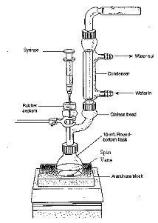

2. 0.275 g (0.0020 mol) of m-toluic acid was added to the reaction flask.

3. In a HOOD(!),0.30 mL (0.489 g, 0.0041 mol) of thionyl chloride was added via syringe.

4. Circulation of water through the reflux condenser was started, then the reaction was heated gently until the mixture began to boil.

5. The mixture was refluxed gently for 20 min, then cooled to room temperature (took about 10 min).

6. Using the syringe, add 4.3 mL anhydrous ether was added to the mixture and it was stirred until a solution was obtained.

7. A solution of 0.70 mL (0.49 g, 0.0067 mol) of ice-cold diethylamine in 1.5 mL of anhydrous diethyl ether was added to the reaction mixture dropwise via syringe over about 15 min. During the addition, a thick white cloud formed over the reaction mixture.

8. After complete addition, the reaction mixture was stirred for 10 min at room temperature.

9. 2.4 mL 10% NaOH (via syringe) was added, and the mixture was stirred for 15 min at room temperature.

10. The mixture was transferred to a separatory funnel and the aqueous (bottom) layer was discarded.

11. The organic layer was washed with 2 mL 10% NaOH, followed by washing with 2 mL 10% HCl. Discard aqueous (bottom) layer.

12. The organic layer was dried over sodium sulfate, then decanted into a small conical vial and evaporated over low heat (setting = 3).

13. The crude, brown liquid product from step 12 was filtered through 1.0 g alumina in a Pasteur pipet column using hexane (5 – 7 mL) as the eluent, and the hexane solution was collected in a small tared beaker (Tare wt = 31.873 g).

14. The hexane solution was evaporated on a hot plate over low heat (setting = 3) to afford a pale yellow oil.

Beaker + DEET = 32.213 g

Wt DEET = 0.340 g

15. An IR (thin film) and proton NMR (CDCl3) spectra were obtained.

**Preparation of *N,N*-Diethyl-*m*-toluamide (DEET) and its Identification by IR and NMR Spectroscopy**

Justin Arthur Student

CHEM 304

September 8, 2014

**INTRODUCTION**

*N,N*-Diethyl-*m*-toluamide (DEET) is the active ingredient in many insect repellants.1 In this experiment, DEET will be prepared from *m*-toluic acid through the intermediate acid chloride and then identified by its IR and proton NMR spectra. The overall reaction is a series of two acyl substitutions and is shown in Scheme 1 below:

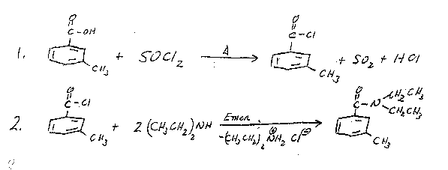

**Scheme 1**

Carboxylic acids can be converted to acid chlorides by treatment with a compound such as phosphorus trichloride (PCl3) or thionyl chloride (SOCl2).2 The reactive acid chloride can then be treated with a primary or secondary amine to give the amide along with HCl, which reacts with the excess amine to give an alkylammonium chloride salt. The mechanism of this process is shown on the following page in Scheme 22:

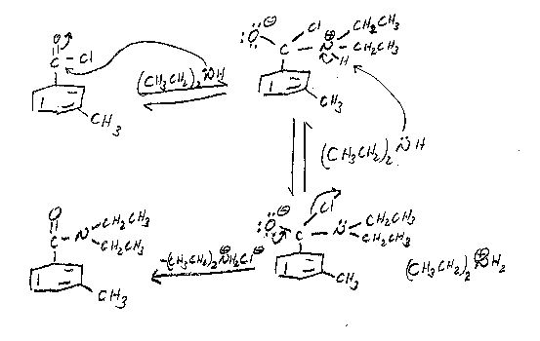

**Scheme 2**

To carry out this reaction, the apparatus shown in Figure 1 will be assembled. **The apparatus must be dry**, since thionyl chloride will react with water to give sulfur dioxide and hydrogen chloride.4

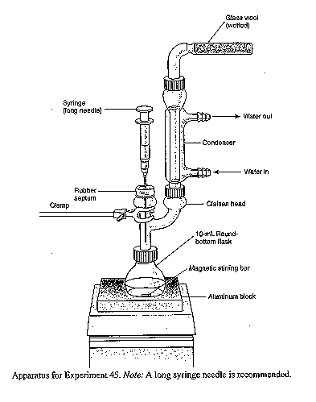

**Figure 1**3

*m*-Toluic acid and thionyl chloride will be charged into the reaction flask (USE A HOOD!), then boiled gently to effect the formation of the acid chloride. The acid chloride will then be cooled to room temperature and dissolved in *anhydrous* ether. Ice-cold diethylamine will be added as a solution in anhydrous ether to form the amide. The resulting ether mixture will washed with aqueous sodium hydroxide (to remove any excess acid chloride), then washed with hydrochloric acid (to remove any excess diethylamine). The resulting ether solution of DEET will be dried and evaporated to yield the crude product, which will then be purified by column chromatography to afford pure DEET. The percent yield from *m*-toluic acid will be determined and the product will be analyzed by transmission infrared spectroscopy (IR) as a neat sample using NaCl plates5 to confirm its structure by (1) looking at the major absorptions and comparing them to a correlation table6 and (2) by comparing the spectrum to that of an authentic sample. The major IR absorption is expected to be the amide carbonyl at 1640 – 1700 cm-1.6 The product will also be analyzed by 1H-NMR spectroscopy as a solution in CDCl3. The 1H-NMR chemical shifts are expected to be a multiplet at  7 – 8 for the four aromatic protons, a singlet around  2 – 3 for the three protons on the benzylic methyl group, a quartet at  2 - 3 for the four CH2 protons in the ethyl groups, and a triplet at around  0.5 – 1 for the six CH3 protons in the ethyl groups.7

**EXPERIMENTAL**

The apparatus shown in Figure 1 was assembled. The 10-mL reaction flask was charged with 0.275 g of *m*-toluic acid (0.0020 mol) and 0.30 mL of thionyl chloride (0.492 g, 0.0041 mol). The condenser water was started, and the mixture was gently heated with stirring on an aluminum block (block temp ~ 90 oC) until boiling started. The reaction mixture was then gently boiled for about 15 minutes. After the boiling period was finished, the reaction mixture was cooled to room temperature. 4.0 mL of anhydrous ether were added, and the mixture was stirred at room temperature until a homogeneous mixture was obtained. To this solution was added (dropwise over a 15 minute period) a solution of 0.66 mL of cold (0 oC) diethylamine (0.462 g, 0.0063 mol) in 1.33 mL of anhydrous ether. During the addition, a thick white cloud of diethylamine hydrochloride was formed. After complete addition, the reaction mixture was stirred at room temperature for about 10 minutes. 10% aqueous sodium hydroxide (2 mL) was then added, and the reaction mixture was stirred for an additional 15 minutes at room temperature, then poured into a separatory funnel and allowed to separate. The aqueous layer was discarded, and the organic layer was washed with an additional portion of 10% aqueous sodium hydroxide (2 mL), followed by a portion of 10% hydrochloric acid (2 mL). The organic layer was washed with water (2 mL), dried (Na2SO4) and evaporated to yield crude *N,N*-diethyl-*m*-toluamide as dark brown liquid. The crude product was filtered through a short alumina column (hexanes) to give pure *N,N*-diethyl-*m*-toluamide as a yellow liquid.

Product mass: 0.340 g

FTIR (film, NaCl plates): 2980, 2880, 1633 (C=O), 1585 (C=C) cm-1.

1H-NMR (300 MHz, CDCl3):  7.3 – 7.1 (m, 5H, Ar-H), 3.53 (q, 2H, CH2), 3.24(q, 2H, CH2), 2.35 (s, 3H, Ar-CH3), 1.23 (t, 3H, ethyl CH3), 1.09 (t, 3H, ethyl CH3)

**RESULTS AND DISCUSSION**

Reaction of *m*-toluic acid with thionyl chloride, followed by diethylamine produced 0.340 g of a yellow liquid the IR spectrum of which unequivocally showed the presence of the amide carbonyl functional group at 1633 cm-1. In addition, absorptions due to aliphatic C-H (2980 – 2880 cm-1), and aromatic C=C (at 1585 cm-1). The IR spectrum is attached to this report. These data are consistent with the structure of *N,N*-diethyl-*m*-toluamide (DEET), shown in Figure 2 below:

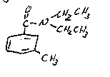

**Figure 2: *N,N*-Diethyl-*m*-toluamide (DEET)**

In addition, the IR of the product closely corresponds with that of an authentic sample of *N,N*-diethyl-*m*-toluamide (DEET) shown in the lab text.9 Also, the 1H-NMR shows the presence of four (4) aromatic protons in the region 7.3 – 7.1 ppm, as well as a three (3) proton singlet at 2.35 ppm, which corresponds to the benzylic methyl group. The presence of two ethyl groups is clearly shown by the presence of two quartets which integrate to 2 protons each at 3.53 and 3.24 ppm, and two triplets which integrate to 3 protons each at 1.23 and 1.09 ppm. Although the ethyl groups look chemically equivalent, because of restricted rotation about the C-N bond (due to the relatively large contribution of the resonance structure shown in Figure 3 to the overall structure of the DEET molecule), they are not equivalent, and this is reflected in the 1H-NMR, which contains signals for two chemically nonequivalent ethyl groups.

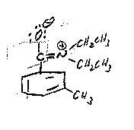

**Figure 3. Alternative Resonance Structure of DEET**

Furthermore, the 1H-NMR of the product isolated from this experiment closely corresponds to that of an authentic sample of DEET.10 It can therefore be concluded that the product synthesized in this laboratory was, in fact, DEET.

0.34 g of *N,N*-diethyl-*m*-toluamide (DEET) was produced from 0.275 g of *m*-toluic acid. This corresponds to a percent yield of 88.1%. The calculations are shown below:

The limiting reactant in this preparation is *m*-toluic acid. Therefore, the theoretical yield of DEET is calculated as follows:

1 mol DEET 193.1 g DEET

Theoretical yield of DEET = (moles *m*-toluic acid) x ------------------------- x ----------------------

1 mol *m*-toluic acid 1 mol DEET

1 mol DEET 193.1 g DEET

Theoretical yield of DEET = (0.0020 mol) x ------------------------- x -------------------- = 0.386 g DEET

1 mol *m*-toluic acid 1 mol DEET

Actual yield of DEET (0.340 g)

% Yield = ------------------------------ ----------------- x 100 = 88.1%

Theoretical Yield of DEET (0.386 g)

The experiment proceeded as planned, giving a very good yield (88.1%) of DEET. There were no spills or other abnormal physical losses, so it is doubtful that this procedure can be improved much further without a significant amount of effort.

**CONCLUSION**

In this experiment, it was shown that *N,N*-diethyl-*m*-toluamide (DEET) could be produced from *m*-toluic acid by treatment with thionyl chloride followed by reaction of the intermediate acid chloride with diethylamine in an overall yield of 88.1%. That the product synthesized was, in fact, *N,N*-diethyl-*m*-toluamide was demonstrated by its IR and 1H-NMR spectra.

**REFERENCES**

1. Pavia, D. L.; Lampman, G. M.; Kriz, G. S.; Engel, R. G. *Introduction to Organic Laboratory Techniques, A Microscale Approach;* 3rd ed.; Brooks/Cole: Pacific Grove, CA, 1999; p. 373.

2. Bruice, P. L. *Organic Chemistry;* 4th ed.; Prentice Hall: Upper Saddle River, NJ, 2004; p. 682.

3. Pavia, D. L.; Lampman, G. M.; Kriz, G. S.; Engel, R. G. *Introduction to Organic Laboratory Techniques, A Microscale Approach;* 3rd ed.; Brooks/Cole: Pacific Grove, CA, 1999; p.375.

4. Pavia, D. L.; Lampman, G. M.; Kriz, G. S.; Engel, R. G. *Introduction to Organic Laboratory Techniques, A Microscale Approach;* 3rd ed.; Brooks/Cole: Pacific Grove, CA, 1999; p. 374.

5. See Pavia, D. L.; Lampman, G. M.; Kriz, G. S.; Engel, R. G. *Introduction to Organic Laboratory Techniques, A Microscale Approach;* 3rd ed.; Brooks/Cole: Pacific Grove, CA, 1999; p. 743 for a description of this type of sample preparation. The holder described in Figure 19.1 will not be used for this experiment.

6. Pavia, D. L.; Lampman, G. M.; Kriz, G. S.; Engel, R. G. *Introduction to Organic Laboratory Techniques, A Microscale Approach;* 3rd ed.; Brooks/Cole: Pacific Grove, CA, 1999; p. A19.

7. Pavia, D. L.; Lampman, G. M.; Kriz, G. S.; Engel, R. G. *Introduction to Organic Laboratory Techniques, A Microscale Approach;* 3rd ed.; Brooks/Cole: Pacific Grove, CA, 1999; p. A37.

8. Data taken from product descriptions and MSDS’s at the Fisher Scientific website. https://new.fishersci.com (accessed June, 2005).

9. *Introduction to Organic Laboratory Techniques, A Microscale Approach;* 3rd ed.; Brooks/Cole: Pacific Grove, CA, 1999; p. 377.

10. Spectral Database for Organic Compounds (SDBS). [www.aist.go.jp/RIODB/SDBS/cgi-bin/cre_index.cgi](http://www.aist.go.jp/RIODB/SDBS/cgi-bin/cre_index.cgi) (accessed May, 2006)

**ANSWERS TO QUESTIONS**

1. Why is the reaction mixture extracted with 10% aqueous sodium hydroxide? Write an equation.

In the event any acid chloride did not react with diethylamine, the sodium hydroxide converts the residual acid chloride to the sodium salt of *m*-toluic acid. This salt is water soluble and is extracted out of the organic layer into the aqueous layer and therefore is separated from the product. The equation which describes this process is:



2. What reaction would take place if the acid chloride of *m*-toluic acid were mixed with water? Write an equation.

The acid chloride would hydrolyze according to the following equation:



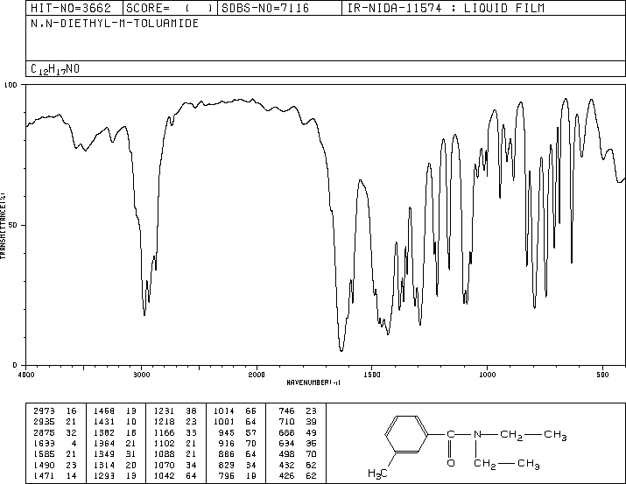

Reproduced from the Spectral Database for Organic Compounds (SDBS). [www.aist.go.jp/RIODB/SDBS/cgi-bin/cre_index.cgi](http://www.aist.go.jp/RIODB/SDBS/cgi-bin/cre_index.cgi) (accessed May, 2006)

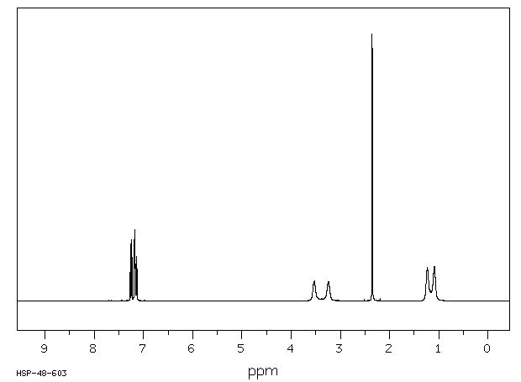

|  |
| --- |
| IMG |
| **Assign. Shift(ppm)**  A 7.251  B 7.18  C 7.139  E *1 3.53  F *1 3.24  G 2.352  J *2 1.23  K *2 1.09 |

Reproduced from the Spectral Database for Organic Compounds (SDBS). [www.aist.go.jp/RIODB/SDBS/cgi-bin/cre_index.cgi](http://www.aist.go.jp/RIODB/SDBS/cgi-bin/cre_index.cgi) (accessed May, 2006)