Name ___________________________ Name ___________________________

Name ___________________________ Name ___________________________

Geol 250 – Examination One – Group Answers

- _______ liters
- _______ grams
- _______ kilograms)
- __________________
- [ texture / composition ] (circle one)
- [True or False]
- [True or False]
- [True or False]
- [True or False]
- [True or False]
- [ heated / cooled ] (circle one)
- scientific theory or a scientific hypothesis (circle one)?

- __________________ __________________

- (circle all that apply): volcanoes / earthquakes / subduction / hotspots

Answer questions 27-30 based on the following cross section.

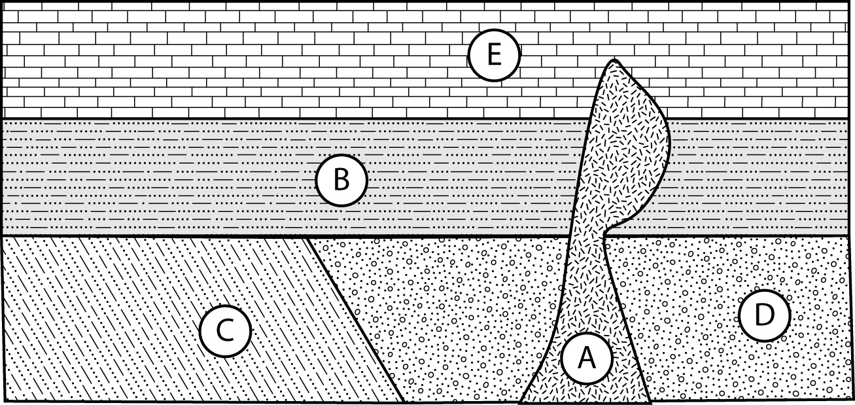

27. Assuming mudstone B and limestone E are in their original horizontal positions, which is older? What stratigraphic principle allowed you to make that determination?

28. What was the last rock in the cross section to form? What stratigraphic principle allowed you to make that determination?

29. What kind of unconformity forms the contact between shale C and mudstone B?

30. From the cross-section, it is not possible to determine the relative ages of conglomerate D and shale C. What physical evidence might you look for to determine which of the rock units is older?

