Name:

Geol 250 – Final Exam

Please answer the following questions (2 points each).

- A pitcher has a volume of 100,000 cm³. What is the volume of the pitcher in liters?

- What would be the mass of the water (in grams) that would fill the pitcher in question #1?

- What would be the mass (in kilograms) of a volume of fluid with a density = 2 g/cm³ that would fill the pitcher in question #1?

- The Earth revolves around the Sun once every __________________ (fill in blank).

- Rhyolite and granite are both felsic igneous rocks, meaning they have the same [ texture / composition ] (circle one).

- [True or False] A 100-year flood has an average recurrence interval of 1,000 years.

- [True or False] The Sun radiates only in the visible spectrum.

- [True or False] The Hawaiian Islands are a textbook example of a volcanic island arc formed from subduction.

- [True or False] High pressure systems are generally associated with the development of large weather systems like warm fronts and cold fronts.

- [True or False] Seismic P-waves can’t travel through the liquid outer core of the Earth but S-waves can. This results in a P-wave shadow on the side of the Earth opposite an earthquake.

- To reach its dew point temperature, a packet of unsaturated air must usually be [ heated / cooled ]. (circle one)

- Which is more likely to be an accurate representation of the natural world, a scientific theory or a scientific hypothesis (circle one)?

- Briefly explain one reason that the interior of the Earth is hot enough for magma to sometimes form in Earth’s crust.

- Dry air in the atmosphere is composed primarily of oxygen and what other gas?

- Name any two common rock forming minerals.

__________________ __________________

- Which fundamental force is primarily responsible for the functioning of chemistry?

- Why do streams flow downhill?

- What chemical weathering process is responsible for breaking down most of Earth’s rock forming minerals?

- Which type of sedimentary rock is particularly susceptible to dissolution by acid rainwater?

- What causes seasonality on Earth?

- Volcanoes are characteristic of what type(s) of plate tectonic boundary(s)?

- What was William Smith’s great contribution to the science of correlating rocks and determining relative timing of geologic events?

- Benioff Zones are associated with which type of plate boundary?

- Which of the following are associated with all three types of plate boundaries (circle all that apply):

volcanoes / earthquakes / subduction / hotspots

- What is the relationship between an earthquake’s focus and its epicenter?

- Explain one specific reason that plate tectonic divergent boundaries are less dangerous to humans than convergent boundaries.

Answer questions 27-30 based on the following cross section.

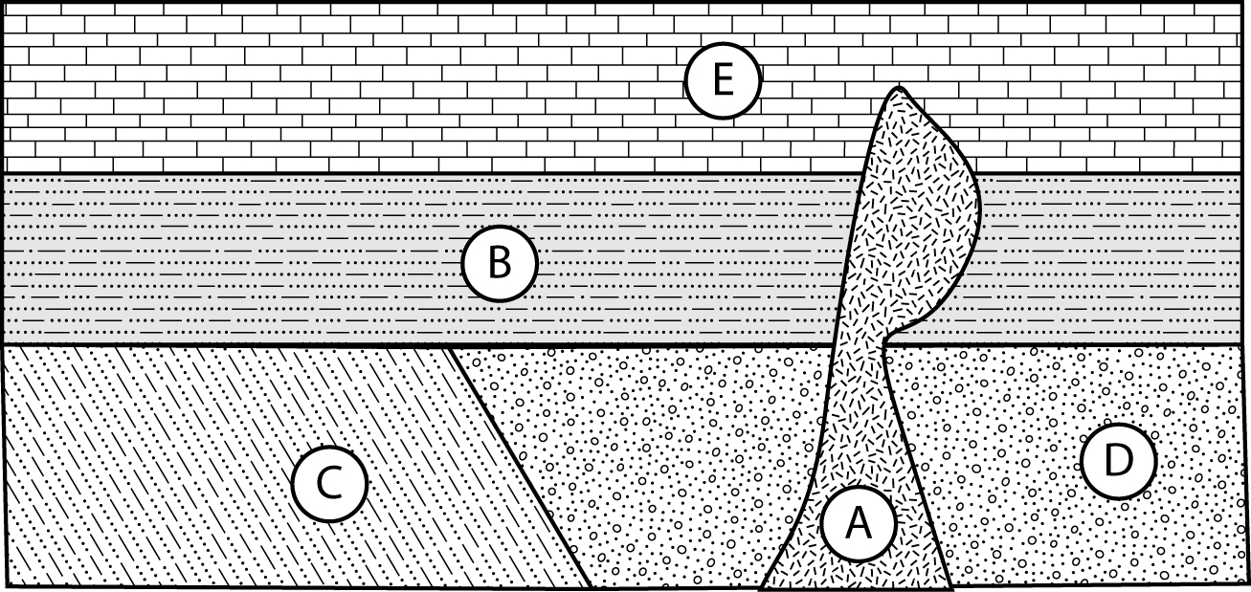

27. Assuming mudstone B and limestone E are in their original horizontal positions, which is older? What stratigraphic principle allowed you to make that determination?

28. What was the last rock in the cross section to form? What stratigraphic principle allowed you to make that determination?

29. What kind of unconformity forms the contact between shale C and mudstone B?

30. From the cross-section, it is not possible to determine the relative ages of conglomerate D and shale C. What physical evidence might you look for to determine which of the rock units is older?
Please answer the following questions (5 points each).

1. List the four fundamental forces of our Universe:

_________________________ _________________________

_________________________ _________________________

2. Earlier this month, Rock Hill experienced the following weather:

Sunday high of 90º, mostly sunny
Monday high of 75 º, morning thunderstorms followed by clearing skies
Tuesday high of 76 º, clear skies

What is the simplest explanation for this change in the weather?

3. List the 8 most abundant elements in Earth’s crust on the eight lines below. You may use the chemical abbreviations or the full spellings of the element names, but whichever you use, spelling counts 100%.

___________________________________ ___________________________________

___________________________________ ___________________________________

___________________________________ ___________________________________

___________________________________ ___________________________________

4. ⁴⁰K decays to ⁴⁰Ar with a half-life of 1.3 billion years. Analysis of one group of minerals in a meteorite indicate that only 50% of the original ⁴⁰K remains. How old is the meteorite?

____________________ billion years

5. List and briefly explain three of the lines of evidence that Wegener used to support his theory of Continental Drift.

1.

2.

3.

6. Earth the Living Machine Matching Exercise: Match each discoverer to their major discovery by writing the letter by their name in the appropriate spot next to their discovery. Note, not all discoverers will be used in this exercise.

A. Alfred Wegener  B. Allan Cox and Brent Dalrymple  C. Bonnie Murchey, D. Jones, D. Howell  D. Ed Wolfe and Tina Neal | E. Fred Vine and Drummond Matthews  F. Glomar Challenger  G. Harry H. Hess  H. James Hutton

_____ Recognized that the Earth’s surface is dynamic, changing dramatically over millions of years due to the “Earth’s Heat Engine.” (1790)

_____ Proposed that all continental masses used to be part of a large land mass called Pangea. The continents “drifted” away from each other after Pangea’s formation to their present positions. (1910)

_____ Proposed that seafloor spreading occurs along mid-ocean ridges as upwelling magma cools and accretes to the edges of the plates. (1960)

_____ First to determine that magnetic reversal “striping” around mid-ocean ridges was caused by sea floor spreading. (1962)

_____ Discovered that much of northern California is made of exotic terranes (crust accreted to the margin of a continent). (1984)

