Questions

1. Why does deforestation contribute to global warming?
2. If the temperature of the earth rises enough so that the polar ice caps begin to melt, would this melting cause the global temperature to remain the same, drop, or rise higher? Why? (Consider feedback mechanisms.)
3. What strategies are available to reduce global warming? What are the detrimental consequences of such actions?

PROBLEMS

1.Gasoline is made up of hydrocarbons. Suppose 80% of the mass of gasoline is carbon, and all of this becomes CO₂ in combustion in an automobile. If the density of gasoline is 6.7 lb/gal, then how much CO₂ is emitted per gallon of gasoline burned?

2. A light bulb draws a current of 2 amps when connected to a wall outlet (120V). What is the resistance and wattage of the bulb?
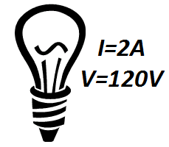

3. What is the cost of running a 1500-W hair dryer for 30 minutes, when the cost of electricity is $0.12/kWh?
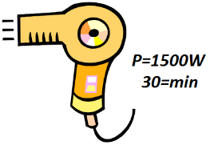

4. How many 10-Ω resistors must be connected in series to give an equivalent resistance to five resistors 100Ω connected in parallel?
5. Suppose that you have a 9.0-V battery and you wish to apply a voltage of only 4.0 V. Given an unlimited supply of 1.0 Ω resistors, how could you connect them so as to make a “voltage divider” that produces a 4.0-V output for a 9.0-V input?

6. Eight bulbs are connected in parallel to a 110-V source by two long leads of total resistance. If 240 mA flows through each bulb, what is the resistance of each, and what fraction of the total power is wasted in the leads?

7. Determine (a) the equivalent resistance of the circuit shown in Fig. 26–39, and (b) the voltage across each resistor.
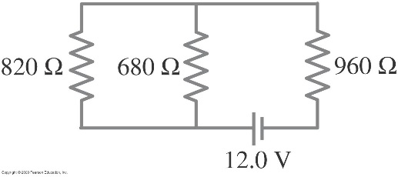
8. A 75-W, 110-V bulb is connected in parallel with a 25-W, 110-V bulb. What is the net resistance?

