1. What illustrations can you give of the second law of thermodynamics in your everyday life?

My ice cream melts if I leave it out on the counter, but I can freeze it again, as long as I supply energy to the refrigerator. My car’s engine is much less than 50% efficient at converting its gasoline’s chemical energy to motion,...

1. A simple heat engine might make use of the warm air around New York City. Energy could be taken as heat from the atmosphere (assume 30ºC) and rejected as heat to the Hudson River (10ºC). What is the maximum efficiency of such an engine for the conversion of thermal energy into mechanical energy?



1. How long will it take to heat 40 gal of water from 70ºF to 120ºF with a 20-kW immersion heater? Use units of Btu/lb/°F.



1. A small immersion heater is rated at 350 W. Estimate how long it will take to heat a cup of soup (assume this is 250 mL of water) from 15°C to 75°C.

Q= mcΔT and P= Q/t so t= Q/P



1. A hot iron horseshoe (m=0.40kg) just forged (Fig. below), is dropped into 1.05 L of water in a 0.30-kg iron pot initially at 20.0°C. If the final equilibrium temperature is 25.0°C, estimate the initial temperature of the hot horseshoe.

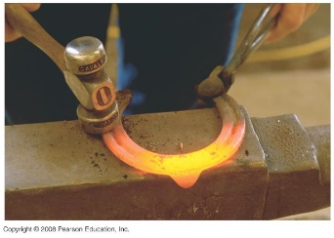

The heat lost by the horseshoe must be equal to the heat gained by the iron pot and the water. Note that 1 L of water has a mass of 1 kg.







1. An iron boiler of mass 180 kg contains 730 kg of water at 18°C. A heater supplies energy at the rate of How long does it take for the water (a) to reach the boiling point, and (b) to all have changed to steam?

(*a*) The heater must heat both the boiler and the water at the same time.





(*b*) Assume that after the water starts to boil, all the heat energy goes into boiling the water, and

none goes to raising the temperature of the iron or the steam.



Thus, the total time is 

1. The specific heat of mercury is 138J/kg °C. Determine the latent heat of fusion of mercury using the following calorimeter data: 1.00 kg of solid Hg at its melting point of -39 °C is placed in a 0.620-kg aluminum calorimeter with 0.400 kg of water at 12.80°C; the resulting equilibrium temperature is 5.06°C.

The heat lost by the aluminum and the water must equal the heat needed to melt the mercury and to warm the mercury to the equilibrium temperature.

