1. What illustrations can you give of the second law of thermodynamics in your everyday life?
2. A simple heat engine might make use of the warm air around New York City. Energy could be taken as heat from the atmosphere (assume 30ºC) and rejected as heat to the Hudson River (10ºC). What is the maximum efficiency of such an engine for the conversion of thermal energy into mechanical energy?
3. How long will it take to heat 40 gal of water from 70ºF to 120ºF with a 20-kW immersion heater? Use units of Btu/lb/°F.
4. A small immersion heater is rated at 350 W. Estimate how long it will take to heat a cup of soup (assume this is 250 mL of water) from 15°C to 75°C.
5. A hot iron horseshoe (m=0.40kg) just forged (Fig. below), is dropped into 1.05 L of water in a 0.30-kg iron pot initially at 20.0°C. If the final equilibrium temperature is 25.0°C, estimate the initial temperature of the hot horseshoe.

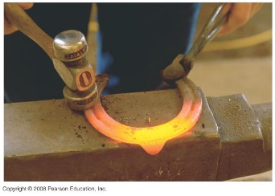

1. An iron boiler of mass 180 kg contains 730 kg of water at 18°C. A heater supplies energy at the rate of 52,000kJ/h. How long does it take for the water (a) to reach the boiling point, and (b) to all have changed to steam?
2. The specific heat of mercury is 138J/kg °C. Determine the latent heat of fusion of mercury using the following calorimeter data: 1.00 kg of solid Hg at its melting point of -39 °C is placed in a 0.620-kg aluminum calorimeter with 0.400 kg of water at 12.80°C; the resulting equilibrium temperature is 5.06°C.