**PHYS305: Energy HW 1-Solutions Dr. Amir**

1. The most significant aspect of world consumption of energy over the last 40 years has

been the ________.

a. growth of nuclear power

b. expanding use of oil

c. increased use of coal

d. emphasis on energy conservation

e. increase in our fossil fuel reserves

1. A horse canters away from its trainer in a straight line, moving 116 m away in 14.0 s. It then turns abruptly and gallops halfway back in 4.8 s. Calculate (*a*) its average speed and (*b*) its average velocity for the entire trip, using “away from the trainer” as the positive direction.

The distance traveled is  and the displacement is

 The total time is 14.0 s + 4.8 s = 18.8 s.

(*a*) Average speed = 

(*b*) Average velocity = 

1. The position of a rabbit along a straight tunnel as a function of time is plotted in Fig. 2 –36. What is its instantaneous velocity (*a*) at  and (*b*) at  What is its average velocity (*c*) between  and  (*d*) between  and  and (*e*) between  and 

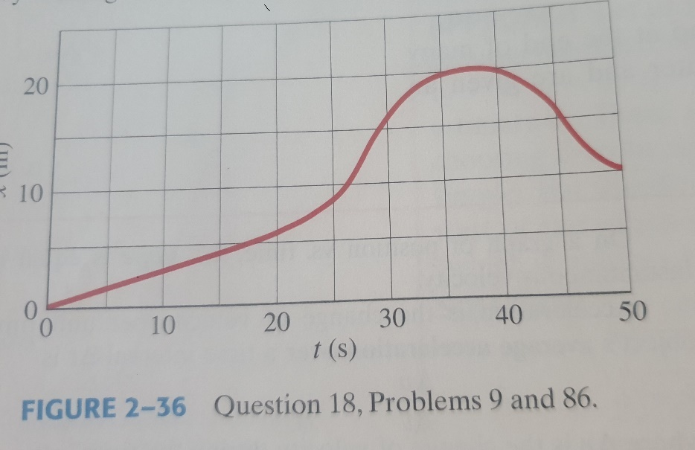

Slightly different answers may be obtained since the data comes from reading the graph.

(*a*) The instantaneous velocity is given by the slope of the tangent line to the curve. At 

the slope is approximately 

(*b*) At  the slope of the tangent line to the curve, and thus the instantaneous velocity, is

approximately 

(*c*) The average velocity is given by 

(*d*) The average velocity is given by 

(*e*) The average velocity is given by 

1. a) What is the exponential growth?

b) Today the United States has the equivalent of 400 standard sized 1000 MW power plants. If the electrical consumption continues to rise at the present rate of 2% per year. How many additional power plants will be needed in 35 years to meet those needs?

Growth with a constant relative (percentage) rate, rather than a constant absolute rate.

400 additional plants. (At 2%, the doubling rate is 35 year).

1. A car traveling at 105 kmh strikes a tree. The front end of the car compresses and the driver comes to rest after traveling 0.80 m. What was the magnitude of the average acceleration of the driver during the collision? Express the answer in terms of “*g*’s,” where 

The final velocity of the driver is zero. The acceleration is found from Eq. 2-12c with  and

solving for .



Converting to “*g*’s”: 

(*a*) What is the acceleration of two falling sky divers ( including parachute) when the upward force of air resistance is equal to one-fourth of their weight? (*b*) After popping open the parachute, the divers descend leisurely to the ground at constant speed. What now is the force of air resistance on the sky divers and their parachute? See Figure below

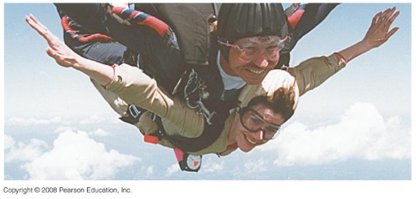

(*a*) There will be two forces on the skydivers – their combined weight, and the

upward force of air resistance,  Choose up to be the positive direction. Write Newton’s second law for the skydivers.



Due to the sign of the result, the direction of the acceleration is down.

(*b*) If they are descending at constant speed, then the net force on them must

be zero, and so the force of air resistance must be equal to their weight.



1. A rocket rises vertically, from rest, with an acceleration of  until it runs out of fuel at an altitude of 950 m. After this point, its acceleration is that of gravity, downward. (*a*) What is the velocity of the rocket when it runs out of fuel? (*b*) How long does it take to reach this point? (*c*) What maximum altitude does the rocket reach? (*d*) How much time (total) does it take to reach maximum altitude? (*e*) With what velocity does it strike the Earth? ( *f* ) How long (total) is it in the air?

(*a*) Choose upward to be the positive direction, and  at the ground. The rocket has 

 and  when it runs out of fuel. Find the velocity of the rocket when it runs out of fuel from Eq 2-12c, with *x* replaced by *y*.



The positive root is chosen since the rocket is moving upwards when it runs out of fuel.

(*b*) The time to reach the 950 m location can be found from Eq. 2-12a.



(*c*) For this part of the problem, the rocket will have an initial velocity  an

acceleration of  and a final velocity of  at its maximum altitude. The altitude reached from the out-of-fuel point can be found from Eq. 2-12c.



(*d*) The time for the “coasting” portion of the flight can be found from Eq. 2-12a.



Thus the total time to reach the maximum altitude is 

(*e*) For the falling motion of the rocket,  and the displacement is  (it falls from a height of 1260 m to the ground). Find the velocity upon reaching the Earth from Eq. 2-12c.



The negative root was chosen because the rocket is moving downward, which is the negative direction.

(*f*) The time for the rocket to fall back to the Earth is found from Eq. 2-12a.



Thus the total time for the entire flight is .