- Most consumer electronic devices that plug into a 110V wall socket (computers, home theater, alarm clocks, even clocks on ovens) require an internal transformer to convert that 110V into 9V for the actual electronic components that run the device. What’s the turns ratio on such a transformer and what is the current ratio (secondary current divided by primary current)?

- Consider why we want to send current long distances at high voltage (and therefore at low currents). Imagine that some length of power lines has a resistance of 10 ohms.
- We want to send 300MW of power over 10kV power lines. What’s the current in the wires? How much power is dissipated (wasted) in the wires? [Careful: the entire 110V is NOT across the 10 ohm wires!]
- If we send the 300MW over 700kV power lines, what is the current in the wires? How much power is wasted in the wires? [Same warning as above]

- Consider the following nuclear reaction:
where AX is some unknown element, X, of atomic mass, A. What is this reaction element?
Uranium has an atomic number of Z=92 (See Periodic Table).

- Balance the following nuclear reactions:

5. In Fig. below, charged particles move in the vicinity of a current-carrying wire. For each charged particle, the arrow indicates the direction of motion of the particle, and the + or $-$ indicates the sign of the charge. For each of the particles, indicate the direction of the magnetic force due to the magnetic field produced by the wire.
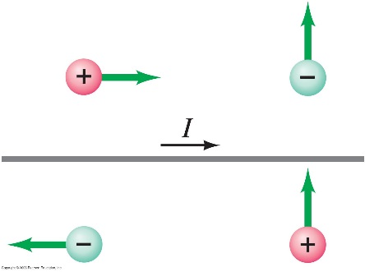

- Calculate the magnitude of the magnetic force on a 240-m length of wire stretched between two towers and carrying a 150-A current. The Earth’s magnetic field of 5.0$×{10}^{-5} T$ makes an angle of 68° with the wire.
- A stiff wire 50.0 cm long is bent at a right angle in the middle. One section lies along the z axis and the other is along the line $y=2x$ in the xy plane. A current of 20.0 A flows in the wire—down the z axis and out the line in the xy plane. The wire passes through a uniform magnetic field given by $\vec{B}=\left(0.318\hat{i }\right)T$ Determine the magnitude and direction of the total force on the wire.
- A long wire stretches along the x axis and carries a 3.0-A current to the right (+x). The wire is in a uniform magnetic field $\vec{B}=(0.20\hat{i}$ $-0.36\hat{j}$ +$0.25\hat{k} ) T$ . Determine the components of the force on the wire per cm of length.
- From the following nuclear reaction with heavy ions, find the mass and atomic number of the argon nucleus:

- Complete the following nuclear reaction:

11. How much CO₂ is produced by driving 100mi, drying a load of clothes, and watching 5 hours of television?
(work with energy)


20lb of CO₂ per gal

Assume 20mi/gal

 P=5000W
@2lb CO₂/kWh

12. Gasoline is made up of hydrocarbons. Suppose 80% of the mass of gasoline is carbon, and all of this becomes CO₂ in combustion in an automobile. If the density of gasoline is 6.7 lb/gal, then how much CO₂ is emitted per gallon of gasoline burned?

13. Determine (a) the equivalent resistance of the circuit shown in Fig. below, and (b) the voltage across each resistor.
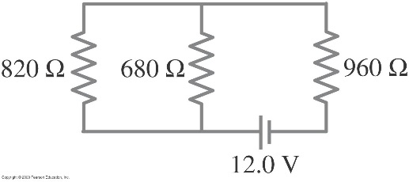

14. A close inspection of an electric circuit reveals that a 480 Ω resistor was inadvertently soldered in the place where a 370 Ω resistor is needed. How can this be fixed without removing anything from the existing circuit?
15. Calculate the current in the circuit of Fig. below, and show that the sum of all the voltage changes around the circuit is zero.

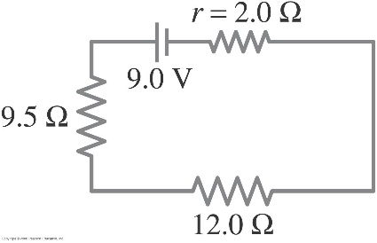
16. A 650Ω and a 2200 Ω resistor are connected in series with a 12-V battery. What is the voltage across the 2200Ω resistor?
17. (I) Three 45Ω lightbulbs and three 65Ω lightbulbs are connected in series. (a) What is the total resistance of the circuit? (b) What is the total resistance if all six are wired in parallel?
18. How many 10-Ω resistors must be connected in series to give an equivalent resistance to five resistors 100Ω connected in parallel?
19. Suppose that you have a 9.0-V battery and you wish to apply a voltage of only 4.0 V. Given an unlimited supply of 1.0 Ω resistors, how could you connect them so as to make a “voltage divider” that produces a 4.0-V output for a 9.0-V input?

