PHYS212 Spectra
Name:____________________Partner(s):________________________
A. Pre-Lab:
Pre-Lab: https://www.youtube.com/watch?v=0YnvHbAUHtA
a.1. Expain the origin of light? https://www.youtube.com/watch?v=7BFM46vJbrI

2. Energy levels of the electron of the hydrogen atom are shown below. Calculate and list the energy values, $E_{n}=-\frac{13.6}{n^{2}}$eV, with the orbitals.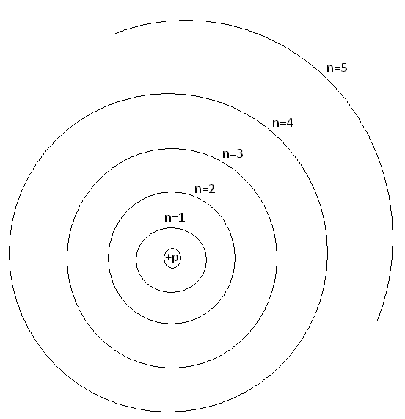
a. Watch this video for an understanding of electron transitions.
https://www.youtube.com/watch?v=wiINTUZoAiw

b. Show the transitions of electron for the Lyman (Higher level 1), Balmer (Higher level 2), and Paschen (Higher level 3) series in the above diagram.

c. A photon of light is emitted when the electron transitions to a lower energy. The wavelength (λ) of emitted light is given by:
∆E=hc/λ; h = 6.626$×$10⁻³⁴ J.s and c = 2.998$×$10⁸ m/s. 1eV=1.602$×$10⁻¹⁹ J
- Calculate the value of hc, in the unit eV.nm.

2. Calculate the 4 of the highest wavelengths (λ) of the Balmer series.

b. Visit this simulation: https://javalab.org/en/spectrum_of_hydrogen_en/
1. The simulation shows the light emission for the hydrogen atom. Make a note of the wavelength (λ), energy difference (ΔE), and energy levels involved for the light emitted. Wavelength range in nm of the visible spectrum: 400 nm ----700 nm.
2. Record the wavelength (λ) and change in energy (ΔE) from the different electron orbits to the ground state and complete the data table.
You will complete the last three columns when you do the measurements with the Ocean Optics spectrometer.
B. Experiments
Data for H-spectrum:
Transition from | ΔE | λ, from website | λ, measured | %Difference | Intensity Count
3rd electron orbit
4th electron orbit
5th electron orbit
6th electron orbit
7th electron orbit
7. Plot ΔE versus 1/λ, determine the slope with unit. Slope = ______________
Calculate a theoretical value for the slope in the same unit.
_______________________________________________________________________
8. Set up the fiber optic cable next to the hydrogen spectrum tube and turn on the tube.
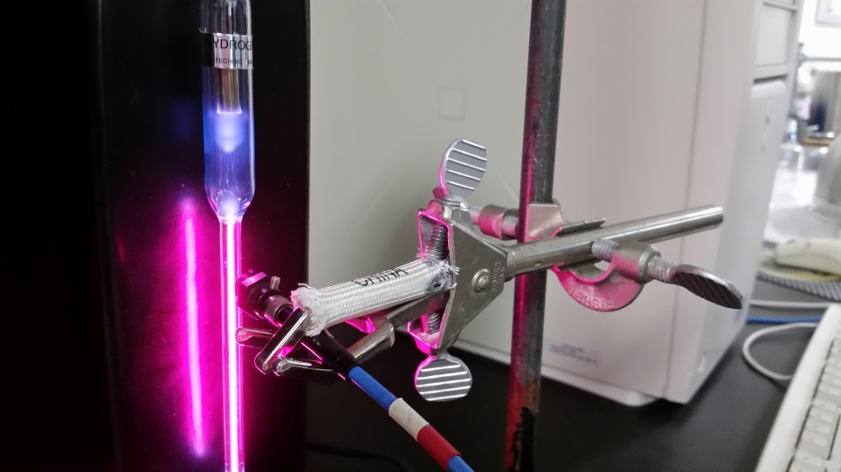

9. Open the Ocean Optics program (OOIBase32, from desktop).
10. Click on the Toggle Cursor BUTTON (8th starting from right-top) to display the green vertical line (curser).
11. Click on a peak to move the cursor over the peak, use the arrow keys to align the cursor over the peak. Wavelength and intensity are read from either the bottom-left corner or the upper right corner.
12. Measure the wavelengths for the lines you observe. Starting with the highest peak, record the measured values between 400-700nm in the above data table, and calculate the %difference.
13. Adjust the position of the cable-head so that the intensity of the highest peak is close to the maximum count.
14. Click on the Global Snapshot button (3rd from top-right) and record the intensity counts for all the peaks.
15. Replace the hydrogen tube with the helium tube and repeat procedure-13, Adjust the position of the cable-head so that the intensity of the highest peak is close to the maximum count.
16. Record the wavelengths and intensity counts for all the peaks of the helium spectrum.
DATA for He-spectrum:
Wavelength of the line | Intensity count of the line

Fluorescent light spectrum:
Identifying peaks and measuring wavelength: http://en.wikipedia.org/wiki/File:Fluorescent_lighting_spectrum_peaks_labelled.gif
Aim the fiber-optic cable at the ceiling light fixture, observe the spectrum of the fluorescent light bulb, and complete the following data table.
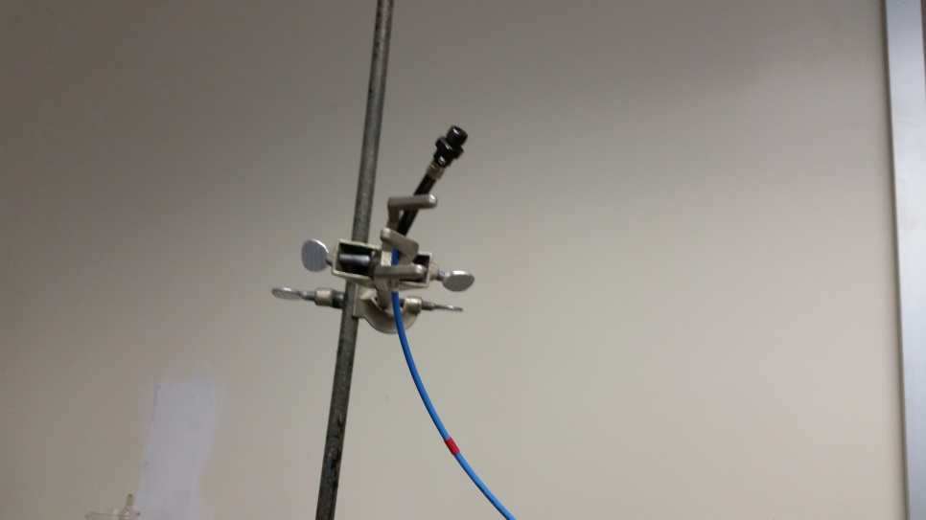
The spectrum taken should be similar to the figure below:
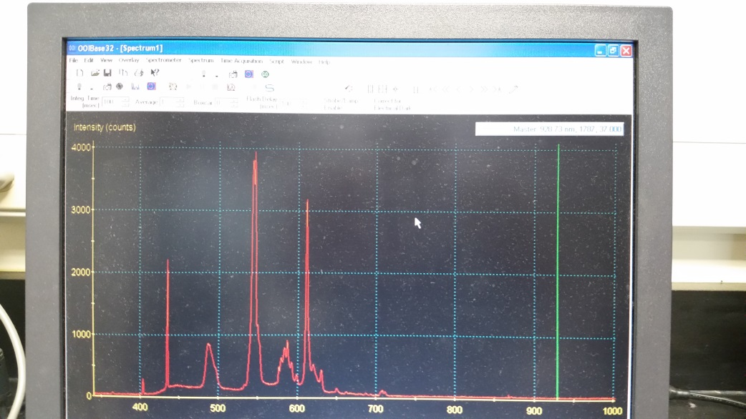

DATA for the fluorescent light:
Peak Number | Wavelength of Peak (nm)
 | From Wikipedia | Measured

C. Conclusion:

