PHYS212L Ohm’s Law Name:____________________
Partner(s): ______________________
Purpose: To investigate Ohm’s law, measure resistances, and study I-V characteristics.
Watch the video: https://www.youtube.com/watch?app=desktop&v=J4Vq-xHqUo8
Theory: Georg Simon Ohm (1787-1854), a German physicist, discovered Ohm’s law in 1826. This is an experimental law, valid for both alternating current (ac) and direct current (dc) circuits. When you pass an electric current (I) through a resistance (R) there will be an electric potential difference (V) created across the resistance as shown below.
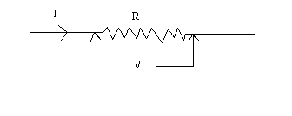
Ohm’s law says that the current (I) is directly proportional to the potential difference (V). The resistance R can be obtained using the following equation:
V = I R
Units: V------> volt (V), I------> ampere (A), R-----> ohm (Ω).
Electric power, P is given by the following equation:
Power = Voltage $×$Current. P = V $×$ I
For ohmic resistances, V versus I is a linear relationship, and they have a constant resistance. Resistance can be calculated using, R = V/I. The slope of the V versus I, line will also give the resistance, R.
For non-ohmic resistances, I versus V is a non-linear relationship, and they have a varying resistance. The resistance at a particular point can be calculated using, R = V/I, where V and I are the potential difference (or voltage) and current at that point.
In the first part of this activity, investigate the relationship between current and voltage in a standard 10-ohm and 5-ohm resistors. Then, investigate the relationship between current and voltage in the filament of a small light bulb. Finally, investigate the relationship between current and voltage in a p-n junction diode (Si) and an LED.

Answer the following:
1. Electricity comes in two types. Name these two types and give an example for each.
____________________________________________________________________
2. Name five quantities and their units, used in electricity.
Terms in Electricity
Physical Quantity | Unit (unit abbreviation)

3. Go to the following simulation.
https://phet.colorado.edu/sims/html/ohms-law/latest/ohms-law_en.html
a. Keep the resistance constant; change the voltage, observe what happens. Describe the relationship between current and voltage. Also, include a plot.

b. Keep the voltage constant; change the resistance, observe what happens. Describe the relationship between current and resistance. Also, include a plot.

Experiments:
Purpose: To investigate Ohm’s law, measure resistances, and study I-V characteristics of common elements.
Apparatus: DC power supply, connecting wires-3 (red-1 and black-2), 2-alligator clips, 5-ohm resistor, 10-ohm resistor, light bulb, diode, LED, voltage sensor, current sensor, and PASCO 850 interface w/Capstone.
Procedure:
- Turn on the power supply and turn down the voltage and current controls to zero.
- Set up the following circuit:
a. Turn on the interface and plug-in the current sensor to the interface.
b. Connect the power supply, 5-ohm resistor, and the current sensor in series. (Keep track of the polarities: positive with positive and negative with negative).
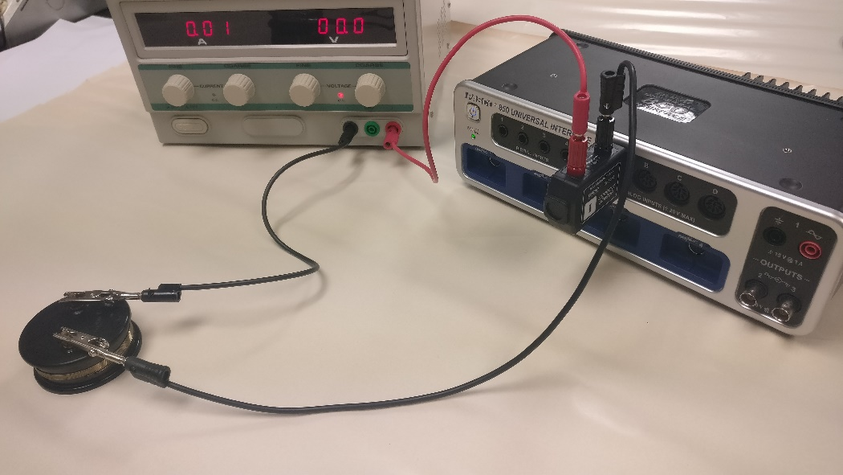
c. Connect the voltage sensor across the 5-ohm resistor, and plug-in to the interface.
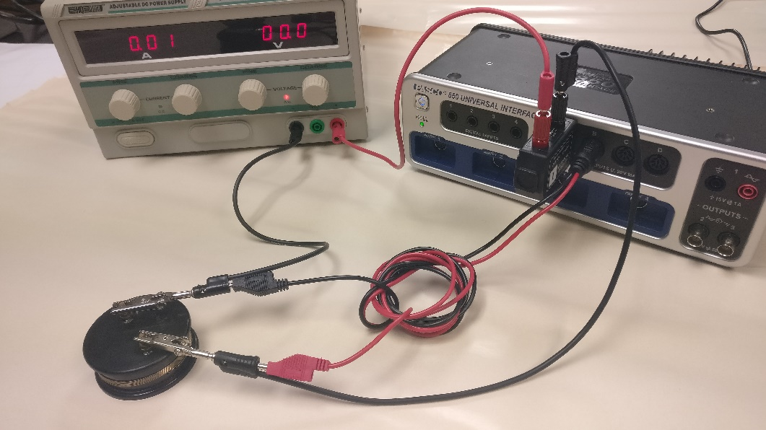
- Setting up the interface/PC for data collection using the Keep Mode (in this mode you have the control to collect data when the conditions are right):
a. Open PASCO Capstone software from the desktop.
b. Click Hardware Setup under Tools on the left.
c. Click on the interface input where the current sensor is connected and select Current Sensor (A of the interface).
d. Click on the interface input where the voltage sensor is connected and select Voltage Sensor (B of the interface).
e. Click Hardware Setup again to close it.
f. Click on “Continuous Mode” at the bottom, and select Keep Mode.
g. Click Table and Graph at the same time, click Select Measurement on the first column, and select Current. Click Select Measurement on the second column, and select Voltage. For the graph, choose current on the x-axis and voltage on the y-axis.
h. Click Preview, you should see data in the table.
- Increase the voltage to about 2.5 Vin the power supply. Current will also increase. When the current and voltage are steady, Click Keep Sample to collect the first set of data. Collect more data by lowering the voltage by 0.2 volt, until the current goes to zero. You need to click on keep sample for each data point
- Reverse the connections to the power supply. Continue collecting data by increasing the voltage by 0.2 volt, until you reach a voltage of -2.5 V. [The power supply won’t indicate -].
- Stop the data collection, determine the resistance using the slope, enter the data in an excel file, and save your results, print the data and graph from PASCO and include to your report.
- Replace the 5-ohm resistor by the 10-ohm. Click Preview, and repeat the measurements for a 10-ohm resistor, and save your results. Print the data and graph from PASCO and include to your report.

I. Constant Resistances 5-Ω and 10-Ω
 | 5-Ω Resistance | 10-Ω Resistance
Measured value from slope of
V vs. I plot
% Difference
II. Light Bulb
- Repeat the measurements for a light bulb, collect more data when the graph curves.
- Complete the data table for the light bulb, and save your results as you did for the resistances.
- Use the “Slope” feature in the Voltage VS. Current graph, determine the resistance of the bulb. Click on the 9th square on the menu to fit each part of the graph with a line, and read the slop. Read the current and voltage at the different positions (Zero, Intermediate, Maximum) in your graph. Calculate power using the current and voltage values. Print the data and graph from PASCO and include to your lab report.
 | Brightness | Resistance | Current | Voltage | Power
Zero current & voltage
Intermediate current & voltage
Maximum current & voltage
III. Si diode and LED
- Repeat the measurements for a Si diode: For the graph, choose Voltage on the x-axis and Current on the y-axis. Collect data only for positive values, collect more data when the graph curves.
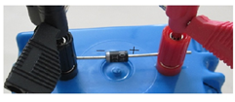
- Determine the voltage that makes the diode conducting using the multipoint coordinates tool in PASCO, and calculate the forward resistance of the diode. Print the data and graph from PASCO and include to your report.
- Repeat the measurements for an LED: Make sure that the LED is on otherwise switch the connections. For the graph, choose Voltage on the x-axis and Current on the y-axis. Collect data only for positive values, collect more data when the graph curves.
- Determine the voltage that makes the LED conducting and the forward resistance of the LED. Print the data and graph from PASCO and include to your report.

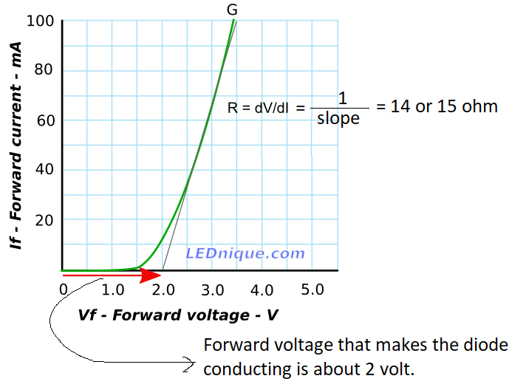 | Slope Forward Resistance Forward voltage that makes the diode conducting  Si Diode  LED
IV. Write an overall conclusion.

