PHYS212 Lab Transistor, Breadboard, and Measuring e/k
Name:______________________ Partner(s):_____________________________
Purpose: In this lab we will measure the ratio of two fundamental constants, namely e/k, using a transistor.
1. Pre-lab
1. Fundamental constants are used extensively in the sciences. Can you name the one we already measured in one of the labs this semester?__________________________________________
Write the values of e =__________________ and k=________________________
2. Watch the following video for an introduction of Transistor, and answer the following questions:
- Define a transistor

- What is a semiconductor?

- What is doping in semiconductor technology?

- What is a p-type semiconductor?

- What is an n-type semiconductor?

- Number of valence electrons in Silicon_____, Phosphorous______, and Boron_______.

3. h_{FE} (or β) of a transistor: (http://www.learningaboutelectronics.com/Articles/What-is-hfe-of-a-transistor)
h_{FE} of a transistor is the current gain or amplification factor of a transistor.
h_{FE} (which is also referred to as β) is the factor by which the base current is amplified.
A transistor works by feeding a base current into the base of the transistor. The base current is then amplified by h_{FE} to yield its amplified current. The formula is:
I_{C}= h_{FE}I_{B}=βI_{B}

So if 1mA is fed into the base of a transistor and it has a h_{FE} of 100, the collector current will be 100 mA. Every transistor has its own unique h_{FE}. The h_{FE} is normally seen to be a constant value, normally around 10 to 500, but it may change slightly with temperature and with changes in collector-to-emitter voltage.

2. Experiment:
2.1. Activity I: Identify E, B, and C of the transistor and measure the h_{FE} (or β) of the given PNP transistor, as shown below, using the blue digital multimeter (DMM).
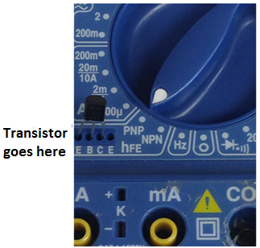 | 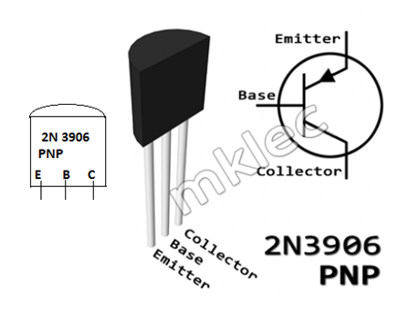  h_{FE} = β = ____________

2.2. Activity II: Identifying the internal connections of the holes in a breadboard, using the breadboard to connect resistors, and measure their equivalent resistance.
Apparatus: Breadboard, small connecting wires, 2-alligator clips, 2-resistors, and white DMM.
Solder-less breadboards are important in electronics. They allow us to make quick circuits, test out ideas before making a more permanent circuit. They often look like the one shown below on the right. Although you can't see it, inside the breadboard are many strips of metal that connect some of the rows and columns together. The metal strips are springy so that when you poke a wire into the hole, the clips grab onto it.
2.2.a. In this activity the holes that are connected internally will be identified. Use a DMM and connect two holes to the COM and Ω, as shown below. Move the dial to continuity test (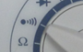). If a sound is created, then they are connected. Draw a line along the connected holes, in the breadboard diagram.
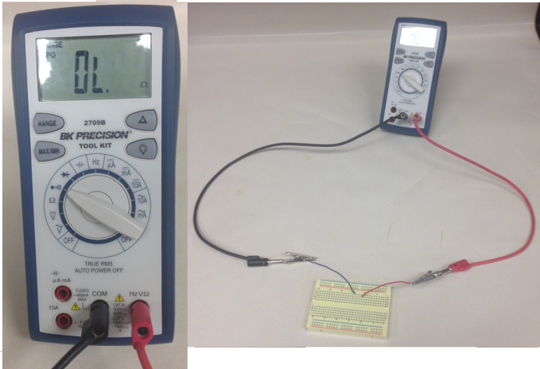 | 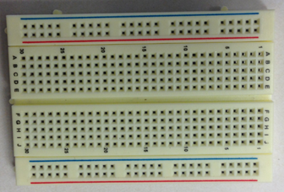
2.2.b. For the given two resistors, first measure their values individually. Then, connect them in series using the breadboard, and measure the equivalent resistance. Also, calculate this resistance. Finally, connect them in parallel using the breadboard, and measure the equivalent resistance. Also, calculate this resistance.
R₁
R₂
 | Measured | Calculated
R₁ and R₂ in Series
R₁ and R₂ in Parallel

2.3. Activity III: Checking the biasing conditions for a transistor.
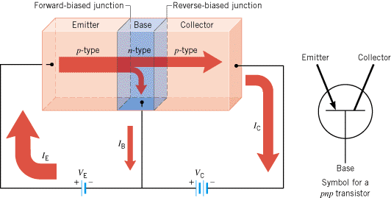
A transistor is made of two diodes, sandwiched together. The emitter-base junction is forward biased, and the base-collector junction is reverse biased. Set up a circuit as shown below, in Figures I and II, and test the biasing condition for the two junctions. When the DMM displays a voltage in the range of 0.75 volt, it is forward biased and an overload, OL means reverse biased.
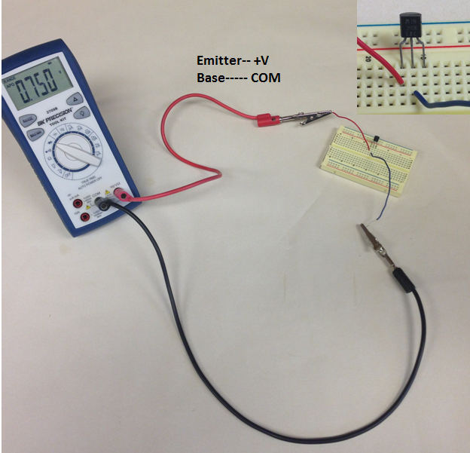  + | 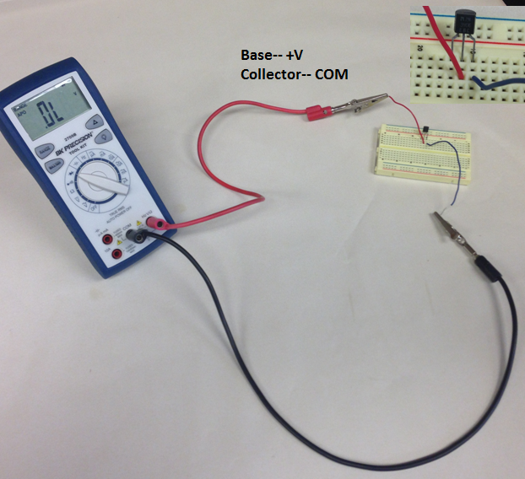
Figure I | Figure II
Emitter-Base junction_____________________ | Base-Collector junction________________

2.4. Activity IV
Purpose: Experimentally measure e/k, where e is the electronic charge and k is the Boltzmann’s constant, and compare it with the accepted value.
Apparatus: Temperature sensor, PNP transistor, proto-board, 2-digital-multimeters (A and V), rheostat, D-cell battery w/holder, 3 proto-board wires, 5 alligator clips, 4 red banana plug wires, and 4 black banana plug wires.
The figure below shows how to insert and connect a transistor in a breadboard.
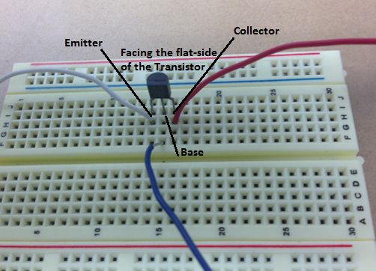
The figure below shows the circuit diagram to measure the emitter-base voltage, V [0.453 V] and collector- current, I [0.4 µA]. 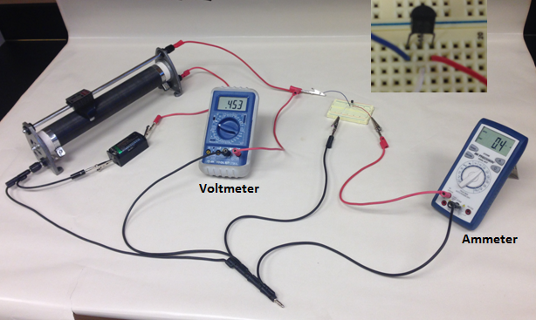
+

Procedure:
1. Set up the above circuit. V: 2V DC, A: DC µA, and slider at the bottom.
2. Slide up the control in the rheostat until the ammeter reads a very low current, say 0.5 µA.
3. Increase the current and collect I and V data. [About 30 set of data, evenly spread with the voltage, until the current reaches 100 µA]. DO NOT USE MORE THAN 100 µA.
4. Record the voltage, V and current, I in an Excel data table.
5. The current (I) and the voltage (V) are related by the following equation: (where k is the Boltzmann constant, e is the electronic charge, and T is the temperature)
$I=I_{0}exp⁡\left(\frac{eV}{kT}\right)$
6. Plot I versus V, fit the data with an appropriate Trendline, and obtain e/kT from the trendline equation.
DATA TABLE
Voltage (V) | Current (µA)

7. Manipulate the above equation and identify the variables for a linear plot.
$I=I_{0}exp⁡\left(\frac{eV}{kT}\right)$

8. Calculate the new variables and plot the linear graph, and obtain e/kT from the slope.
10. Measure the room temperature and use it with the above slope, and calculate e/k.
DATA: Room temperature T= _________________ᵒC = ____________ᵒK
Magnitude of electron charge e = _______________Boltzmann constant k = _____________
 | e/kT | e/k |  | % Error
 |  | Measured | Accepted
From I VS. V graph
From linear graph

- Conclusion:

