**Chapter 26**

**11.** (II) A battery with an emf of 12.0 V shows a terminal voltage of 11.8 V when operating in a circuit with two lightbulbs, each rated at 4.0 W (at 12.0 V), which are connected in parallel. What is the battery’s internal resistance?

**18.** (II) (*a*) Determine the equivalent resistance of the “ladder” of equal resistors shown in Fig. 26–40. In other words, what resistance would an ohmmeter read if connected between points A and B? (*b*) What is the current through each of the three resistors on the left if a 50.0-V battery is connected between points A and B?



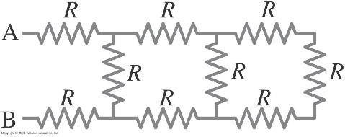

**28.** (II) Determine the terminal voltage of each battery in Fig. 26–46.

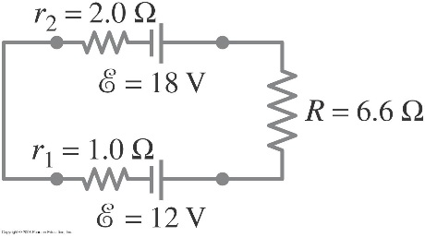

**32.** (II) Calculate the currents in each resistor of Fig. 26–50.

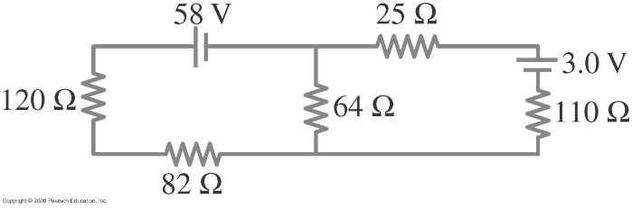

**50.** (III) Determine the time constant for charging the capacitor in the circuit of Fig. 26–61. [*Hint*: Use Kirchhoff’s rules.] (*b*) What is the maximum charge on the capacitor?

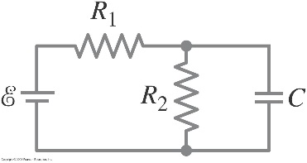

**51.** (III) Two resistors and two uncharged capacitors are arranged as shown in Fig. 26–62. Then a potential difference of 24 V is applied across the combination as shown. (*a*) What is the potential at point a with switch S open? (Let at the negative terminal of the source.) (*b*) What is the potential at point b with the switch open? (*c*) When the switch is closed, what is the final potential of point b? (*d*) How much charge flows through the switch S after it is closed?



