**Homework 2 Solutions PHYS 212 Dr. Amir**

**25.** (I) The electric force on a +4.20 μC charge is $\vec{F}=(7.22×{10}^{-4}N)\vec{j}$. What is the electric field at the position of the charge?

25. Use the definition of the electric field, Eq. 21-3.



**31.** (II) A long uniformly charged thread (linear charge density λ =2.5C/m) lies along the *x* axis in Fig. 21–56. A small charged sphere (*Q=-2.0C)* is at the point *y=-5.0*cm. What is the electric field at the point and represent fields due to the long thread and the charge *Q*, respectively **(show the work for the electric field for the Thread).**



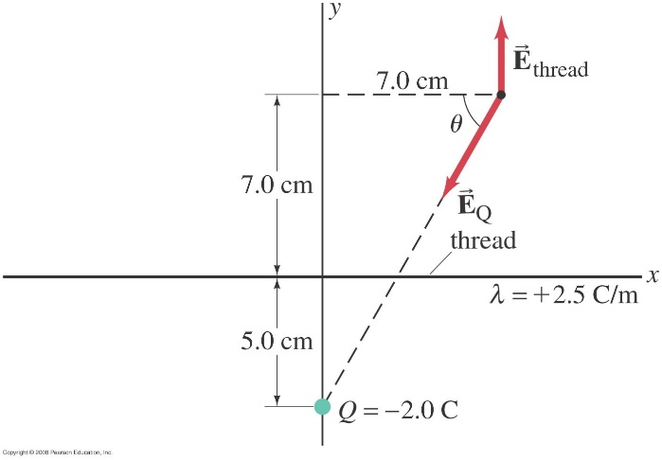

31. The field at the point in question is the vector sum of the two fields shown in Figure 21-56. Use the results of Example 21-11 to find the field of the long line of charge.



**35.** (II) Determine the direction and magnitude of the electric field at the point P in Fig. 21–57. The charges are separated by a distance 2*a*, and point P is a distance *x* from the midpoint between the two charges. Express your answer in terms of *Q*, *x*, *a*, and *k*.

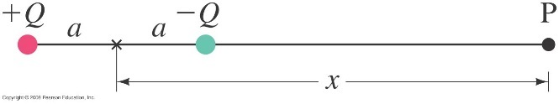

35. Choose the rightward direction to be positive. Then the field due to +*Q* will be positive, and the

field due to –*Q* will be negative.



The negative sign means the field points to the left .

**36.** (II) Two point charges, *Q1*= -25 μC and *Q2*=+45 μC are separated by a distance of 12 cm. The electric field at the point P (see Fig. 21–58) is zero. How far from is P?



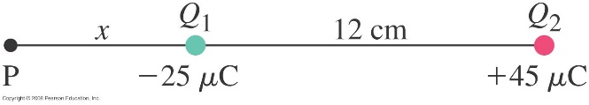

36. For the net field to be zero at point P, the magnitudes of the fields created by  and  must be

equal. Also, the distance  will be taken as positive to the left of . That is the only region where the total field due to the two charges can be zero. Let the variable  represent the 12 cm distance, and note that .



**38.** (II) (*a*) Determine the electric field  at the origin 0 in Fig. 21–59 due to the two charges at A and B. (*b*) Repeat, but let the charge at B be reversed in sign.

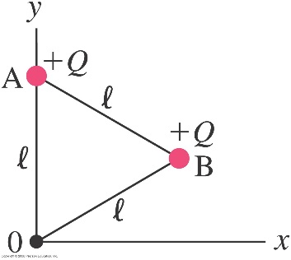

38. (*a*) The field due to the charge at A will point straight downward, and

the field due to the charge at B will point along the line from A to

the origin, 30o below the negative *x* axis.



(*b*) Now reverse the direction of 







**46.** (II) The uniformly charged straight wire in Fig. 21–29 has the length $l$ where point 0 is at the midpoint. Show that the field at point P, a perpendicular distance *x* from 0, is given by

$$E=\frac{λ}{2πε_{0}}\frac{l}{x{(l^{2}+4x^{2})}^{1/2}}$$

where $λ$ is the charge per unit length.

*x*

*x*

**

*r*



*P*

46. This is essentially Example 21-11 again, but with different limits of integration. From the diagram here, we see that the maximum angle is given by  We evaluate the results at that angle.



