- (I) A uniform electric field of magnitude 5.8 passes through a circle of radius
13 cm. What is the electric flux through the circle when its face is (a) perpendicular to the field lines, (b) at 45° to the field lines, and (c) parallel to the field lines?
The electric flux of a uniform field is given by Eq. 22-1b.
(a)
(b)
(c)

6. (I) Figure 22–26 shows five closed surfaces that surround various charges in a plane, as indicated. Determine the electric flux through each surface, and The surfaces are flat “pillbox” surfaces that extend only slightly above and below the plane in which the charges lie.
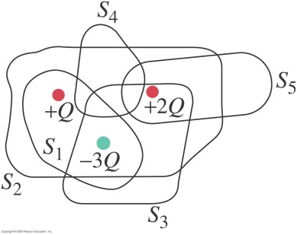
The net flux through each closed surface is determined by the net charge inside. Refer to the picture in the textbook.

24. (II) Two large, flat metal plates are separated by a distance that is very small compared to their height and width. The conductors are given equal but opposite uniform surface charge densities Ignore edge effects and use Gauss’s law to show (a) that for points far from the edges, the electric field between the plates is E= and (b) that outside the plates on either side the field is zero. (c) How would your results be altered if the two plates were nonconductors? (See Fig. 22–30).
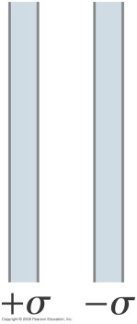

Since the charges are of opposite sign, and since the charges are free to move since they are on conductors, the charges will attract each other and move to the inside or facing edges of the plates. There will be no charge on the outside edges of the plates. And there cannot be charge in the plates themselves, since they are conductors. All of the charge must reside on surfaces. Due to the symmetry of the problem, all field lines must be perpendicular to the plates, as discussed in Example 22-7.
(a) To find the field between the plates, we choose a gaussian cylinder, perpendicular to the plates, with area A for the ends of the cylinder. We place one end inside the left plate (where the field must be zero), and the other end between the plates. No flux passes through the curved surface of the cylinder.
+
+
+
+
–
–
–
–
The field lines between the plates leave the inside surface of the left plate, and terminate on the inside surface of the right plate. A similar derivation could have been done with the right end of the cylinder inside of the right plate, and the left end of the cylinder in the space between the plates.
(b) If we now put the cylinder from above so that the right end is
+
+
+
+
–
–
–
–
inside the conducting material, and the left end is to the left of the left plate, the only possible location for flux is through the left end of the cylinder. Note that there is NO charge enclosed by the Gaussian cylinder.
(c) If the two plates were nonconductors, the results would not change. The charge would be
distributed over the two plates in a different fashion, and the field inside of the plates would not be zero, but the charge in the empty regions of space would be the same as when the plates are conductors.

27. (II) Two thin concentric spherical shells of radii and contain uniform surface charge densities and respectively (see Fig. 22–31). Determine the electric field for (a) (b) and (c) (d) Under what conditions will for (e) Under what conditions will for Neglect the thickness of the shells.
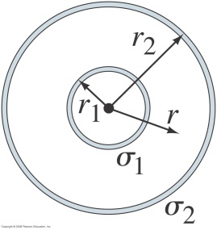

(a) In the region a gaussian surface would enclose no charge. Thus, due to the spherical
symmetry, we have the following.
(b) In the region only the charge on the inner shell will be enclosed.
(c) In the region the charge on both shells will be enclosed.
(d) To make for we must have This implies that the shells are of
opposite charge.
(e) To make for we must have Or, if a charge were placed
at the center of the shells, that would also make

35. (II) A thin cylindrical shell of radius is surrounded by a second concentric cylindrical shell of radius (Fig. 22–35). The inner shell has a total charge and the outer shell Assuming the length of the shells is much greater than or determine the electric field as a function of R (the perpendicular distance from the common axis of the cylinders) for (a) (b) and (c) (d) What is the kinetic energy of an electron if it moves between (and concentric with) the shells in a circular orbit of radius Neglect thickness of shells.
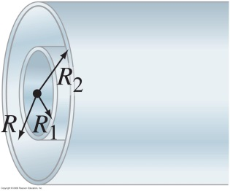
The geometry of this problem is similar to Problem 33, and so we use the same development, following Example 22-6. See the solution of Problem 33 for details. We choose the gaussian cylinder to be the same length as the cylindrical shells.
(a) For no charge is enclosed, and so
(b) For charge is enclosed, and so
(c) For both charges of and are enclosed, and so
(d) The force on an electron between the cylinders points in the direction opposite to the electric
field, and so the force is inward. The electric force produces the centripetal acceleration for the electron to move in the circular orbit.
Note that this is independent of the actual value of the radius, as long as

