Homework 2 PHYS 212 Dr. Amir

**25.** (I) The electric force on a +4.20 μC charge is $\vec{F}=(7.22×{10}^{-4}N)\vec{j}$. What is the electric field at the position of the charge?

**31.** (II) A long uniformly charged thread (linear charge density λ =2.5C/m) lies along the *x* axis in Fig. 21–56. A small charged sphere (*Q=-2.0C)* is at the point *y=-5.0*cm. What is the electric field at the point and represent fields due to the long thread and the charge *Q*, respectively **(show the work for the electric field for the Thread).**



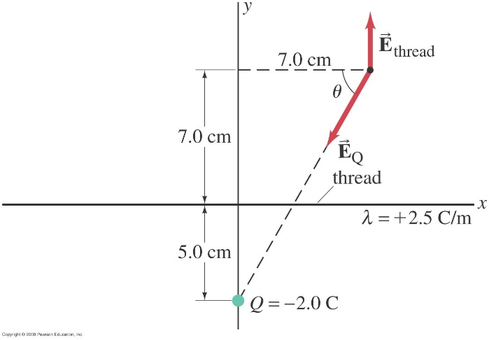

**35.** (II) Determine the direction and magnitude of the electric field at the point P in Fig. 21–57. The charges are separated by a distance 2*a*, and point P is a distance *x* from the midpoint between the two charges. Express your answer in terms of *Q*, *x*, *a*, and *k*.

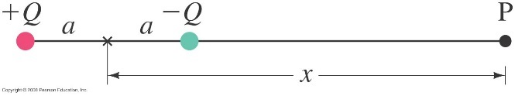

**36.** (II) Two point charges, *Q1*= -25 μC and *Q2*=+45 μC are separated by a distance of 12 cm. The electric field at the point P (see Fig. 21–58) is zero. How far from is P?



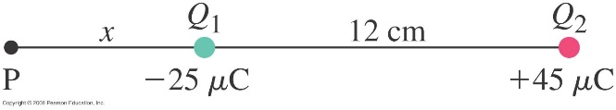

**38.** (II) (*a*) Determine the electric field  at the origin 0 in Fig. 21–59 due to the two charges at A and B. (*b*) Repeat, but let the charge at B be reversed in sign.

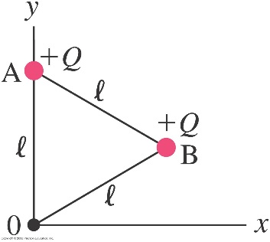

**46.** (II) The uniformly charged straight wire in Fig. 21–29 has the length $l$ where point 0 is at the midpoint. Show that the field at point P, a perpendicular distance *x* from 0, is given by

$$E=\frac{λ}{2πε_{0}}\frac{l}{x{(l^{2}+4x^{2})}^{1/2}}$$

where $λ$ is the charge per unit length.