**Chapter 7:**

**16.** (I) What is the dot product of  and 

Use Eq. 7.4 to calculate the dot product.



**19.** (I) Show that **A**(**B)**= (**A** **B**)

19. We utilize the fact that if  then 



**46.** (II) Assume that a force acting on an object is given by  where the constants *a*=3.0N/m and *b*=4.0N/m. Determine the work done on the object by this force as it moves in a straight line from the origin to 

46. Because the object moves along a straight line, we know that the *x*-coordinate increases linearly from 0 to 10.0 m, and the *y*-coordinate increases linearly from 0 to 20.0 m. Use the relationship developed at the top of page 170.



**Chapter 8:**

**20.** (II) A roller-coaster car shown in Fig. 8–32 is pulled up to point 1 where it is released from rest. Assuming no friction, calculate the speed at points 2, 3, and 4.

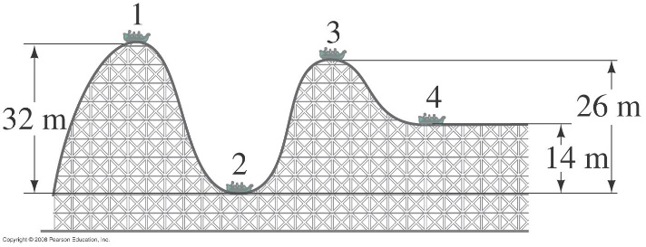

20. Since there are no dissipative forces present, the mechanical energy of the roller coaster will be conserved. Subscript 1 represents the coaster at point 1, etc. The height of point 2 is the zero location for gravitational potential energy. We have  and 

Point 2: 



Point 3: 



Point 4: 



**23.** (II) A block of mass *m* is attached to the end of a spring (spring stiffness constant *k*), Fig. 8–35. The mass is given an initial displacement  from equilibrium, and an initial speed  Ignoring friction and the mass of the spring, use energy methods to find (*a*) its maximum speed, and (*b*) its maximum stretch from equilibrium, in terms of the given quantities.

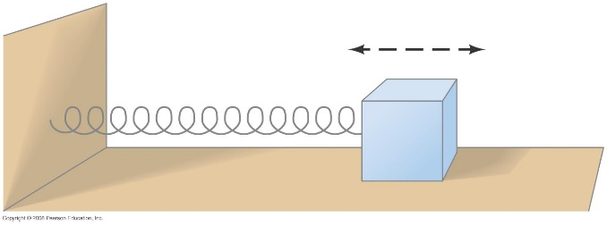

23. At the release point the mass has both kinetic energy and elastic potential energy. The total energy is  If friction is to be ignored, then that total energy is constant.

(*a*) The mass has its maximum speed at a displacement of 0, and so only has kinetic energy at that point.



(*b*) The mass has a speed of 0 at its maximum stretch from equilibrium, and so only has potential energy at that point.



**33.** (II) A 96-kg crate, starting from rest, is pulled across a floor with a constant horizontal force of 350 N. For the first 15 m the floor is frictionless, and for the next 15 m the coefficient of friction is 0.25. What is the final speed of the crate?

33. We apply the work-energy theorem. There is no need to use potential energy since the crate moves along the level floor, and there are no springs in the problem. There are two forces doing work in this problem – the pulling force and friction. The starting speed is  Note that the two forces do work over different distances.





**68.** (II) A 1400-kg sports car accelerates from rest to  in 7.4 s. What is the average power delivered by the engine?

68. The average power is the energy transformed per unit time. The energy transformed is the change in

kinetic energy of the car.



**71.** (II) A ski area claims that its lifts can move 47,000 people per hour. If the average lift carries people about 200 m (vertically) higher, estimate the maximum total power needed.

71. The force to lift a person is equal to the person’s weight, so the work to lift a person up a vertical distance *h* is equal to *mgh*. The work needed to lift *N* people is *Nmgh*, and so the power needed is the total work divided by the total time. We assume the mass of the average person to be 70 kg.

.