**32.** (II) A window washer pulls herself upward using the bucket–pulley apparatus shown in Fig. 4–36. (*a*) How hard must she pull downward to raise herself slowly at constant speed? (*b*) If she increases this force by 15%, what will her acceleration be? The mass of the person plus the bucket is 72 kg.

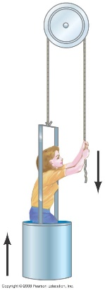

**35.** (II) Two snowcats in Antarctica are towing a housing unit to a new location, as shown in Fig. 4–38. The sum of the forces  and  exerted on the unit by the horizontal cables is parallel to the line L, and  Deter­­mine  and the magnitude of 

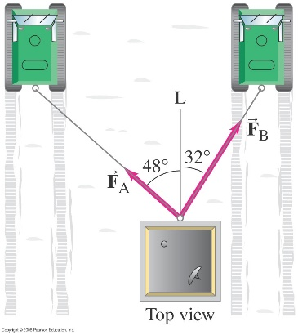

**48.** (II) The block shown in Fig. 4–43 has mass  and lies on a fixed smooth frictionless plane tilted at an angle θ= 22° to the horizontal. (*a*) Determine the acceleration of the block as it slides down the plane. (*b*) If the block starts from rest 12.0 m up the plane from its base, what will be the block’s speed when it reaches the bottom of the incline?

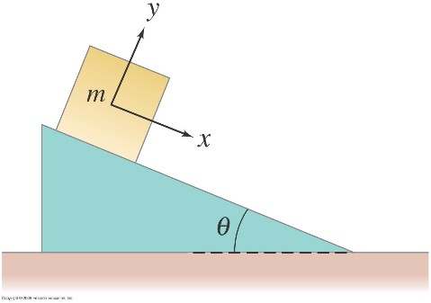

**49.** (II) A block is given an initial speed of 4.5 m/s up the 22° plane shown in Fig. 4–43. (*a*) How far up the plane will it go? (*b*) How much time elapses before it returns to its starting point? Ignore friction.

**52.** (II) (*a*) If  and  in Fig. 4–45, determine the acceleration of each block. (*b*) If initially  is at rest 1.250 m from the edge of the table, how long does it take to reach the edge of the table if the system is allowed to move freely? (*c*) If  how large must  be if the acceleration of the system is to be kept at 

**54.** (III) Suppose the pulley in Fig. 4–46 is suspended by a cord C. Determine the tension in this cord after the masses are released and before one hits the ground. Ignore the mass of the pulley and cords.

