**Homework 2 Solutions PHYS 211 Dr. Amir**

**Chap.2**

**51**. Choose upward to be the positive direction, and take  to be at the height where the ball was hit. For the upward path,   at the top of the path, and 

(*a*) The displacement can be found from Eq. 2-12c, with *x* replaced by *y* .



(*b*) The time of flight can be found from Eq. 2-12b, with *x* replaced by *y* , using a displacement of 0

for the displacement of the ball returning to the height from which it was hit.



The result of *t* = 0 s is the time for the original displacement of zero (when the ball was hit), and the result of *t* = 4 s is the time to return to the original displacement. Thus the answer is *t* = 4 s.

**63.** Choose up to be the positive direction, so  Let the ground be the location. As an intermediate result, the velocity at the bottom of the window can be found from the data given. Assume the rocket is at the bottom of the window at *t* = 0, and use Eq. 2-12b.





Now use the velocity at the bottom of the window with Eq. 2-12c to find the launch velocity, assuming the launch velocity was achieved at the ground level.





The maximum height can also be found from Eq. 2-12c, using the launch velocity and a velocity of 0 at the maximum height.



**67.** The displacement is found from the integral of the velocity, over the given time interval.



**Chap.3**

**3.** 3. Given that  units and  units, the magnitude of  is given by  The direction is given by   below the positive *x*-axis.

**5.** (*a*) See the accompanying diagram

(*b*) 

(*c*) 



**10.** 



(*a*) 



(*b*)  

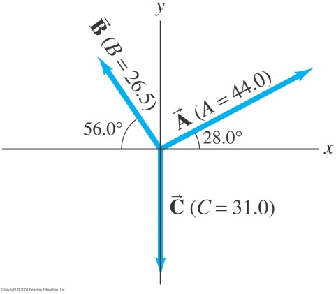 Fig. 3–38

**38.** Choose the origin to be the point on the ground directly below the point where the baseball was hit. Choose upward to be the positive *y* direction. Then  at the end of the motion,  and  Use Eq. 2-12b to find the time of flight.



The smaller time is the time the baseball reached the building’s height on the way up, and the larger time is the time the baseball reached the building’s height on the way down. We must choose the larger result, because the baseball cannot land on the roof on the way up. Now calculate the horizontal distance traveled using the horizontal motion at constant velocity.



**46.** Choose the origin to be at ground level, under the place where the projectile is launched, and upwards to be the positive *y* direction. For the projectile,     and 

(*a*) The time taken to reach the ground is found from Eq. 2-12b, with a final height of 0.



Choose the positive time since the projectile was launched at time *t* = 0.

(*b*) The horizontal range is found from the horizontal motion at constant velocity.



(*c*) At the instant just before the particle reaches the ground, the horizontal component of its

velocity is the constant  The vertical component is found from Eq. 2-12a.



(*d*) The magnitude of the velocity is found from the *x* and *y* components calculated in part (*c*)

above.



(*e*) The direction of the velocity is , and so the object is

moving 

(*f*) The maximum height above the cliff top reached by the projectile will occur when the *y*-

velocity is 0, and is found from Eq. 2-12c.

